

**HCMC UNIVERSITY OF TECHNOLOGY AND EDUCATION  
FACULTY OF INTERNATIONAL EDUCATION**------------------------------



**CAPSTONE PROJECT**

**BUILDING A SOCIAL NETWORK PLATFORM   
WITH INTEGRATED E-COMMERCE FEATURES**

**INSTRUCTOR: NGUYỄN TRẦN THI VĂN, MSc.**

**STUDENTS:**

**21110759 HỒ THANH DUY**

**21110806 VŨ TIẾN TRÌNH**

***Ho Chi Minh City, May 2025***



**HCMC UNIVERSITY OF TECHNOLOGY AND EDUCATION  
FACULTY OF INTERNATIONAL EDUCATION**------------------------------



**CAPSTONE PROJECT**

**BUILDING A SOCIAL NETWORK PLATFORM   
WITH INTEGRATED E-COMMERCE FEATURES**

**INSTRUCTOR: NGUYỄN TRẦN THI VĂN, MSc.**

**STUDENTS:**

**21110759 HỒ THANH DUY**

**21110806 VŨ TIẾN TRÌNH**

***Ho Chi Minh City, May 2025***

# OBJECTIVES FOR CAPSTONE PROJECT

Full name: Hồ Thanh Duy ….…………………………………….……ID: 21110759

Full name: Vũ Tiến Trình………………………………………….……ID: 21110806

**Major**: Software Engineering

**Project**: Building a social network platform with integrated e-commerce features

**Instructor**: Nguyễn Trần Thi Văn, MSc

**Contents:**

*Theory:* Learn about some technologies:

* RESTful API with SpringBoot Framework
* Building website with NextJs Framework
* Building application with Flutter Framework
* Spring Security (JWT, OAuth with Google Login)
* Docker to deploy production
* Websocket protocol
* LLM model
* Online Payment Integration

*Practice:* Build a social network system with such features:

* Profile Management: Update personal info, manage profile pictures, and view profiles.
* Post Management: Create, edit, delete posts, like, comment.
* Authentication: Register, log in (JWT), with OAuth and password recovery.
* Relationships: Send friend requests, follow/unfollow, and manage connections.
* Real-Time messaging: WebSocket messaging with basic online chatting
* File Management: Upload and manage media in posts and profiles.
* Ecommerce Features: Enables users to purchase products, make secure payments, and track orders in real-time.
* Recommendation: Recommending post, another user and products base on interactive of user.

**Time:** 15 weeks (from 10/02/2025 to 26/05/2025)

 Sign of student: ……………………………………………………………

 Sign of student: ……………………………………………………………

*TP.HCM, day…. month…. year …*

  CHAIR OF THE PROGRAM     INSTRUCTOR

       (*write, sign full name*) (*write, sign full name*)

**SOCIALIST REPUBLIC OF VIETNAM**

**Independence – Freedom – Happiness**

**------------------------------------**

# INSTRUCTOR’S EVALUATION SHEET

**Student Name**: Hồ Thanh Duy **Student ID:** 21110759

**Student Name**: Vũ Tiến Trinh **Student ID:** 21110806

**Project title:** Building a social network platform with integrated e-commerce features

**Instructor:** Nguyễn Trần Thi Văn, MSc

**EVALUATION**

**1.** Content of the project:

............................................................................................................................................

............................................................................................................................................

**2.** Strengths:

............................................................................................................................................

............................................................................................................................................

**3.** Weaknesses:

............................................................................................................................................

............................................................................................................................................

**4.** Approval for oral defense? (Approved or denied)

............................................................................................................................................

**5.** Overall evaluation: (Excellent, Good, Fair, Poor)

............................................................................................................................................

**6.** Mark: ………. (In words: .........................................................................................)

Ho Chi Minh City, May 2025

**INSTRUCTOR**

*(Sign with full name)*

**SOCIALIST REPUBLIC OF VIETNAM**

**Independence – Freedom – Happiness**

**------------------------------------**

# REVIEWER’S EVALUATION SHEET

**Student Name**: Hồ Thanh Duy **Student ID:** 21110759

**Student Name**: Vũ Tiến Trình **Student ID:** 21110806

**Project title:** Building a social network platform with integrated e-commerce features

**Reviewer:** Lê Văn Vinh, PhD.

**EVALUATION**

**1.** Content of the project:

............................................................................................................................................

............................................................................................................................................

**2.** Strengths:

............................................................................................................................................

............................................................................................................................................

**3.** Weaknesses:

............................................................................................................................................

............................................................................................................................................

**4.** Approval for oral defense? (Approved or denied)

............................................................................................................................................

**5.** Overall evaluation: (Excellent, Good, Fair, Poor)

............................................................................................................................................

**6.** Mark: ………. (In words: .........................................................................................)

Ho Chi Minh City, May 2025

**REVIEWER**

*(Sign with full name)*

# ACKNOWLEDGEMENT

*First and foremost, I would like to express our heartfelt gratitude to Mr. Nguyễn Trần Thi Văn for his unwavering support and guidance throughout the process of researching and implementing this topic. I'd want to express our gratitude to the teacher for his passionate instruction and guidance in selecting themes, techniques, and rectifying flaws in the implementation process.*

*I'd also want to express our gratitude to the professors at Ho Chi Minh City's University of Technology and Education, particularly the Faculty Lecturers, who energetically taught and shared a wealth of information and expertise with us during our schooling. To assist me in effectively completing the topic.*

*However, faults made during the implementation of the topic may be overlooked by teachers. I eagerly await instructor feedback so that I may get more experience and increase my expertise in order to better serve the learning and working process in the future*.

|  |  |
| --- | --- |
|  | *Thank you sincerely!*  Hồ Thanh Duy  Vũ Tiến Trình |

**CONTENTS**

CHAPTER 1. INTRODUCTION 1

1. Reasons for choosing the topic 1

2. Purpose of the topic 2

3. Research subjects and scope 2

4. Expected results 3

CHAPTER 2. BASIC CONCEPTS 4

2.1. NodeJs 4

2.2. NextJs 5

2.3. Redis 6

2.4. Kafka 7

2.5. SpringAI 8

2.6. Apache Flink 8

2.7. ZooKeeper 9

2.8. Debezium 10

2.9. Docker 11

2.10. PostgreSQL 12

2.11. Spring Boot Framework 12

2.12. WebSocket 13

2.13. Flutter 14

2.14. MySQL 15

CHAPTER 3. REQUIREMENTS AND MODELING 16

3.1. Current status survey 16

3.1.1. Facebook 17

3.1.2. Reddit 18

3.1.3. Linkedin 19

3.2. System Requirements 20

3.2.1. List of actions 20

3.2.2. Business functional 22

3.2.3. System functional 26

3.2.4. Non-functional 27

3.3. Use Case Models 28

3.3.1. Use case diagrams 28

3.3.2. Use case specifications 31

CHAPTER 4. SYSTEM ANALYSIS AND DESIGN 48

4.1. System architecture 48

4.2. Sequence diagrams 48

4.2.1. Register 48

4.2.2. Login 49

4.2.3. Delete user 49

4.2.4. Change profile’s user 50

4.2.5. Create Post 50

4.2.6. Edit Post 51

4.2.7. Delete Post 51

4.2.8. Create comment post 52

4.2.9. Update comment post 52

4.2.10. Delete comment post 53

4.2.11. Like/Unlike post 53

4.2.12. Send message 54

4.2.13. Follow/Unfollow user 54

4.2.14. Save/Unsave post 55

4.2.15. Create friend request 55

4.2.16. Accept friend request 56

4.2.17. Delete friend 56

4.2.18. Like/Unlike Product 57

4.2.19. Like/Unlike comment 57

4.2.20. Create comment product 58

4.2.21. Delete comment product 58

4.2.22. Create cart 59

4.2.23. Create order 59

4.2.24. Create address 60

4.2.25. Delete address 60

4.2.26. Create new category 61

4.2.27. Update/Delete category 61

4.2.28. Create product 62

4.2.29. Update product 62

4.2.30. Delete product 63

4.2.31. Create topic 63

4.2.32. Update/Delete topic 64

4.3. Database design 65

4.3.1. Table description 66

4.4. User interface design 83

4.4.1. Admin interface 85

4.4.2. User interface 89

CHAPTER 5. IMPLEMENTATION AND TESTING 116

5.1. Development environment 116

5.1.1. Implementation 117

5.1.2. Tools 119

5.1.3. TechStack 120

5.2.Deploy Environment 120

5.2.1. Environment Overview 120

5.2.2. Hardware Specifications. 121

5.3. Testing 121

5.2.1. Test case with user 121

5.2.2. Test case with Admin 122

CHAPTER 6. CONCLUSION 123

6.1. Achievements 123

6.1.1. Knowledge 123

6.1.2. Skills 123

6.1.3. Product 124

6.2. Strength and drawback 125

6.2.1. Strength 125

6.2.2. Drawback 125

6.3. Future work 125

REFERENCES 127

**LIST OF FIGURES**

**Chapter 2. Theoretical foundations**

Figure 2-1. Nodejs 4

Figure 2-2. NextJs 5

Figure 2-3. Redis 6

Figure 2‑4. Kafka 7

Figure 2‑5. Spring AI 8

Figure 2‑6. Apache Flink 8

Figure 2‑7. Apache ZooKeeper 9

Figure 2‑8. Debezium 10

Figure 2‑9. Docker 11

Figure 2‑10. PostgreSQL 12

Figure 2‑11. Java Spring boot Framework 12

Figure 2‑12. Flutter 14

Figure 2‑13. MySQL 15

**Chapter 3. Requirements capturing and modeling**

Figure 3‑1. Survey faccebook 17

Figure 3‑2. Survey reddit 18

Figure 3‑3. Survey linkedin 19

Figure 3‑4. User management use case diagram 28

Figure 3‑5. Post management use case diagram 29

Figure 3‑6. Product management use case diagram 30

**Chapter 4. System analysis and design**

Figure 4‑1. System architechture 48

Figure 4‑2. Register sequence diagram 48

Figure 4‑3. Login sequence diagram 49

Figure 4‑4. Delete user sequence diagram 49

Figure 4‑5. Change profile’s user sequence diagram 50

Figure 4‑6. Create post sequence diagram 50

Figure 4‑7. Edit post sequence diagram 51

Figure 4‑8. Delete post sequence diagram 51

Figure 4‑9. Create comment sequence diagram 52

Figure 4‑10. Delete comment sequence diagram 52

Figure 4‑11. Delete comment sequence diagram 53

Figure 4‑12. Liked/Unliked post sequence diagram 53

Figure 4‑13. Send message sequence diagram 54

Figure 4‑14. Follow/Unfollow user sequence diagram 54

Figure 4‑15. Save/Unsave post sequence diagram 55

Figure 4‑16. Create friend request sequence diagram 55

Figure 4‑17. Accept friend request sequence diagram 56

Figure 4‑18. Remove friend sequence diagram 56

Figure 4‑19. Like/Unlike product 57

Figure 4‑20. Like/Unlike comment sequence diagram 57

Figure 4‑21. Create comment product 58

Figure 4‑22. Delete comment product 58

Figure 4‑23. Create cart sequence diagram 59

Figure 4‑24. Create order sequence diagram 59

Figure 4‑25. Create address sequence diagram 60

Figure 4‑26. Delete address sequence diagram 60

Figure 4‑27. Create new category sequence diagram 61

Figure 4‑28. Update/Delete category sequence diagram 61

Figure 4‑29. Create product sequence diagram 62

Figure 4‑30. Update product sequence diagram 62

Figure 4‑31. Delete product sequence diagram 63

Figure 4‑32. Create topic sequence diagram 63

Figure 4‑33. Update/Delete topic sequence diagram 64

Figure 4‑34. Entity-Relational database 65

Figure 4‑35. Dashboard admin screen 85

Figure 4‑36. Topic management screen 86

Figure 4‑37. User management screen 87

Figure 4‑38. Product management screen 87

Figure 4‑39. Register screen 89

Figure 4‑40. Login screen 90

Figure 4‑41. Login screen mobile 91

Figure 4‑42. Main screen light mode 92

Figure 4‑43. Main screen dark mode 92

Figure 4‑44. Main screen mobile 93

Figure 4‑45. Post detail screen 95

Figure 4‑46. Post detail mobile screen 95

Figure 4‑47. Create post screen 96

Figure 4‑48. Create post mobile screen 97

Figure 4‑49. Saved items screen 98

Figure 4‑50. Saved items screen 99

Figure 4‑51. Resource screen 100

Figure 4‑52. Resource screen 101

Figure 4‑53. Chatting screen 102

Figure 4‑54. Chatting mobile screen 103

Figure 4‑55. Search screen 104

Figure 4‑56. Show all friend screen 105

Figure 4‑57. Show all friend mobile screen 106

Figure 4‑58. Market place screen 107

Figure 4‑59. Market place mobile screen 107

Figure 4‑60. Cart screen 109

Figure 4‑61. Cart mobile screen 109

Figure 4‑62. Order detail screen 110

Figure 4‑63. Order detail mobile screen 111

Figure 4‑64. Tracking orders screen 112

Figure 4‑65. Tracking orders mobile screen 113

Figure 4‑66. Product detail screen 114

Figure 4‑67. Product detail mobile screen 114

**Chapter 5. Implementation and testing**

Figure 5-1. Docker container 117

Figure 5-2. Selected device 119

# LIST OF TABLES

**Chapter 3. Requirements capturing and modeling**

Table 3‑1. Advantages and disadvantages of facebook social media application 17

Table 3‑2. Advantages and disadvantages of reddit social media application 18

Table 3‑3. Advantages and disadvantages of linkedin social media application 20

Table 3‑4. List of actions from requirements capturing 21

Table 3‑5. Detail requirement's type of requirements 21

Table 3‑6. Manage account functional 22

Table 3‑7. Manage post functional 22

Table 3‑8. Media resources functional 23

Table 3‑9. Manage reporting functional 24

Table 3‑10. Manage relationship functional 24

Table 3‑11. Manage conversation functional 24

Table 3‑12. Manage profile functional 25

Table 3‑13. Notifications functional 25

Table 3‑14. Feed and search functional 26

Table 3‑15. System functional 27

Table 3‑16. Non-functional 27

Table 3‑17. Register (UC-1) 31

Table 3‑18. Login (UC-2) 32

Table 3‑19. Delete user (UC-3) 32

Table 3‑20. Change profile’s user (UC-4) 33

Table 3‑21. Create post (UC-5) 33

Table 3‑22. Edit post (UC-6) 34

Table 3‑23. Delete post (UC-7) 35

Table 3‑24. Comment post (UC-8) 35

Table 3‑25. Update comment post (UC-9) 35

Table 3‑26. Delete comment post (UC-10) 36

Table 3‑27. Like/unlike post (UC-11) 36

Table 3‑28. Send message (UC-12) 37

Table 3‑29. Follow/Unfollow user (UC-13) 37

Table 3‑30. Save/Unsave post (UC-14) 38

Table 3‑31. Create friend request (UC-15) 38

Table 3‑32. Accept friend request (UC-16) 39

Table 3‑33. Deleted friend (UC-17) 39

Table 3-34. Like/unlike product (UC-18) 40

Table 3‑35. Like/Unlike comment (UC-19) 40

Table 3‑36. Create comment product (UC-20) 41

Table 3‑37. Delete comment product (UC-21) 42

Table 3‑38. Create cart (UC-22) 42

Table 3‑39. Create order (UC-23) 43

Table 3‑40. Create address (UC-24) 43

Table 3‑41. Delete address (UC-25) 44

Table 3‑42. Create new category (UC-26) 44

Table 3‑43. Edit/Delete category (UC-27) 45

Table 3‑44. Create product (UC-28) 45

Table 3‑45. Update product (UC-29) 46

Table 3‑46. Delete product (UC-30) 46

Table 3‑47. Create topic (UC-31) 47

Table 3‑48. Delete product (UC-32) 47

**Chapter 4. System analysis and design**

Table 4‑1. User entity 66

Table 4‑2. Payment entity 67

Table 4‑3. Address entity 68

Table 4‑4. Role entity 69

Table 4‑5. User roles entity 69

Table 4‑6. Post entity 70

Table 4‑7. Content entity 70

Table 4‑8. Reaction entity 71

Table 4‑9. Comment entity 71

Table 4‑10. Image entity 72

Table 4‑11. Follow entity 73

Table 4‑12. Friend entity 73

Table 4‑13. Topic entity 74

Table 4‑14. File entity 75

Table 4‑15. Notification entity 76

Table 4‑16. Post images entity 76

Table 4‑17. Conversation entity 77

Table 4‑18. Product entity 78

Table 4‑19. Product-like entity 79

Table 4‑20. Product images entity 79

Table 4‑21. Category entity 80

Table 4‑22. Product comment entity 80

Table 4‑23. Line items entity 81

Table 4‑24. Order entity 82

Table 4‑25. Payment entity 83

Table 4‑26. List of user interface design 84

Table 4‑27. Dashboard admin screen 86

Table 4‑28. Topic management screen 86

Table 4‑29. User management screen 87

Table 4‑30. Product management screen 88

Table 4‑31. Register screen 90

Table 4‑32. Login screen 91

Table 4‑33. Main screen 94

Table 4‑34. Post detail screen 96

Table 4‑35. Create post screen 98

Table 4‑36. Saved items screen 100

Table 4‑37. Resource screen 101

Table 4‑38. Chatting screen 104

Table 4‑39. Search screen 105

Table 4‑40. All friend screen 106

Table 4‑41. Market screen 108

Table 4‑42. Cart screen 110

Table 4‑43. Product detail screen 111

Table 4‑44. Market screen 114

Table 4‑45. Product detail screen 115

**Chapter 5. Implementation and testing**

Table 5‑1. List of application need for system 116

Table 5‑2. Tool needed for social application 120

Table 5‑3. Technologies stask of system 120

Table 5‑4. Test case with user 122

Table 5‑5. Test case with admin 122

# CHAPTER 1. INTRODUCTION

## 1. Reasons for choosing the topic

The advent of the Fourth Industrial Revolution (Industry 4.0) has fundamentally reshaped communication paradigms, accelerating the integration of advanced digital technologies into daily life. Social networking applications stand as a prime example, serving as pivotal platforms for global interaction, information exchange, and community building. Popular platforms like Facebook, Zalo, Instagram, and Reddit underscore this trend, having achieved significant user adoption and societal impact.

However, despite their widespread utility, these platforms are primarily designed for general social interaction. They often lack structural support for domain-specific engagement or integrated commercial functionalities tailored to niche communities. This generalization leads to content saturation, reduced relevance, and inefficient pathways for both information retrieval and e-commerce activities.

Moreover, as consumer behavior increasingly shifts toward socially influenced purchasing decisions, there's a growing demand for platforms that seamlessly combine social networking with contextual, community-driven commerce. Current solutions often force users to toggle between separate applications for social engagement and online shopping, creating fragmented experiences and missed opportunities for meaningful interaction and transaction.

In response to these critical gaps, this project proposes the development of an integrated platform that merges social networking with e-commerce capabilities within a cohesive, user-centric ecosystem. Our platform is specifically designed to empower focused communities, enabling users not only to share knowledge and interests but also to seamlessly buy, sell, and promote products within the same virtual environment. This approach promises a more efficient, engaging, and relevant digital experience.

## 2. Purpose of the topic

This study aims to design and develop a comprehensive digital platform that integrates the core functionalities of a social network with robust e-commerce features. The goal is to create a domain-specific ecosystem that supports both dynamic social interaction and seamless commercial transactions, tailored to the needs of specific user communities.

Unlike conventional social media platforms or standalone e-commerce sites, this system is engineered to deliver targeted content distribution, community-based moderation, and context-aware product discovery. Through intelligent filtering mechanisms and thematic content organization, the platform enhances relevance, reduces information overload, and improves user efficiency in both social and shopping activities.

A key feature of the system is its multi-platform architecture, designed to provide a consistent and responsive user experience across mobile devices, web browsers, and desktop applications. This approach ensures accessibility, usability, and performance regardless of the user’s preferred device.

By combining social networking capabilities with integrated e-commerce tools, the platform empowers users to connect, share, and transact within a unified digital environment. This hybrid model not only fosters user engagement and trust but also supports personalized marketing and community-driven commerce. Ultimately, the project seeks to contribute to the evolution of integrated digital platforms that merge social interaction with economic utility, offering enhanced value to both users and businesses.

## 3. Research subjects and scope

This research focuses on the integration of social media functionalities with e-commerce features to deliver a seamless and engaging user experience. The study aims to explore how typical social networking features - such as user profiles, newsfeeds, posts, likes, comments, and shares - can be effectively combined with e-commerce elements, including product catalogs, shopping carts, payment gateways, and order tracking systems.

The application is designed to serve the following target groups:

* General social media users: Individuals who frequently use social platforms to connect, share content, and engage with others.
* Online shoppers: Users who are interested in purchasing products through digital platforms and may benefit from social features influencing their shopping behavior.
* Content creators and influencers: People who generate engaging content and can play a key role in promoting products through reviews, live, and recommendations.
* Small and medium-sized businesses (SMEs): E-commerce vendors seeking to reach new audiences and improve customer engagement through social features.
* Marketers and brand managers: Professionals looking to leverage social commerce tools to analyze trends, drive engagement, and boost sales.

## 4. Expected results

* Increase user engagement through features like sharing, commenting, liking, and real-time chat.
* Provide personalized experiences via a recommendation system for content, connections, and products.
* Boost product discovery and purchases through organic social interactions.
* Generate rich user-created content such as reviews, product shares, and lifestyle posts.
* Enhance sales and improve the overall customer journey.
* Build a modern, scalable, and flexible platform that performs well on both web and mobile devices.

# CHAPTER 2. BASIC CONCEPTS

## 2.1. NodeJs



Figure 2-1. Nodejs

Node.js is an open-source, cross-platform JavaScript runtime that runs on the V8 engine outside the browser. It handles asynchronous I/O using non-blocking code, allowing high performance without creating new threads for each request.

We choose it because some advantages:

* Speed & Performance: Extremely fast due to its event-loop and non-blocking I/O, efficiently handling concurrent requests.
* High Productivity: Ideal for real-time, single-threaded applications such as chat and video streaming.
* Robust Error Handling: Simplifies error management with built-in, event-based mechanisms.
* Cost-Effective: Reduces IT expenses through minimal hardware needs and low maintenance.
* Rapid Development: Enables quick creation of high-performance applications, perfect for microservices and fast product launches.
* Performance in Slow Networks: Its single-threaded, non-blocking I/O ensures quick responses even with limited connectivity.
* High Scalability: Easily adapts to evolving data demands, with cloud providers further enhancing performance.

## 2.2. NextJs



Figure 2-2. NextJs

Next.js is a React framework for building full-stack web applications. You use React Components to build user interfaces, and Next.js for additional features and optimizations.

Core concept of NextJs:

* File-based Routing: Automatically generates routes based on the page’s directory structure.
* Server-side Rendering (SSR): Renders pages on the server per request for better performance and SEO.
* Static Site Generation (SSG): Pre-renders pages at build time for fast load speeds.
* Incremental Static Regeneration (ISR): Updates static content post-build with configurable revalidation.
* API Routes: Define serverless API endpoints in the pages/api folder.
* Image Optimization: Optimizes images with next/image, including lazy loading and modern formats.
* Dynamic Routing: Supports routes with dynamic URL segments.
* Client-side Rendering (CSR): Fetch data on the client using React hooks.
* Middleware: Runs at the edge to modify requests/responses (e.g., for auth, logging).
* CSS and Sass Support: Built-in support for importing CSS/Sass and using CSS Modules.
* TypeScript Support: Full TypeScript integration out of the box.
* Edge & Serverless Functions: Supports scalable, globally-distributed serverless functions and edge logic.
* Internationalization (i18n): Built-in support for multiple languages and localized routing.
* Static Asset Serving: Serve static files from the public directory via / paths.
* Performance Optimization: Includes code splitting, tree shaking, and efficient bundling.
* Deployment: Easily deployable to platforms like Vercel with optimized defaults.

## 2.3. Redis



Figure 2-3. Redis

Redis is a versatile, in-memory data store that significantly boosts application performance by enabling faster data retrieval and supporting atomic operations. It's an excellent choice for building high-performance, scalable web applications due to its speed and efficiency.

Redis have some benefits:

* Speed and Performance: Processes millions of requests per second, ideal for applications requiring rapid data access (e.g., gaming leaderboards, social media feeds).
* Scalability: Supports clustering to distribute data across multiple nodes, enhancing system capacity, availability, and redundancy for seamless application growth.
* Flexibility with Data Types: Offers a wide range of data types including strings, lists, sets, sorted sets, and more.
* Durability and Persistence: Provides persistence options like snapshotting and append-only files (AOF), balancing performance with data safety even during failures.

## 2.4. Kafka



Figure 2‑4. Kafka

Kafka is an open-source messaging system that was created by LinkedIn and later donated to the Apache Software Foundation. It’s built to handle large amounts of data in real time, making it perfect for creating systems that respond to events as they happen.

Some benefits of kafka:

* High Throughput: Efficiently handles massive, continuous data streams.
* Reliability & Fault Tolerance: Ensures data durability and accessibility through replication, even during server failures.
* Real-Time Processing: Supports immediate reactions to data changes in real-time pipelines and streaming applications.
* Decoupled Architecture: It’s publish-subscribe model fosters independent operation of producers and consumers, promoting flexible system design.
* Diverse Data Format Support: Processes structured, semi-structured, and unstructured data, accommodating various use cases.
* Extensive Ecosystem & Community: Benefits from a large, active community and strong integrations with leading data processing tools like Apache Spark and Flink.

## 2.5. SpringAI



Figure 2‑5. Spring AI

Spring AI is a framework that integrates artificial intelligence (AI) and machine learning (ML) capabilities into the Spring ecosystem. It aims to simplify the development of AI-driven applications by providing tools, libraries, and integrations that leverage the strengths of the Spring framework.

Some benefits of SpringAI:

* Seamless Integration: integrates seamlessly with the Spring ecosystem, allowing developers to use familiar tools and methodologies to build AI-driven applications.
* Extensible Architecture: The architecture of Spring AI is designed to be extensible, enabling developers to add support for new AI models and providers easily. ificial intelligence.
* Ease of use: Spring AI provides a simplified API for interacting with AI models, making it accessible to developers with varying levels of expertise in AI and machine learning.

## 2.6. Apache Flink



Figure 2‑6. Apache Flink

Apache Flink is an open-source, distributed engine for stateful processing over unbounded (streams) and bounded (batches) data sets. Stream processing applications are designed to run continuously, with minimal downtime, and process data as it is ingested. Apache Flink is designed for low latency processing, performing computations in-memory, for high availability, removing single point of failures, and to scale horizontally.

Some benefits of Apache Flink:

* Unified Stream and Batch Processing: Processes both unbounded (streams) and bounded (batches) data sets.
* Scalable Execution: Designed to run stateful applications at virtually any scale, parallelizing processing across thousands of tasks and multiple machines.
* In-Memory Performance: Achieves high performance by partitioning data and state across machines, enabling local, often in-memory, computation.
* Exactly-Once State Consistency: Guarantees consistent internal state for stateful applications, even during failures and across application stops and restarts.
* Extensive Connectors: Provides numerous proven connectors to popular messaging and streaming systems, data stores, search engines, and file systems.

## 2.7. ZooKeeper



Figure 2‑7. Apache ZooKeeper

Zookeeper is a distributed, open-source coordination service for distributed applications. It exposes a simple set of primitives to implement higher-level services for synchronization, configuration maintenance, and group and naming.

Some benefits of Apache ZooKeeper:

* Simplified Distributed Coordination: Streamlines service coordination in distributed environments.
* Synchronization: Ensures mutual exclusion and cooperation between server processes, vital for configuration management (e.g., Apache HBase).
* Message Ordering: Maintains strict message order for predictable and consistent communication between distributed components.
* Serialization: Encodes data with defined rules to maintain cross-application consistency (e.g., coordinating MapReduce task queues).
* Reliability: Provides a highly reliable infrastructure, ensuring service availability and consistency even during failures.

## 2.8. Debezium



Figure 2‑8. Debezium

It is a distributed platform for CDC that streams database changes as events, enabling applications to detect and respond to data changes in real-time. Built on Apache Kafka, Debezium provides Kafka Connectconnectors that capture row-level changes from various databases and publish them as event streams to Kafka Topic.

Some benefits of Debenzium:

* Real-Time Change Data Capture (CDC): Enables near real-time streaming of database insert, update, and delete operations, allowing immediate reaction to data changes.
* Non-Intrusive Integration: Reads the database's transaction log, eliminating the need to modify existing applications or add intrusive polling.
* Broad Database Support: Compatible with popular databases like MySQL, PostgreSQL, MongoDB, SQL Server, and Oracle.
* Seamless Kafka Integration: Natively integrates with Apache Kafka, making it ideal for event-driven and stream-processing architectures.
* Exactly-Once Delivery Semantics: Ensures exactly-once event delivery when used with Kafka, minimizing duplicated or missing data.
* High Scalability: Leverages Kafka's distributed nature for horizontal scaling with increasing throughput and data volume.
* Schema Evolution Handling: Tracks and propagates schema changes, allowing consuming systems to dynamically adapt to evolving data structures.

## 2.9. Docker



Figure 2‑9. Docker

Docker is an open platform for developing, shipping, and running applications. Docker enables you to separate your applications from your infrastructure so you can deliver software quickly. With Docker, you can manage your infrastructure in the same ways you manage your applications.

Some benefits of Docker:

* Your application will work same on any system whether you are using any laptop, server or any cloud (AWS, GCP, Azure).
* In docker each application will run on its own space, so it won’t hamper another application work.
* Docker containers start quickly, do your app runs in no time.
* You can test new features without changing your main application
* Docker uses less memory and power than virtual machines
* You can easily add more containers if more people use your application.
* Docker works well into development tools and automation setup.

## 2.10. PostgreSQL



Figure 2‑10. PostgreSQL

PostgreSQL is a powerful, open-source object-relational database system that uses and extends the SQL language combined with many features that safely store and scale the most complicated data workloads.

Some benefits of PostgresSQL:

* An open-source database that provides affordable solutions without a license charge.
* Maintains data integrity by enforcing constraints, verifying data types, and enabling referential integrity through foreign vital regulations.
* Maintains data integrity by enforcing constraints, verifying data types, and enabling referential integrity through foreign vital regulations.
* Manage demanding workloads and large-scale applications. Sharding facilitates horizontal scalability and offers performance-enhancing tools like query planning, caching, and parallel query execution.

## 2.11. Spring Boot Framework



Figure 2‑11. Java Spring boot Framework

Spring Boot is an open-source Java-based framework that simplifies the development of standalone, production-grade Spring applications. It provides rapid application development experience by automating configuration and setup tasks, reducing boilerplate code, and offering a wide range of features out of the box.

Some benefits of Springboot:

* Time-efficient and effortless development of Spring-based apps.
* Autoconfiguration of all components for a production-grade Spring application.
* Prebuilt embedded servers (Tomcat, Jetty, and Undertow), leading to accelerated and more productive app deployment.
* HTTP end-points, letting enter inner app features such as metrics, health status, etc and don’t have XML configuration.
* A vast choice of plugins, facilitating developers’ work with embedded and in-memory databases.
* Easy access to databases and queue services such as MySQL, Oracle, MongoDB, Redis, ActiveMQ, and others.
* Large community and a great variety of tutorials, facilitating the getting-to-know period.

## 2.12. WebSocket

WebSocket is used as a communication protocol that provides full-duplex communication channels over a single, long-lived connection between a client and a server. In this protocol, there are no restrictions like HTTP that for a response you have to make a request first. The server can send the message without getting any request and we use it in the chat feature and send notifications.

Some benefits of WebSocket:

* Persistent connections reduce bandwidth and latency compared to HTTP methods like long polling.
* Supported by major browsers and numerous libraries/frameworks across programming languages.
* Allows custom application-level protocols and extensions (e.g., pub/sub messaging).
* Instantly pushes data, ideal for unpredictable events like alerts.
* Enables simultaneous bidirectional messaging, perfect for multi-user applications like chat rooms.
* Outperforms one-way protocols like Server-Sent Events (SSE).

## 2.13. Flutter



Figure 2‑12. Flutter

Flutter, powered by Google's Dart language, is a robust mobile UI toolkit for building natively compiled applications for iOS and Android from a single codebase.

Some benefits of Flutter:

* Cross-Platform Efficiency: Develop for both iOS and Android simultaneously, eliminating the need for separate codebases, reconfigurations, or redesigns.
* Reduced Development Overhead: Requires fewer developers, leading to lower development costs and faster time-to-market.
* Accelerated Time-to-Market: Launch applications quicker by developing a single app that works seamlessly across platforms.
* Powerful and Modern Design: Leverage Flutter's cutting-edge framework to create visually appealing and high-performing app designs with minimal effort.

## 2.14. MySQL



Figure 2‑13. MySQL

MySQL is a widely used open-source Relational Database Management System (RDBMS) that leverages SQL for efficient data management. Renowned for its speed, reliability, and user-friendliness, it's a top choice for web applications and integrates seamlessly with languages like PHP, Java, and Python to power dynamic websites and applications.

Some benefits of MySQL:

* **Open Source:** Free to use, modify, and distribute with no licensing costs.
* **Scalability:** Easily handles growth via sharding, replication, and clustering.
* **Performance:** Fast response times with indexing, caching, and query optimization.
* **Reliability:** Ensures data integrity with ACID compliance, transactions, and crash recovery.

# CHAPTER 3. REQUIREMENTS AND MODELING

## 3.1. Current status survey

Social media applications have continued to grow and evolve in 2025, reflecting both regional and global shifts in user engagement. The number of social media users has surged to over 5 billion globally, marking an 8% annual growth. This trend illustrates not only increasing accessibility to technology but also a deepening integration of social media into daily life.

Platforms such as TikTok, Instagram, and YouTube continue to lead in user acquisition and engagement, with their growth strategies now intrinsically linked to e-commerce. TikTok, for instance, has seen a dramatic rise in its ad audience, particularly among younger demographics, and its TikTok Shop feature is rapidly converting viral trends into direct sales, boasting significant gross merchandise value (GMV) growth. Instagram has solidified its position as a visual discovery and shopping hub, with a substantial portion of users, especially Gen Z and Millennials, utilizing features like shoppable posts, stories, and a dedicated "Shop" tab to find and purchase products. Indeed, reports indicate that a high percentage of Instagram users actively research new products and brands on the platform, with many making purchases directly.

The behavior of users across different platforms highlights evolving interaction patterns, with many using social media for exploring brands, engaging with video content, and connecting through shared interests are now frequently intertwined with direct purchasing opportunities. Video formats, including both short-form and longer content, remain dominant in capturing attention and driving engagement, increasingly serving as a direct conduit to sales through features like live shopping events and in-video product links. Meanwhile, regional penetration varies widely, with Europe maintaining some of the highest usage rates, while areas in Africa show opportunities for growth.

An analysis of the current landscape and performance of various social media application:

### 3.1.1. Facebook

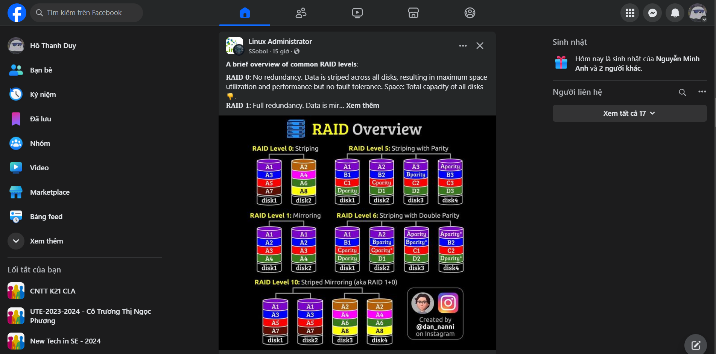

Figure 3‑. Survey faccebook

|  |  |
| --- | --- |
| **Advantages** | - Large user base enables broad social and business networking.  - Offers versatile features like groups, marketplace, and events for diverse purposes.  - Robust advertising platform with advanced targeting options for businesses.  - Easy to use, connecting people across the globe with intuitive tools. |
| **Disadvantages** | - Concerns over privacy and data security due to past breaches.  - Increasing spread of misinformation and unregulated content.  - Declining popularity among younger users, who prefer other platforms.  - Algorithmic feeds can encourage excessive screen time and decrease productivity. |

Table 3‑. Advantages and disadvantages of facebook social media application

### 3.1.2. Reddit

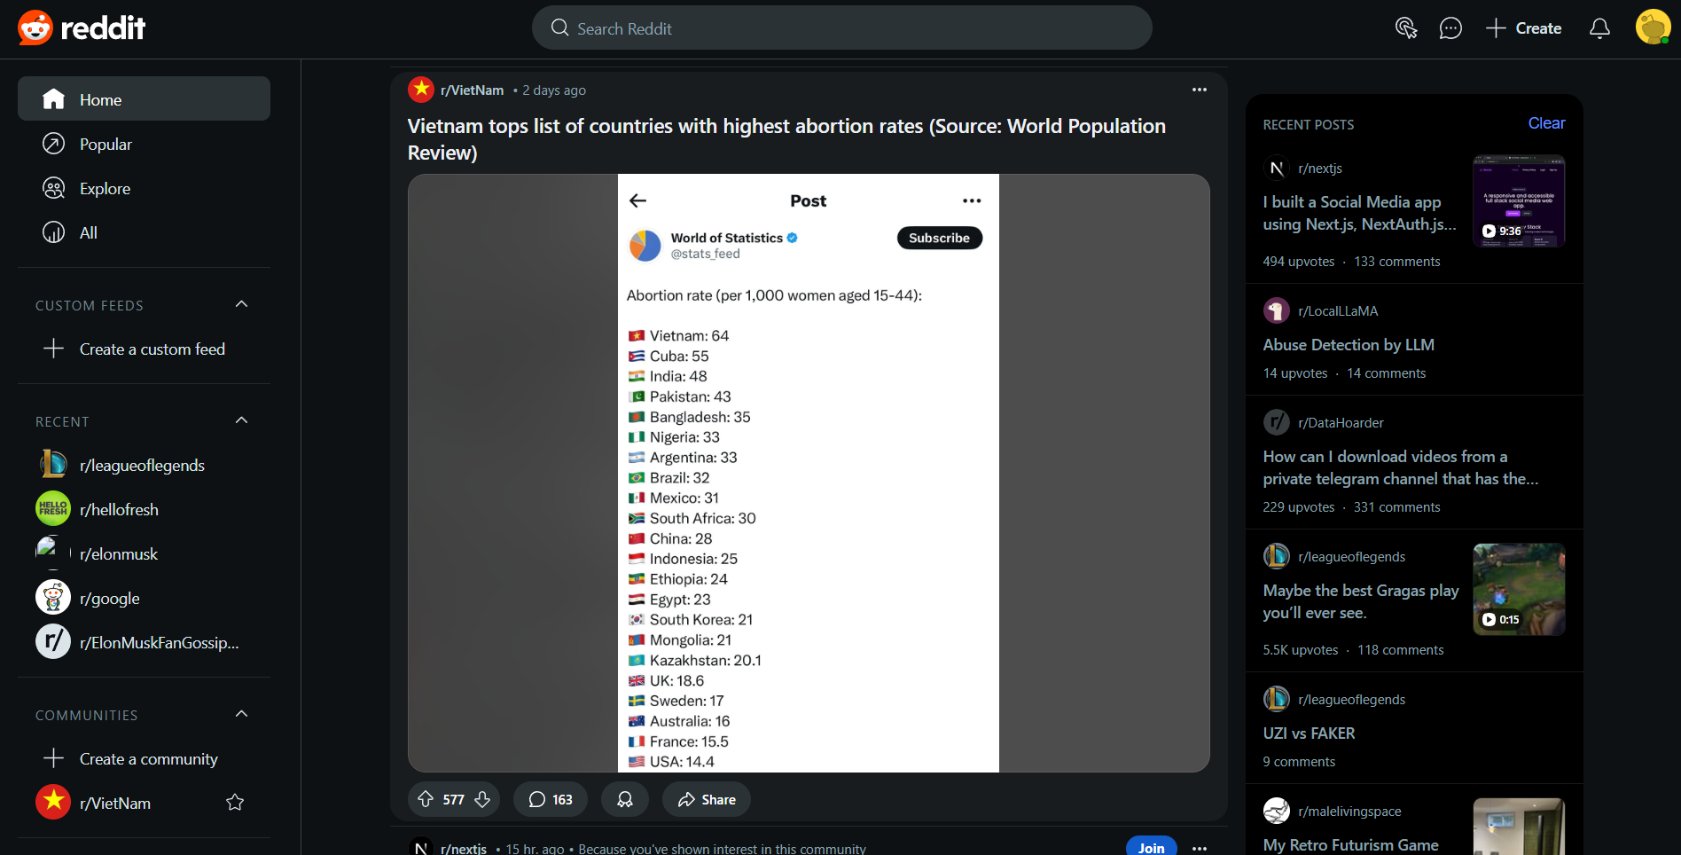

Figure 3‑. Survey reddit

|  |  |
| --- | --- |
| **Advantages** | - Community-driven platform allows for in-depth discussions on niche topics through subreddits.  - Users can remain anonymous, providing privacy and freedom of expression.  - Wide variety of content, from entertainment to educational resources, curated by users.  - Transparent, user-driven moderation fosters a sense of community and inclusiveness. |
| **Disadvantages** | - Decentralized moderation can lead to inconsistency in quality and handling of inappropriate content.  - Some subreddits may foster toxic environments or polarizing debates.  - Interface and culture can be challenging for new users to adapt to.  - Quality of content is inconsistent, as it heavily depends on user contributions. |

Table 3‑. Advantages and disadvantages of reddit social media application

### 3.1.3. Linkedin

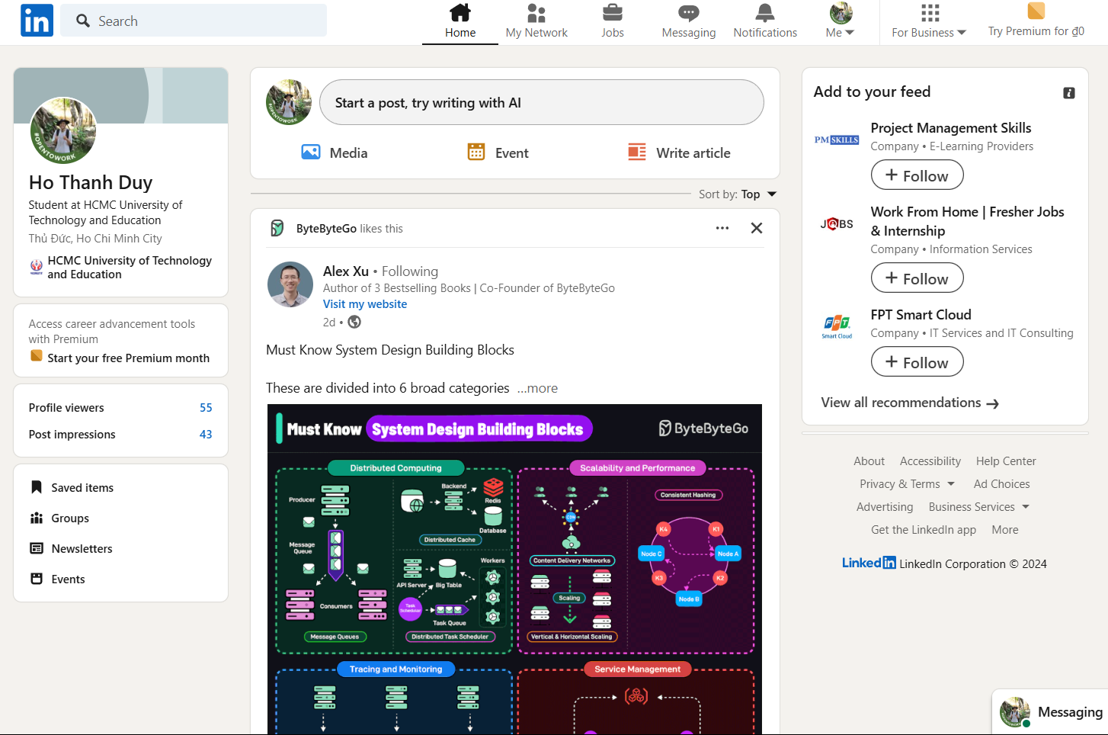

Figure 3‑. Survey linkedin

|  |  |
| --- | --- |
| **Advantages** | - Focused on professional networking, making it ideal for career growth and job hunting.  - Provides a platform to showcase professional skills, achievements, and portfolios.  - Valuable resource for companies to recruit talent and generate leads.  - Analytics tools help users measure their reach and engagement effectively. |
| **Disadvantages** | - Many advanced features, such as InMail and analytics, require costly premium subscriptions.  - Can feel overly formal and lacks casual interaction compared to other platforms.  - High competition on job postings can make it harder for applicants to stand out.  - Users may encounter spam or excessive solicitation from recruiters or salespeople. |

Table 3‑. Advantages and disadvantages of linkedin social media application

## 3.2. System Requirements

### 3.2.1. List of actions

|  |  |
| --- | --- |
| **Management** | **Action** |
| Account | * Login with authentication |
| Post | * Create post * Attach files * Edit post * Set post’s status * Set post’s topic * Delete post * Reaction * Comment * React comment * Save post |
| Media Resources | * Upload media * Download media |
| Reporting | * View user activity reports * Manage user accounts * Monitor content * Approve/reject posts * Ban/unban users * View admin actions history * Assign admin roles * Manage comment lists * Manage order lists * Manage products, topics, categories * Chatbot |
| Relationship | * Send friend requests * Manage friends list * Manage follow list |
| Conversation | * Send messages * Online status |
| Profile | * View profile * Edit profile information * Upload profile cover/ avatar * Update contact information * View friends list * View saved posts * Set profile visibility * Profile activity log * Deactivate account * Manage address * Manage orders, private products |
| Notifications | * Post notifications * Message notifications * React notifications * Request friend notifications |
| Feed and Search | * View posts in news feed * Filter news feed content * Search posts * Search products * Filter products |
| Cart | * Manage items * Manage address * Set payment |

Table 3‑. List of actions from requirements capturing

|  |  |
| --- | --- |
| **Type** | **Detail requirement’s type** |
| Storage | Storing or persisting data in a database or other storage system. |
| Lookup | Fetching data from a predefined set of values or reference data (e.g., drop-downs, lists). |
| Search | Querying data from the system with filters or search criteria. |
| Output | Displaying data, such as reports or data views, to users. |

Table 3‑. Detail requirement's type of requirements

### 3.2.2. Business functional

|  |  |  |  |
| --- | --- | --- | --- |
| **Division: manage account** | | | |
| **No.** | **Function** | **Type** | **Constrains/**  **Formula code** | | **Description** |
| 1 | Login | Search | Only username & password with authentication from system can login | | Check authentication user account and login application |

Table 3‑. Manage account functional

|  |  |  |  |
| --- | --- | --- | --- |
| **Division: manage post** | | | |
| **No.** | **Function** | **Type** | **Constrains/**  **Formula code** | **Description** |
| 1 | Create post | Storage |  | Users can create posts with text, images, videos, or links. |
| 2 | Attach files | Storage |  | Users can attach files (images, documents) to posts. |
| 3 | Edit post | Storage |  | Users can edit their posts after publishing. |
| 4 | Set post’s status | Storage |  | Adjusting post’s status after publishing |
| 5 | Save | Storage |  | Users can save posts of other. |
| 6 | Delete post | Storage |  | Users can delete their own posts. |
| 7 | Reaction/  Comment/ Delete Comment/ React Comment | Output |  | Users can interact with posts and comments of posts through likes, comments, etc.. |

Table 3‑. Manage post functional

|  |  |  |  |
| --- | --- | --- | --- |
| **Division: media resources** | | | |
| **No.** | **Function** | **Type** | **Constrains/**  **Formula code** | | **Description** |
| 1 | Upload media | Storage |  | | Users can upload photos and videos to their profiles. |
| 2 | View/  Download Media | Output |  | | Users can view and download uploaded media content. |

Table 3‑. Media resources functional

|  |  |  |  |  |
| --- | --- | --- | --- | --- |
| **No.** | **Function** | **Type** | **Constrains/**  **Formula**  **code** | **Description** |
| 1 | View user activity reports | Output | Admin | Admins can view detailed reports on user activities (posts, messages, interactions, comments, orders) and interact with chatbot about the users. |
| 2 | Manage user accounts | Output | Admin | Admins can deactivate, delete, or reset user accounts. |
| 3 | Monitor content | Output | Admin | Admins can monitor posts, comments, and media for violations. |
| 4 | Approve/  reject posts | Output | Admin | Admins can approve or reject posts pending moderation. |
| 5 | Ban/unban users | Output | Admin | Admins can ban or unban users for violating platform policies. |
| 6 | View admin actions history | Output | Admin | Admins can review the history of actions taken by other admins. |
| 7 | Assign admin roles | Output | Admin | Admins can assign or remove admin roles to/from other users. |
| 8 | Manage products | Output | Admin | Admins can manage products, categories. |

Table 3‑. Manage reporting functional

|  |  |  |  |
| --- | --- | --- | --- |
| **Division: manage relationship** | | | |
| **No.** | **Function** | **Type** | **Constrains/**  **Formula code** | | **Description** |
| 1 | Send friend requests | Storage |  | | Users can send requests to other users to become friends. |
| 2 | Manage friends list | Lookup |  | | Users can organize, view, or remove friends from their list. |
| 3 | Manage follower/ following lists | Lookup |  | | Users can follow or unfollow to another |

Table 3‑. Manage relationship functional

|  |  |  |  |
| --- | --- | --- | --- |
| **Division: manage conversation** | | | |
| **No.** | **Function** | **Type** | **Constrains/**  **Formula code** | | **Description** |
| 1 | Send messages | Storage |  | | Users can send messages with text, images, or videos. |
| 2 | Online status | Output |  | | Displays the online/offline status of users in real-time. |

Table 3‑. Manage conversation functional

|  |  |  |  |
| --- | --- | --- | --- |
| **Division: manage profile** | | | |
| **No.** | **Function** | **Type** | **Constrains/**  **Formula code** | | **Description** |
| 1 | View profile | Lookup |  | | Users can view their own and others’ profiles. |
| 2 | Edit profile information | Output |  | | Users can update their name, bio, etc. |
| 3 | Upload profile picture | Output |  | | Users can upload or change avatar and cover. |
| 4 | Update contact information | Output |  | | Users can update their email address, phone number, etc. |
| 5 | View friends/followers list | Lookup |  | | Users can view a list of their friends or followers. |
| 6 | Profile activity log | Lookup |  | | Users can view a history of their actions and profile changes. |
| 7 | Deactivate account | Output |  | | Users can temporarily deactivate their account. |

Table 3‑. Manage profile functional

|  |  |  |  |
| --- | --- | --- | --- |
| **Division: notifications** | | | |
| **No.** | **Function** | **Type** | **Constrains/**  **Formula code** | | **Description** |
| 1 | Post notifications | Output |  | | Notifications for posts being liked, comment, friend requests, follows. |
| 2 | Message notifications | Output |  | | Alerts for new messages received in direct chats. |

Table 3‑. Notifications functional

|  |  |  |  |
| --- | --- | --- | --- |
| **Division: Feed and Search** | | | |
| **No.** | **Function** | **Type** | **Constrains/**  **Formula code** | | **Description** |
| 1 | View posts in news feed | Output |  | | Displays posts from friends in a user’s feed. |
| 2 | Filter news feed content | Lookup |  | | Users can filter posts by type (images, videos, text). |
| 3 | Search users | Search |  | | Users can search for others by name or email. |
| 4 | Search posts | Search |  | | Users can search another posts by name or topic. |
| 5 | Search products | Search |  | | Users can search products by names |
| 6 | Filter products | Lookup |  | | Users can filter products by categories, prices and star. |

Table 3‑. Feed and search functional

### 3.2.3. System functional

|  |  |  |  |
| --- | --- | --- | --- |
| **No.** | **Content** | **Criteria** | **Description** |
| 1 | User authentication | Authentication | Only account has authentication with system can login and use various function of Social Network application |
| 2 | User permission | Permission | * User: manage profile, sending media resource through post (upload and download from personal’s storage), post operation like reaction, new post, order products, manage orders … * Admin: retrieve all features and function like user as well as manage all report from application, manage user account, posts, orders, products, topics. |
| 3 | Local area network | Environment | System has to build in website and mobile application (multi platform) |

Table 3‑. System functional

### 3.2.4. Non-functional

|  |  |  |  |
| --- | --- | --- | --- |
| **No.** | **Content** | **Criteria** | **Description** |
| 1 | The software interface is user-friendly, easy to operate | Usability | Interface is easy to use and can be used in all devices. |
| 2 | The software is across various machines, allowing for information sharing | Compatibility | The information can be shared for others in other devices at the same time |
| 3 | The database is securely stored and easily retrievable | Efficiency | Securing the information and easy to retrieve in the database |

Table 3‑. Non-functional

## 3.3. Use Case Models

### 3.3.1. Use case diagrams

#### 3.3.1.1. User management use case diagram

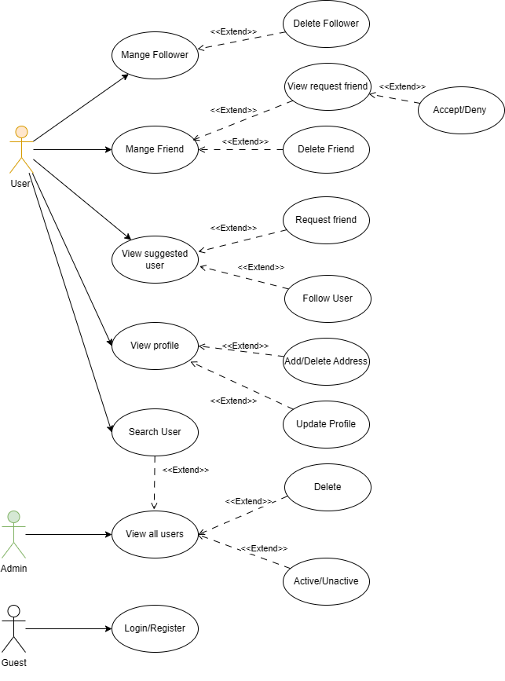

Figure 3‑. User management use case diagram

#### 3.3.1.2. Post management use case diagram

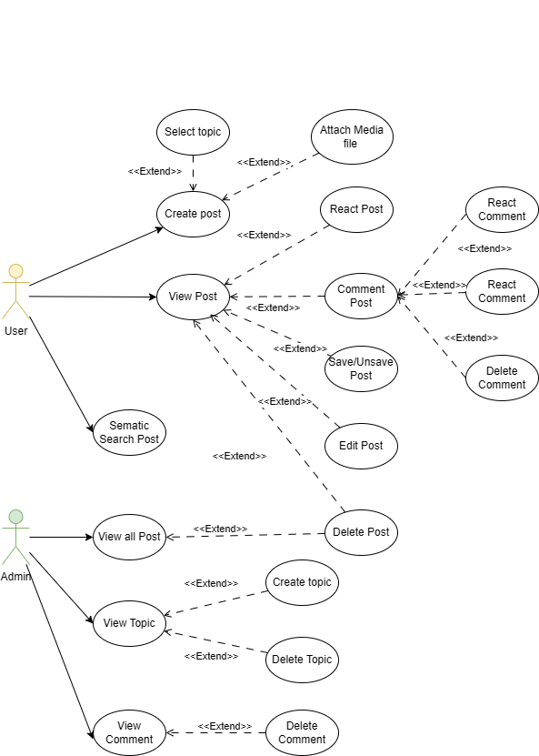

Figure 3‑5. Post management use case diagram

#### 3.3.1.3. Product management use case diagram

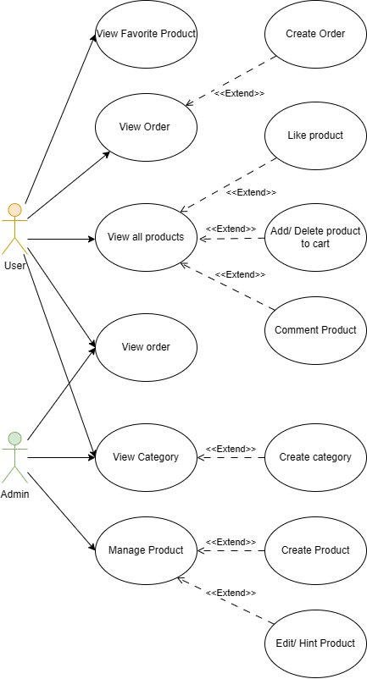

Figure 3‑6. Product management use case diagram

### 3.3.2. Use case specifications

#### 3.3.2.1. Register (UC-1)

|  |  |
| --- | --- |
| **Use case ID** | UC-1 |
| **Use case name** | Register |
| **Short description** | Allows a user or guest to register a new account on the platform. |
| **Actor** | User, Guest |
| **Pre-conditions** | None |
| **Post-conditions** | Actor registers account successfully |
| **Main flow** | 1. Actor click ‘Register’ button  2. The system returns register page.  3. Actor fills all input box (account register & profile)  4. The system authenticates email, password and notifies “Registration Success” and returns login page. |

Table 3‑. Register (UC-1)

#### 3.3.2.2. Login (UC-2)

|  |  |
| --- | --- |
| **Use case ID** | UC-2 |
| **Use case name** | Login |
| **Short description** | Allows a user to log in to their existing account. |
| **Actor** | User |
| **Pre-conditions** | The user must have an existing account. |
| **Post-conditions** | The user is successfully logged in and directed to the dashboard or home page. |
| **Main flow** | 1. Actor enters the email and password. 2. The system validates the credentials. 3. If valid, the system authenticates the user and redirects to the dashboard or home page. 4. If invalid, the system displays an error message. |

Table 3‑18. Login (UC-2)

#### 3.3.2.3. Delete user (UC-3)

|  |  |
| --- | --- |
| **Use case ID** | UC-3 |
| **Use case name** | Delete User |
| **Short description** | Allows a user to permanently delete their account. |
| **Actor** | Admin |
| **Pre-conditions** | The user must be logged in and have access to admin settings. |
| **Post-conditions** | The user’s account is deleted from the system. |
| **Main flow** | 1. Actor navigates to the ‘Admin Settings’ page and choice ‘User’ tab. 2. Actor selects the ‘Delete Account’ icon option. 3. The system prompts the user to confirm the deletion. 4. Actor confirms the deletion. 5. The system permanently deletes the user’s account and all associated data. |

Table 3‑19. Delete user (UC-3)

#### 3.3.2.4. Change profile’s user (UC-4)

|  |  |
| --- | --- |
| **Use case ID** | UC-4 |
| **Use case name** | Change Profile's User |
| **Short description** | Allows a user to update their profile information (e.g., name, profile picture, bio). |
| **Actor** | User |
| **Pre-conditions** | The user must be logged in and have access to their profile settings. |
| **Post-conditions** | The user’s profile is successfully updated with the new information. |
| **Main flow** | 1. Actor clicks on the ‘Edit’ button to modify profile details. 2. The system displays editable fields (e.g., name, profile picture, bio). 3. Actor updates the required information. 4. The system validates the input (e.g., ensures profile picture is a valid file format, name is not empty). 5. If valid, the system updates the profile and shows a confirmation message. 6. If invalid, the system displays an error message (e.g., invalid file format or empty fields). |

Table 3‑20. Change profile’s user (UC-4)

#### 3.3.2.5. Create post (UC-5)

|  |  |
| --- | --- |
| **Use case ID** | UC-5 |
| **Use case name** | Create Post |
| **Short description** | Allows a user to post a new post or delete an existing post. |
| **Actor** | User |
| **Pre-conditions** | The user must be logged in and have access to the posting or their own posts. |
| **Post-conditions** | The post is successfully created or deleted. |
| **Main flow** | 1. Actor click on box create new post. 2. Actor fills in the content for the post (e.g., text, image, or link).  3. System upload all images to cloudinary  4. If valid, the system creates the post and displays a success message. 5. The post is now visible in the user's timeline or feed. 7. If invalid, the system displays an error message (e.g., invalid file format or empty fields). |

Table 3‑21. Create post (UC-5)

#### 3.3.2.6. Edit post (UC-6)

|  |  |
| --- | --- |
| **Use case ID** | UC-6 |
| **Use case name** | Edit Post |
| **Short description** | Allows a user to edit an existing post. |
| **Actor** | User |
| **Pre-conditions** | The user must be logged in and have access to the posting or their own posts. |
| **Post-conditions** | The post is successfully edited. |
| **Main flow** | 1. Actor click on post that user wants to edit.  2. Dalog appear and allowing user edit. 3. If valid, the system edits content of the post and displays a success message. 4. The post now appears in the user's timeline or feed with new content. 5. If invalid, the system displays an error message. |

Table 3‑22. Edit post (UC-6)

#### 3.3.2.7. Delete post (UC-7)

|  |  |
| --- | --- |
| **Use case ID** | UC-7 |
| **Use case name** | Delete post |
| **Short description** | Allows a user to delete an existing post. |
| **Actor** | User |
| **Pre-conditions** | The user must be logged in and have access to the posting or their own posts. |
| **Post-conditions** | The post is successfully deleted. |
| **Main flow** | 1. Actor click on post that user wants to remove.  2. Dialog confirm that user delete post 3. If valid, the system deletes the post and displays a success message. 4. The post is now disappeared in the user's timeline or feed. 5. If invalid, the system displays an error message. |

Table 3‑23. Delete post (UC-7)

#### 3.3.2.8. Create comment post (UC-8)

|  |  |
| --- | --- |
| **Use case ID** | UC-8 |
| **Use case name** | Create comment post |
| **Short description** | Allows a user to comment on a post. |
| **Actor** | User |
| **Pre-conditions** | The user must be logged in and the post must exist. |
| **Post-conditions** | The comment is successfully added to the post. |
| **Main flow** | 1. Actor clicks the ‘Comment’ button in post detail. 2. The system displays a comment input box. 3. Actor enters the comment and submits it. 4. If valid, the system adds the comment to the post and displays it. 5. If invalid, the system displays an error message. |

Table 3‑24. Comment post (UC-8)

#### 3.3.2.9. Update comment post (UC-9)

|  |  |
| --- | --- |
| **Use case ID** | UC-9 |
| **Use case name** | Update comment post |
| **Short description** | Allows a user to delete comment on a post. |
| **Actor** | User |
| **Pre-conditions** | The user must be logged in and the post must exist. |
| **Post-conditions** | The comment is successfully update. |
| **Main flow** | 1. Actor clicks the ‘Edit’ button in comment.  2. Actor edit the comment.  3. Actor submit the change in comment. |

Table 3‑25. Update comment post (UC-9)

#### 3.3.2.10. Delete comment post (UC-10)

|  |  |
| --- | --- |
| **Use case ID** | UC-10 |
| **Use case name** | Delete comment post |
| **Short description** | Allows a user to delete comment on a post. |
| **Actor** | User |
| **Pre-conditions** | The user must be logged in and the post must exist. |
| **Post-conditions** | The comment is successfully deleted. |
| **Main flow** | 1. Actor clicks the ‘Delete Comment’ button in comment. 2. The system will delete the comment. |

Table 3‑26. Delete comment post (UC-10)

#### 3.3.2.11. Like/unlike post (UC-11)

|  |  |
| --- | --- |
| **Use case ID** | UC-11 |
| **Use case name** | Like/ unlike post |
| **Short description** | Allows a user to react (like, love, etc.) to a post. |
| **Actor** | User |
| **Pre-conditions** | The user must be logged in and the post must exist. |
| **Post-conditions** | The post receives a new reaction from the user. |
| **Main flow** | 1. Actor selects a reaction. 2. The system validates the reaction. 3. If valid, the system records the reaction and updates the post’s reaction count. 4. If invalid, the system displays an error message. |

Table 3‑27. Like/unlike post (UC-11)

#### 3.3.2.12. Send message (UC-12)

|  |  |
| --- | --- |
| **Use case ID** | UC-12 |
| **Use case name** | Send message |
| **Short description** | Allows a user to send a message to another user. |
| **Actor** | User |
| **Pre-conditions** | The user must be logged in and have access to the messaging feature. |
| **Post-conditions** | The message is successfully sent to the recipient. |
| **Main flow** | 1. Actor navigates to the messaging interface. 2. Actor selects the user recipient. 3. Actor types the message. 4. Actor sends the message. 5. If valid, the message is sent and appears in the recipient’s inbox. 6. If invalid, the system displays an error message. |

Table 3‑28. Send message (UC-12)

#### 3.3.2.13. Follow/Unfollow user (UC-13)

|  |  |
| --- | --- |
| **Use case ID** | UC-13 |
| **Use case name** | Follow/unfollow user |
| **Short description** | Allows a user to follow or unfollow another user’s profile. |
| **Actor** | User |
| **Pre-conditions** | The user must be logged in and the other user’s profile must exist. |
| **Post-conditions** | The user is now following or no longer following the other user. |
| **Main flow** | 1. Actor navigates to the friend page they wish to follow/unfollow. 2. Actor clicks the ‘Follow’ or ‘Unfollow’ button. 3. The system validates the action. 4. If valid, the system updates the following status and displays a success message. 5. If invalid, the system displays an error message. |

Table 3‑29. Follow/Unfollow user (UC-13)

#### 3.3.2.14. Save/unsave post (UC-14)

|  |  |
| --- | --- |
| **Use case ID** | UC-14 |
| **Use case name** | Save/unsave post items |
| **Short description** | Allows a user to save a post for future reference (bookmark or save to a collection). |
| **Actor** | User |
| **Pre-conditions** | The user must be logged in and the post must exist. |
| **Post-conditions** | The post is saved to the default folder of user |
| **Main flow** | 1. Actor navigates to the post they wish to save. 2. Actor clicks on the ‘Save’ or “Unsave” button. 3. The system saves the post.  4. The system shows a confirmation message indicating the post has been saved. |

Table 3‑30. Save/Unsave post (UC-14)

#### 3.3.2.15. Create friend request (UC-15)

|  |  |
| --- | --- |
| **Use case ID** | UC-15 |
| **Use case name** | Create friend request |
| **Short description** | Allows a user to send friend request to another user. |
| **Actor** | User |
| **Pre-conditions** | The user must be logged in, and access to suggested Friend. |
| **Post-conditions** | The Friend Request will be created and send to the user who you want to make friend. |
| **Main flow** | 1. Navigate to suggested friend screen 2. Actor selects the user and clicks on the ‘Add Friend button. 3. The system validates the action. 4. If valid, the request will be created. 5. If invalid, the system displays an error message. |

Table 3‑31. Create friend request (UC-15)

#### 3.3.2.16. Accept friend request (UC-16)

|  |  |
| --- | --- |
| **Use case ID** | UC-16 |
| **Use case name** | Accept friend request |
| **Short description** | Allows a user to accept friend request from the sender. |
| **Actor** | User |
| **Pre-conditions** | The user must be logged in, and access to Friend Request. |
| **Post-conditions** | The Friend Request will be accepted. |
| **Main flow** | 1. Navigate to friend request screen. 2. Actor selects the user and clicks on the ‘Accept’ button. 3. The system validates the action. 4. If valid, the request will be accepted. 5. If invalid, the system displays an error message. |

Table 3‑32. Accept friend request (UC-16)

#### 3.3.2.17. Deleted Friend (UC-17)

|  |  |
| --- | --- |
| **Use case ID** | UC-17 |
| **Use case name** | Deleted friend |
| **Short description** | Allows a user to delete friend. |
| **Actor** | User |
| **Pre-conditions** | The user must be logged in and have access to the friend management. |
| **Post-conditions** | Friend will be deleted. |
| **Main flow** | 1. Actor navigates to the Friend Screen.  2. Actor clicks ‘Remove’button  3. The system validates the action. 4. If valid, the friend will be deleted. 5. If invalid, the system displays an error message |

Table 3‑33. Deleted friend (UC-17)

#### 3.3.2.18. Like/Unliked Product (UC-18)

|  |  |
| --- | --- |
| Use case ID | UC-18 |
| Use case name | Like product |
| Short description | Allows user to like/unlike to post |
| Actor | User |
| Pre-conditions | The user must be logged in and the product must exist. |
| Post-conditions | The product will be in favorite product |
| Main flow | 1. Actor selects product and click in heart icon. 2. The system validates the reaction. 3. If valid, the system records the reaction and updates the favorite product’s list. 4. If invalid, the system displays an error message. |

Table 3-34. Like/unlike product (UC-18)

#### 3.3.2.19. Like/Unliked comment (UC-19)

|  |  |
| --- | --- |
| Use case ID | UC-19 |
| Use case name | Like/Unlike comment product |
| Short description | Allows user to like/unlike to comment in post |
| Actor | User |
| Pre-conditions | The user must be logged in and the post detail must exist. |
| Post-conditions | The comment will be liked/unliked |
| Main flow | 1. Actor selects comment and click in heart icon. 2. The system validates the reaction. 3. If valid, the system records the reaction  4. If invalid, the system displays an error message. |

Table 3‑35. Like/Unlike comment (UC-19)

#### 3.3.2.20. Create Comment Product (UC-20)

|  |  |
| --- | --- |
| **Use case ID** | UC-20 |
| **Use case name** | Create comment product |
| **Short description** | Allows a user to comment product. |
| **Actor** | User |
| **Pre-conditions** | The user must be logged in and have access to the product detail page. |
| **Post-conditions** | A new comment is created and display in list of reviews. |
| **Main flow** | 1. Actor navigates to the product detail  2. Actor input information to the input field 3. Actor click  4. Actor enters the folder name and clicks ‘Create’. 5. The system validates the folder name (e.g., checks for duplicates or invalid characters). 6. If valid, the system creates the new folder and displays it in the list of folders. 7. If invalid, the system displays an error message and prompts the user to re-enter the folder name. |

Table 3‑36. Create comment product (UC-20)

#### 3.3.2.21. Delete Comment Product (UC-21)

|  |  |
| --- | --- |
| **Use case ID** | UC-21 |
| **Use case name** | Delete comment product |
| **Short description** | Allows a user to comment product. |
| **Actor** | Admin |
| **Pre-conditions** | The user must be logged in and have access to the product management feature. |
| **Post-conditions** | A new comment is created and display in list of reviews. |
| **Main flow** | 1. Actor navigates to the product detail  2. Actor input information to the input field 3. Actor click  4. Actor enters the folder name and clicks ‘Create’. 5. The system validates the folder name (e.g., checks for duplicates or invalid characters). 6. If valid, the system creates the new folder and displays it in the list of folders. 7. If invalid, the system displays an error message and prompts the user to re-enter the folder name. |

Table 3‑37. Delete comment product (UC-21)

#### 3.3.2.22. Create Cart (UC-22)

|  |  |
| --- | --- |
| **Use case ID** | UC-22 |
| **Use case name** | Create cart |
| **Short description** | Allows a user to create a new cart to order. |
| **Actor** | User |
| **Pre-conditions** | The user must be logged in and have access to the product management feature. |
| **Post-conditions** | New cart is created and avalable for user add more products. |
| **Main flow** | 1. Actor navigates to the product management  2. Actor clicks on the ‘Add to cart’ button in the product they want to buy. 3. The system creates new cart and add new product into it. |

Table 3‑38. Create cart (UC-22)

#### 3.3.2.23. Create Order (UC-23)

|  |  |
| --- | --- |
| **Use case ID** | UC-23 |
| **Use case name** | Create order |
| **Short description** | Allows a user to create a new order. |
| **Actor** | User |
| **Pre-conditions** | The user must be logged in and have access to the product management feature. |
| **Post-conditions** | New order is created and move to payment (if using VNPay option) or move to product management page (if using COD option). |
| **Main flow** | 1. Actor navigates to the cart management  2. Actor clicks on the ‘Order’ button in the cart  3. The system create new order. |

Table 3‑39. Create order (UC-23)

#### 3.3.2.24. Create Address (UC-24)

|  |  |
| --- | --- |
| **Use case ID** | UC-24 |
| **Use case name** | Create address |
| **Short description** | Allows a user to create a new address. |
| **Actor** | User |
| **Pre-conditions** | The user must be logged in and have access to the profile. |
| **Post-conditions** | New address is created. |
| **Main flow** | 1. Actor navigates to the address management  2. Actor clicks ‘Add’ button in the address screen  3. Actor fills in the content for the address (e.g., name, phone number, …).  4. Actor clicks “Save” to create new address. |

Table 3‑40. Create address (UC-24)

#### 3.3.2.25. Delete Address (UC-25)

|  |  |
| --- | --- |
| **Use case ID** | UC-25 |
| **Use case name** | Delete address |
| **Short description** | Allows a user to delete a address. |
| **Actor** | User |
| **Pre-conditions** | The user must be logged in and have access to the profile page. |
| **Post-conditions** | Address is deleted. |
| **Main flow** | 1. Actor navigates to the address screen.  2. Actor clicks ‘Delete’ button.  3. The address will be deleted  4. Actor clicks “Hoan Thanh” to create new address, or “Tro Lai” to cancel the process. |

Table 3‑41. Delete address (UC-25)

#### 3.3.2.26. Create new category (UC-26)

|  |  |
| --- | --- |
| **Use case ID** | UC-26 |
| **Use case name** | Create new category |
| **Short description** | Allows admin to create new category. |
| **Actor** | Admin |
| **Pre-conditions** | The user must be logged in and have access to the category management. |
| **Post-conditions** | New category is created. |
| **Main flow** | 1. Admin navigates to the category screen.  2. Actor clicks ‘add’  3. Actor fills in the information for the category (e.g., name, description).  4. Actor clicks “Save” to create new category. |

Table 3‑42. Create new category (UC-26)

#### 3.3.2.27. Edit/Delete category (UC-27)

|  |  |
| --- | --- |
| **Use case ID** | UC-27 |
| **Use case name** | Edit/Delete category |
| **Short description** | Allows a admin to edit/delete category. |
| **Actor** | Admin |
| **Pre-conditions** | The user must be logged in and have access to the category management. |
| **Post-conditions** | Category is updated. |
| **Main flow** | 1. Admin navigates to the category screen.  2. Actor clicks ‘Edit’ or “Delete” in category line item.  3. If actor choose “Edit” button, actor update the information for the category (e.g., name, description) and Click “Save” button; and the category will be deleted if actor choose “delete” button. |

Table 3‑43. Edit/Delete category (UC-27)

#### 3.3.2.28. Create product (UC-28)

|  |  |
| --- | --- |
| **Use case ID** | UC-28 |
| **Use case name** | Create product |
| **Short description** | Allows a admin to create product |
| **Actor** | Admin |
| **Pre-conditions** | The user must be logged in and have access to the product management. |
| **Post-conditions** | Product is created. |
| **Main flow** | 1. Admin navigates to the product screen.  2. Actor clicks “Create” button.  3 Actor fills in the information for the product (e.g., name, description…).  4. Actor clicks “Save” to create new product. |

Table 3‑44. Create product (UC-28)

#### 3.3.2.29. Update product (UC-29)

|  |  |
| --- | --- |
| **Use case ID** | UC-29 |
| **Use case name** | Update product |
| **Short description** | Allows a admin to update product |
| **Actor** | Admin |
| **Pre-conditions** | The user must be logged in and have access to the product management. |
| **Post-conditions** | Product is updated. |
| **Main flow** | 1. Admin navigates to the product screen.  2. Actor clicks “Edit” button.  3.Actor update the information for the product (e.g., name, description…).  4. Actor clicks “Save” to update product. |

Table 3‑45. Update product (UC-29)

#### 3.3.2.30. Delete product (UC-30)

|  |  |
| --- | --- |
| **Use case ID** | UC-30 |
| **Use case name** | Delete product |
| **Short description** | Allows a admin to delete product |
| **Actor** | Admin |
| **Pre-conditions** | The user must be logged in and have access to the product management. |
| **Post-conditions** | Product is deleted. |
| **Main flow** | 1. Admin navigates to the product screen.  2. Actor clicks “Hint” button.  3. The status of the product will change. |

Table 3‑46. Delete product (UC-30)

#### 3.3.2.31. Create topic (UC-31)

|  |  |
| --- | --- |
| **Use case ID** | UC-31 |
| **Use case name** | Create topic |
| **Short description** | Allows a admin to create topic |
| **Actor** | Admin |
| **Pre-conditions** | The user must be logged in and have access to the topic management. |
| **Post-conditions** | Topic is created |
| **Main flow** | 1. Admin navigates to the topic screen.  2. Actor clicks “Create” button.  3. Actor fill the information for the topic (e.g., name, color).  4. Actor clicks “Save” to update product. |

Table 3‑47. Create topic (UC-31)

#### 3.3.2.32. Delete topic (UC-32)

|  |  |
| --- | --- |
| **Use case ID** | UC-32 |
| **Use case name** | Delete topic |
| **Short description** | Allows admin to delete topic |
| **Actor** | Admin |
| **Pre-conditions** | The user must be logged in and have access to the topic management. |
| **Post-conditions** | Topic is deleted. |
| **Main flow** | 1. Admin navigates to the topic screen.  2. Actor clicks “Delete” button.  3. The topic will be deleted. |

Table 3‑48. Delete product (UC-32)

# CHAPTER 4. SYSTEM ANALYSIS AND DESIGN

## 4.1. System architecture

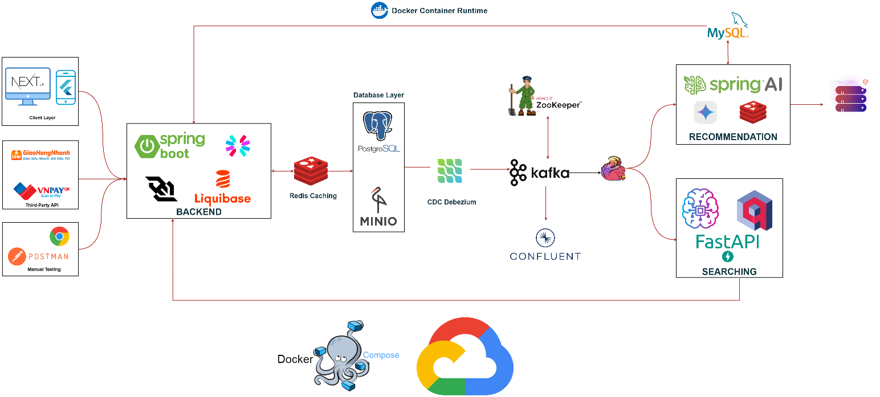

Figure 4‑. System architechture

## 4.2. Sequence diagrams

### 4.2.1. Register

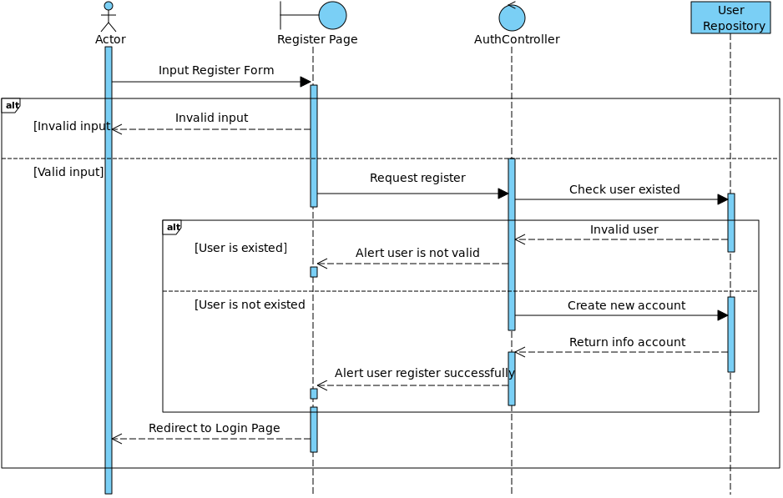

Figure 4‑2. Register sequence diagram

### 4.2.2. Login

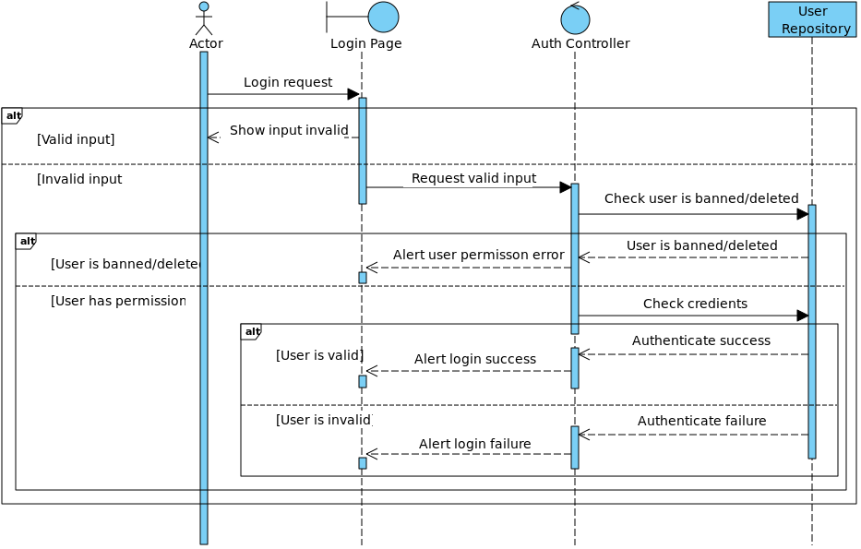

Figure 4‑3. Login sequence diagram

### 4.2.3. Delete user

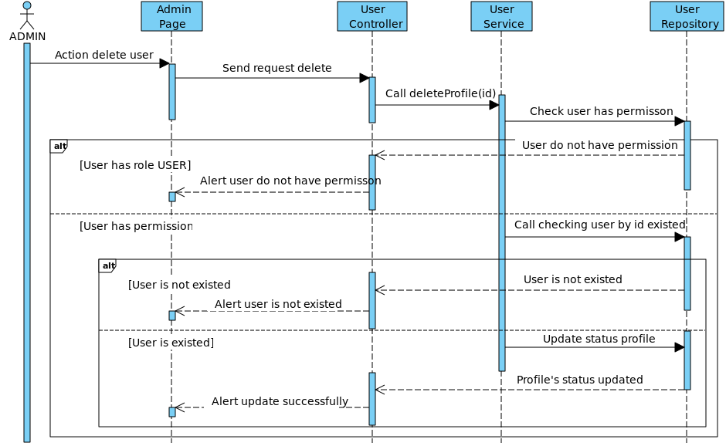

Figure 4‑4. Delete user sequence diagram

### 4.2.4. Change profile’s user

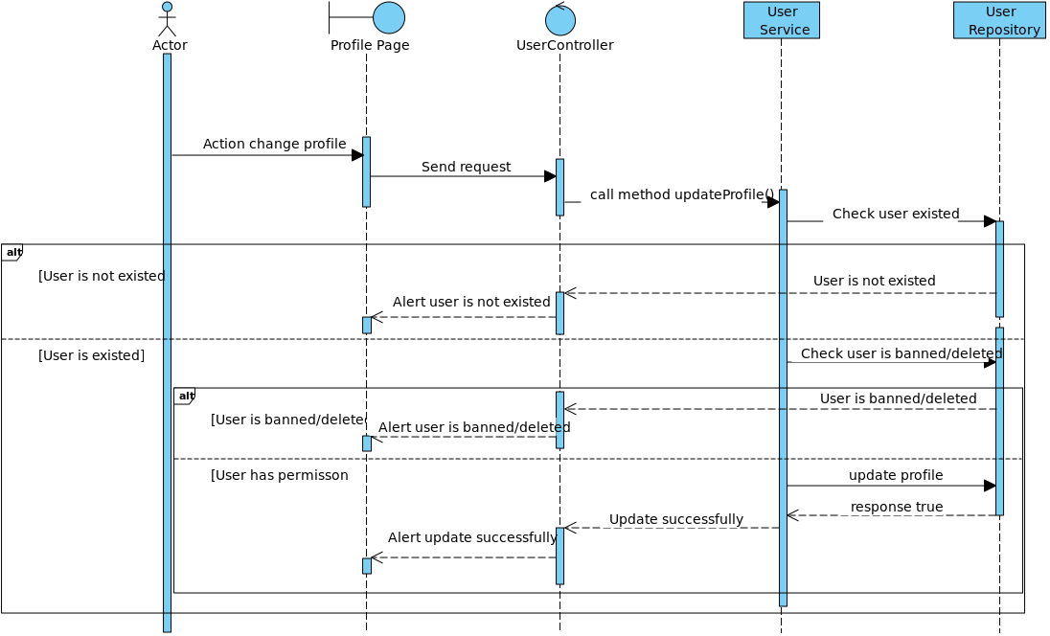

Figure 4‑5. Change profile’s user sequence diagram

### 4.2.5. Create Post

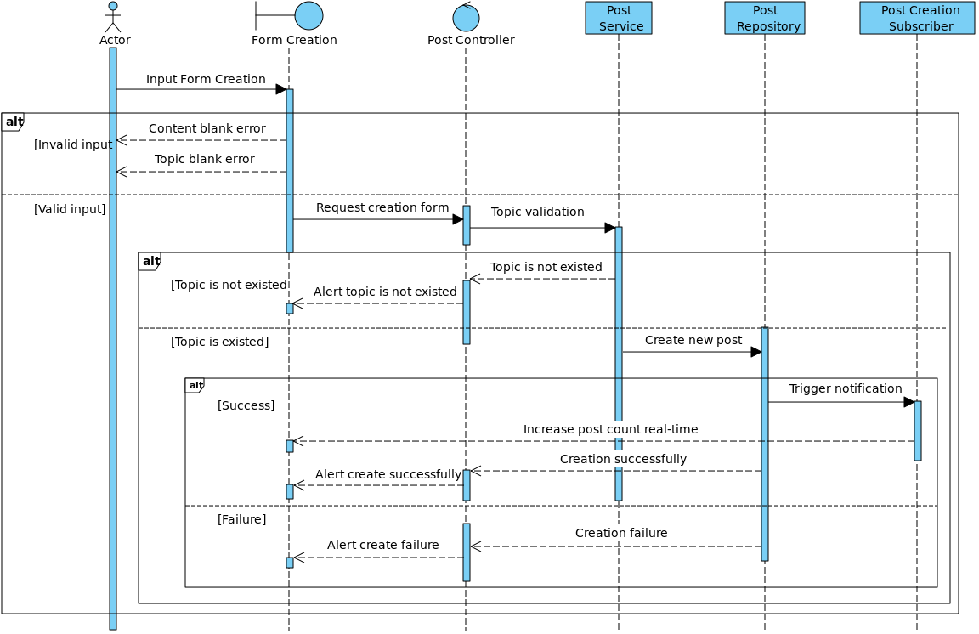

Figure 4‑6. Create post sequence diagram

### 4.2.6. Edit Post

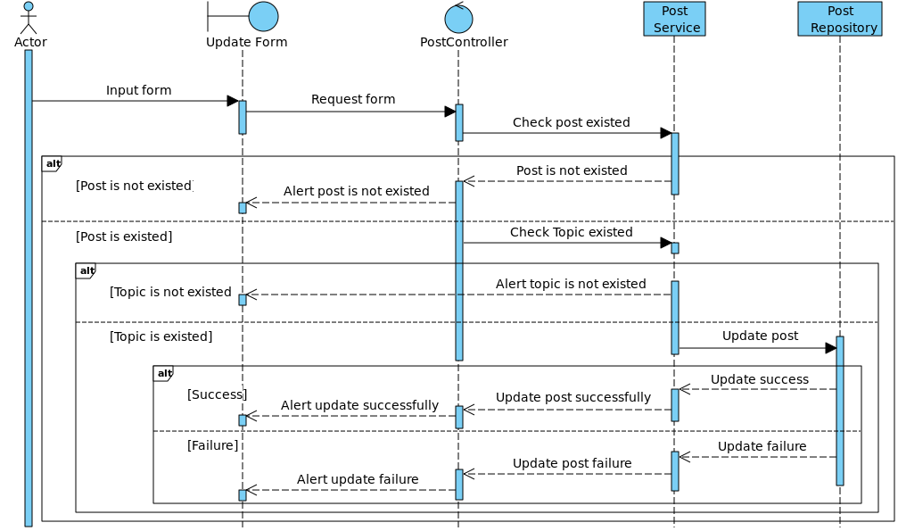

Figure 4‑7. Edit post sequence diagram

### 4.2.7. Delete Post

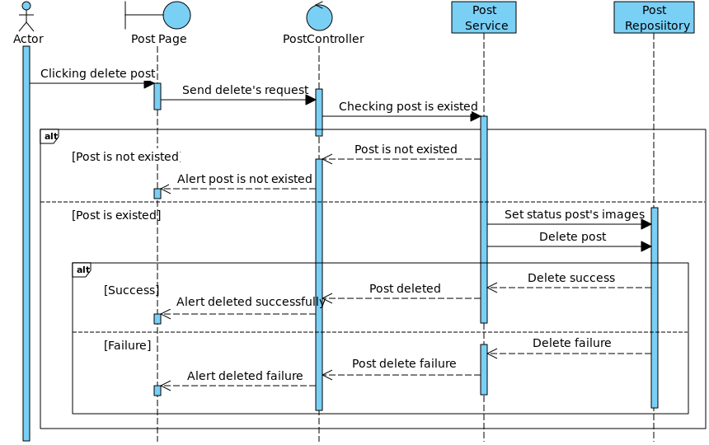

Figure 4‑8. Delete post sequence diagram

### 4.2.8. Create comment post

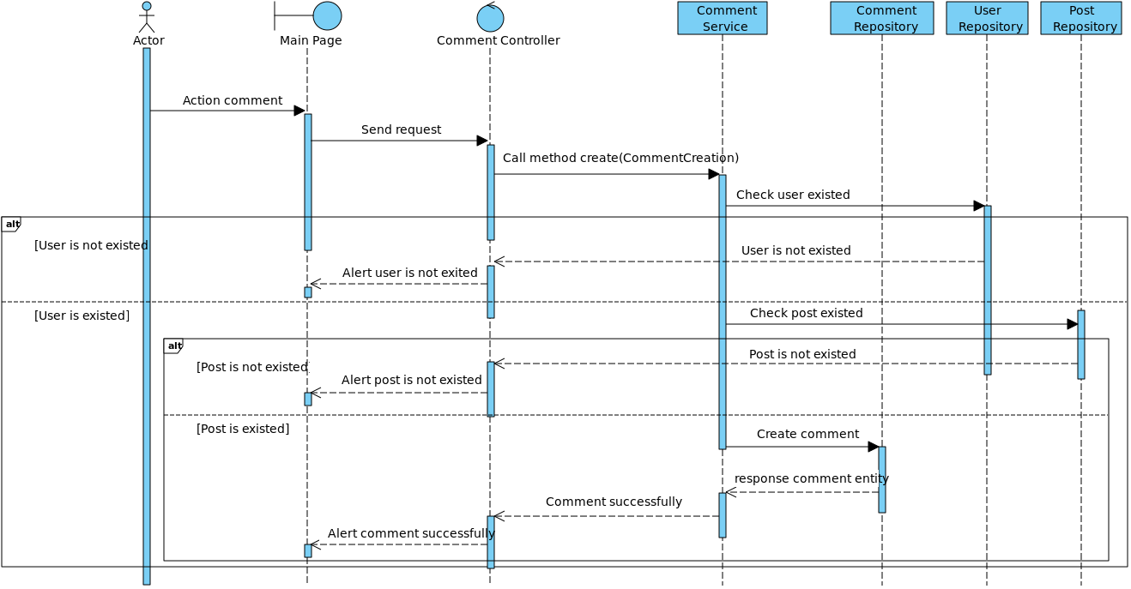

Figure 4‑9. Create comment sequence diagram

### 4.2.9. Update comment post

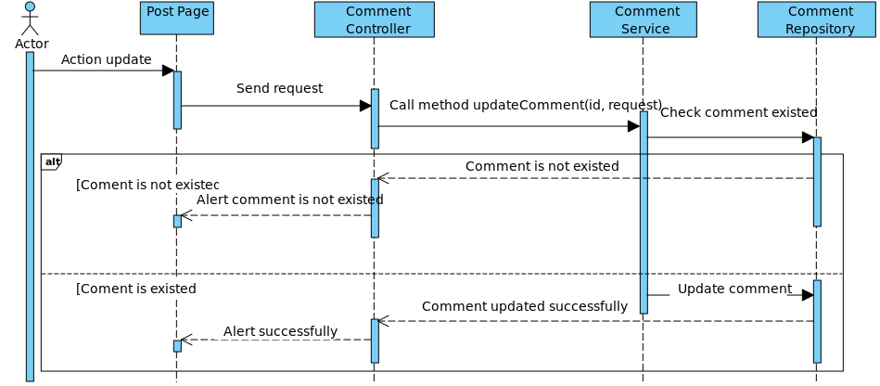

Figure 4‑10. Delete comment sequence diagram

### 4.2.10. Delete comment post

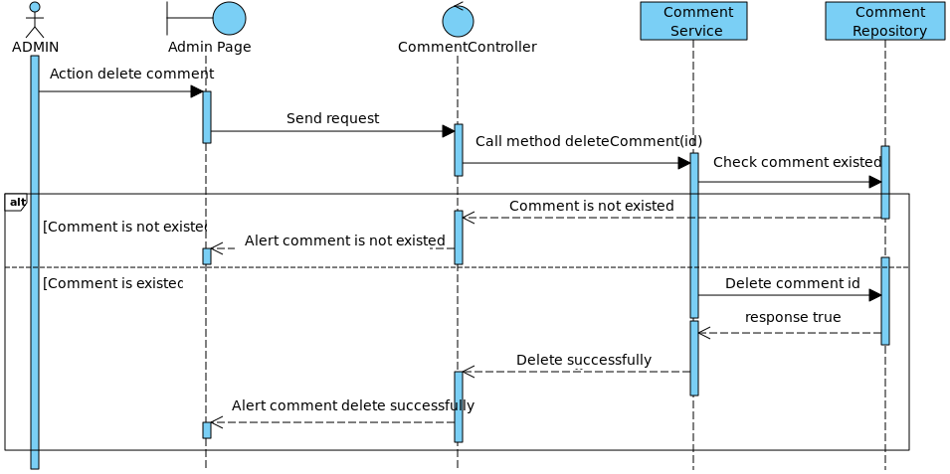

Figure 4‑11. Delete comment sequence diagram

### 4.2.11. Like/Unlike post

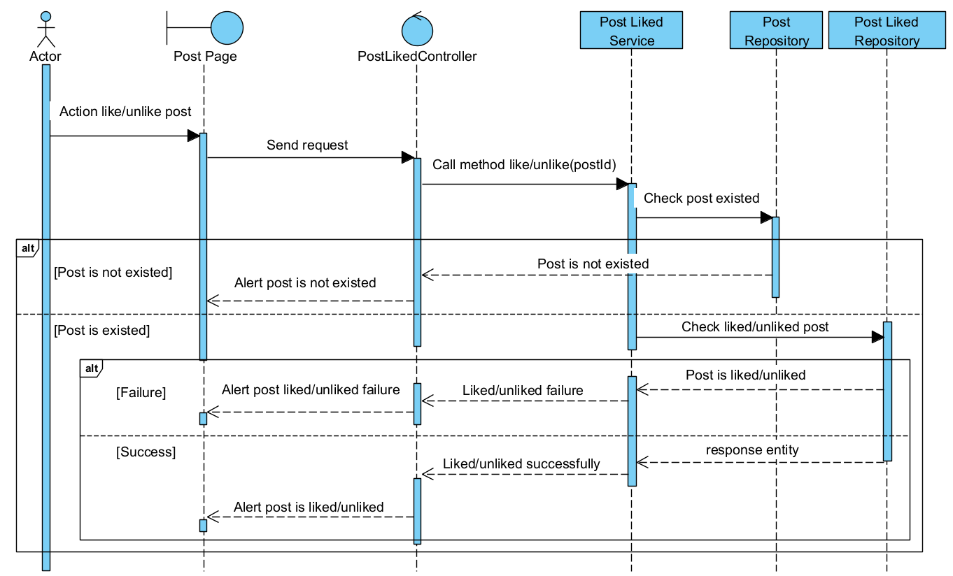

Figure 4‑12. Liked/Unliked post sequence diagram

### 4.2.12. Send message

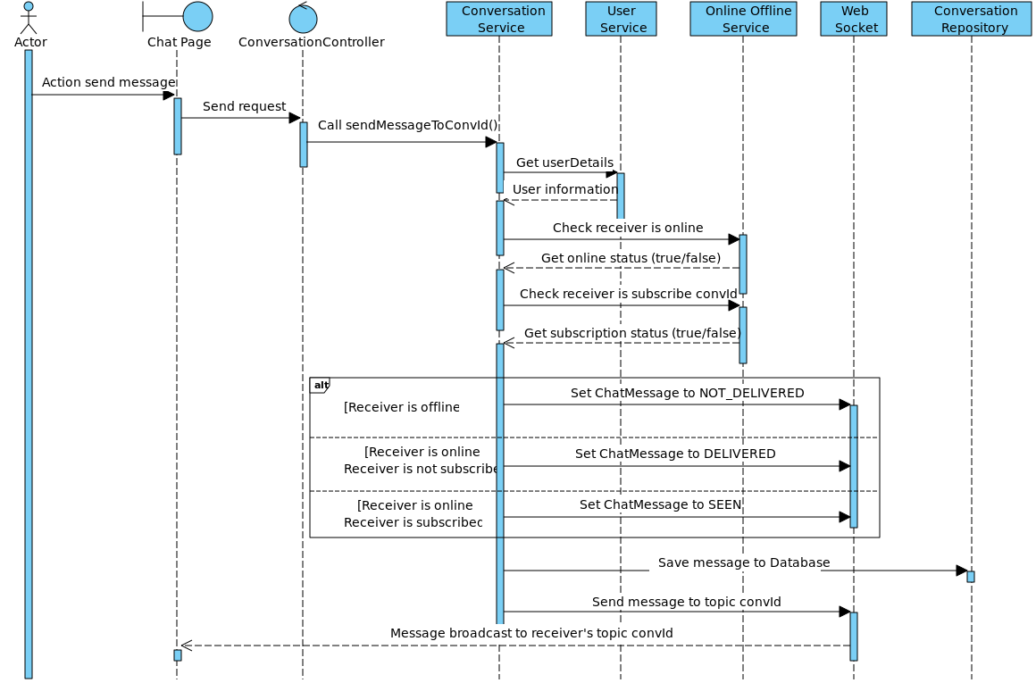

Figure 4‑13. Send message sequence diagram

### 4.2.13. Follow/Unfollow user

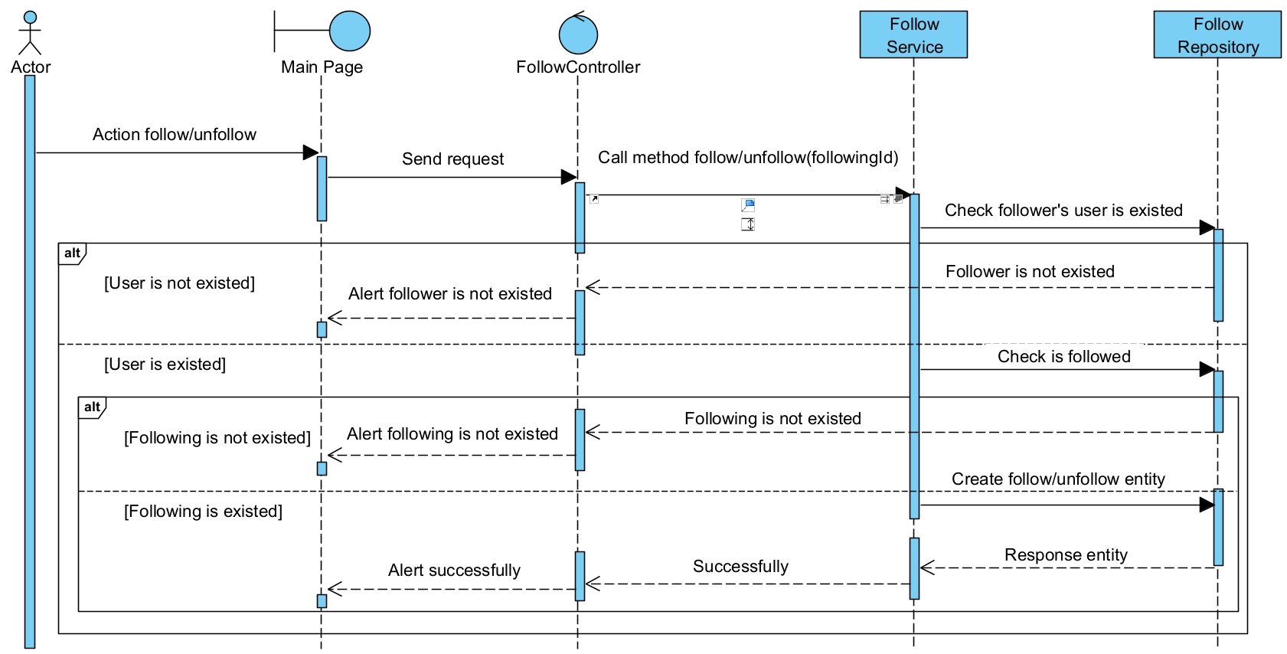

Figure 4‑14. Follow/Unfollow user sequence diagram

### 4.2.14. Save/Unsave post

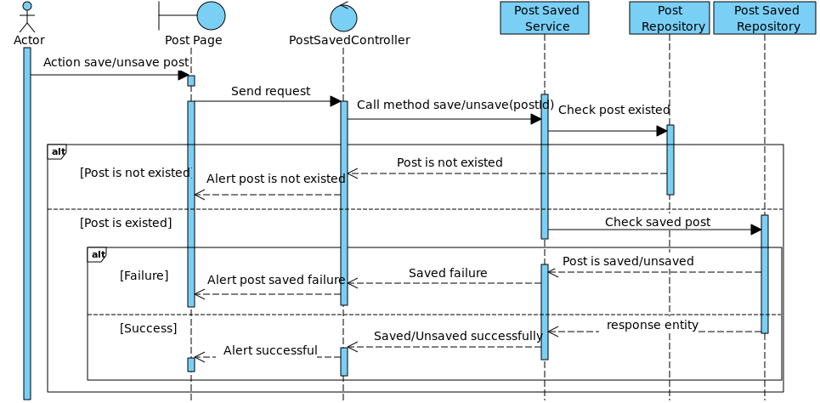

Figure 4‑15. Save/Unsave post sequence diagram

### 4.2.15. Create friend request

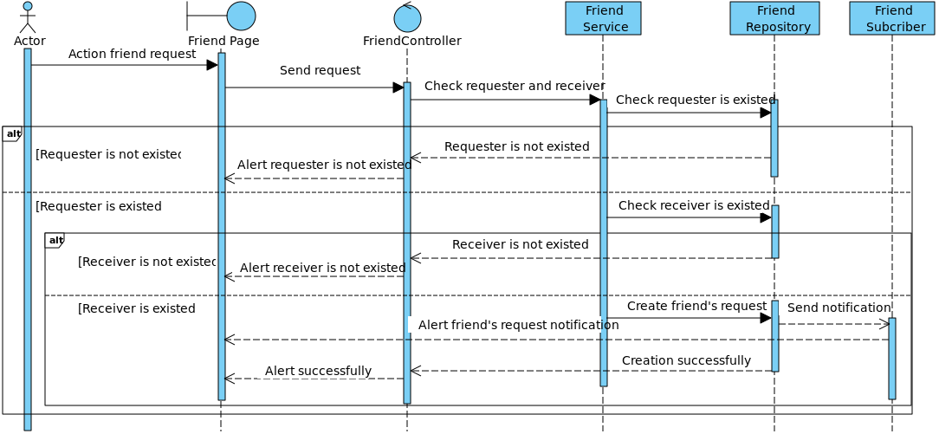

Figure 4‑16. Create friend request sequence diagram

### 4.2.16. Accept friend request

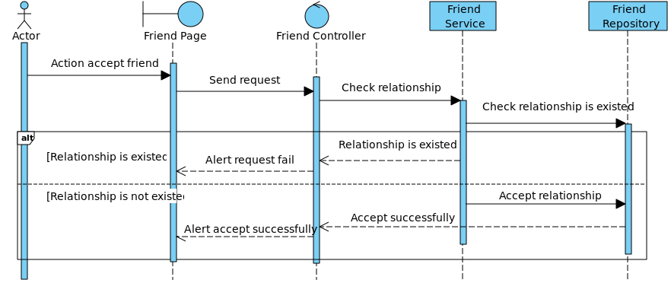

Figure 4‑17. Accept friend request sequence diagram

### 4.2.17. Delete friend

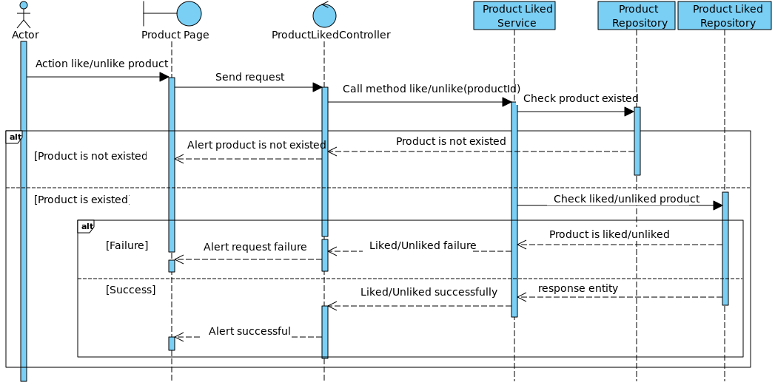

Figure 4‑18. Remove friend sequence diagram

### 4.2.18. Like/Unlike Product



Figure 4‑19. Like/Unlike product

### 4.2.19. Like/Unlike comment

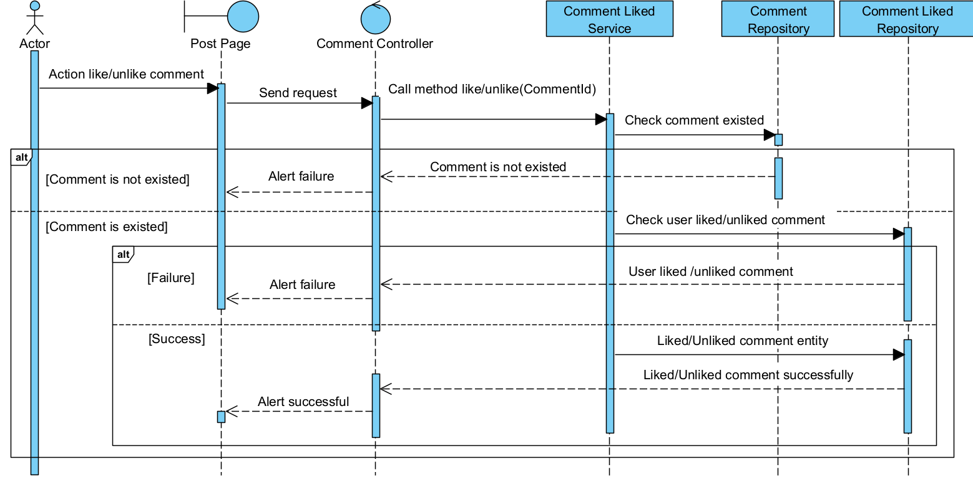

Figure 4‑20. Like/Unlike comment sequence diagram

### 4.2.20. Create comment product

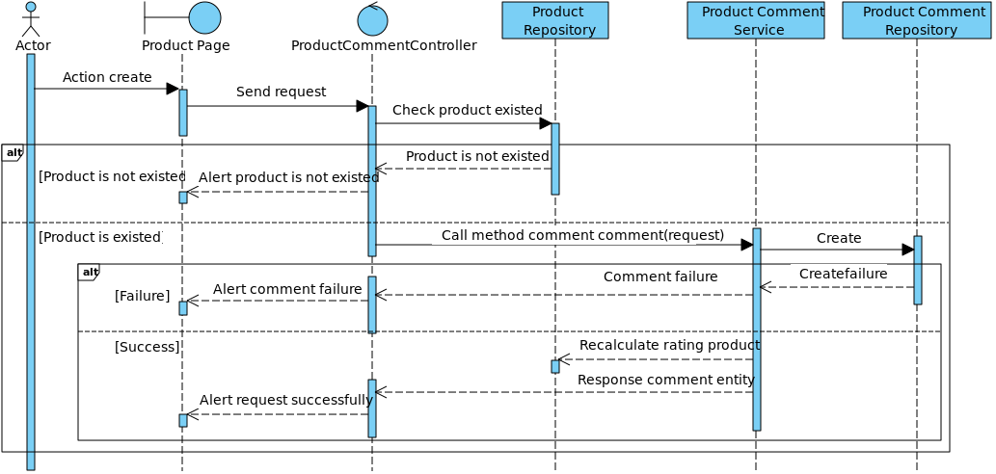

Figure 4‑21. Create comment product

### 4.2.21. Delete comment product

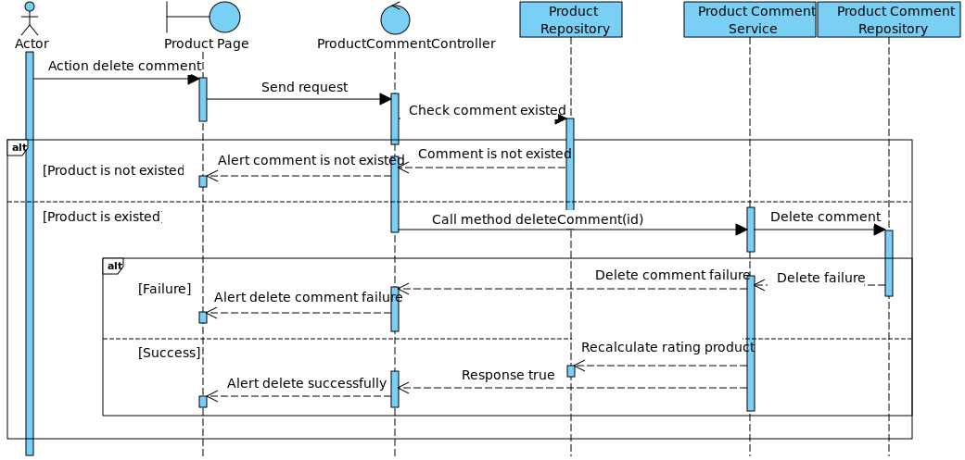

Figure 4‑22. Delete comment product

### 4.2.22. Create cart

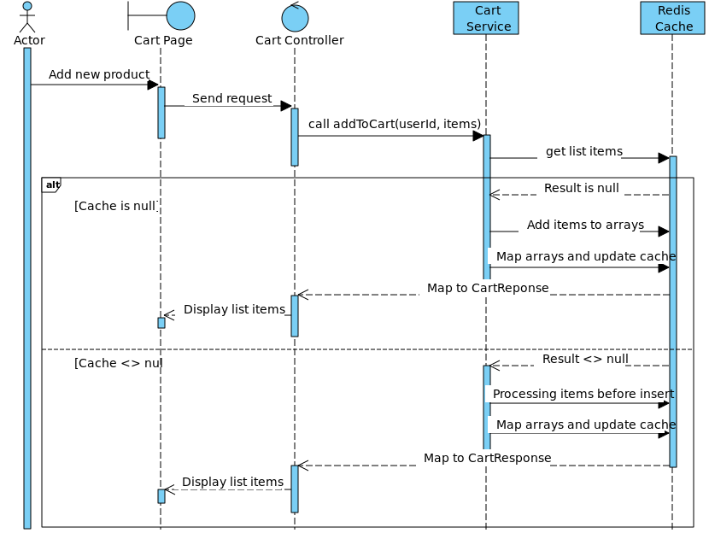

Figure 4‑23. Create cart sequence diagram

### 4.2.23. Create order

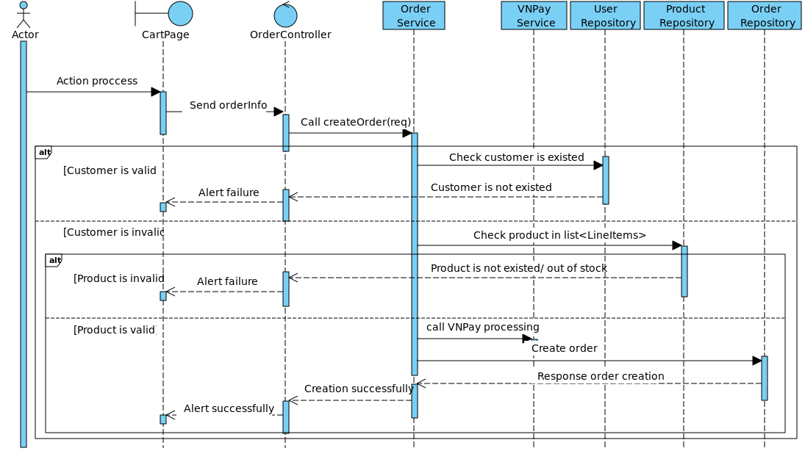

Figure 4‑24. Create order sequence diagram

### 4.2.24. Create address

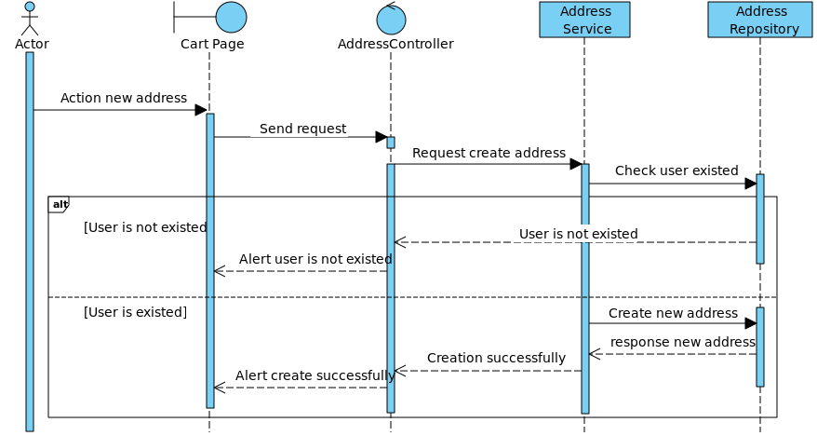

Figure 4‑25. Create address sequence diagram

### 4.2.25. Delete address

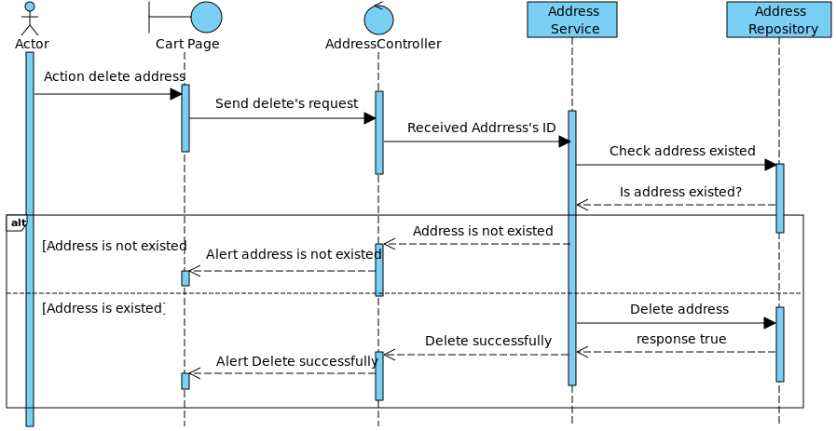

Figure 4‑26. Delete address sequence diagram

### 4.2.26. Create new category

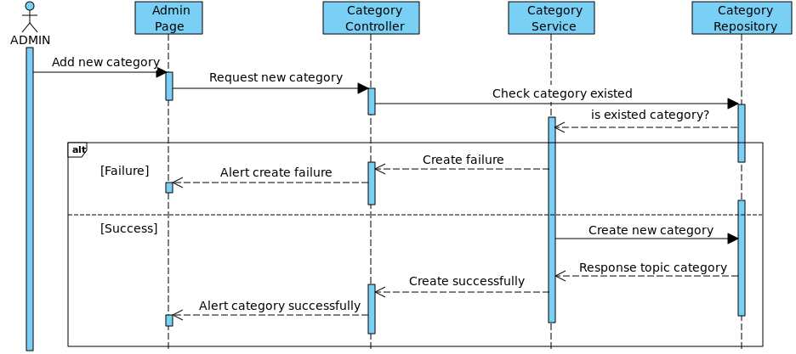

Figure 4‑27. Create new category sequence diagram

### 4.2.27. Update/Delete category

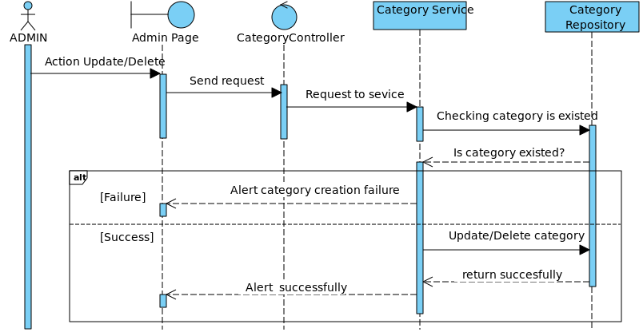

Figure 4‑28. Update/Delete category sequence diagram

### 4.2.28. Create product

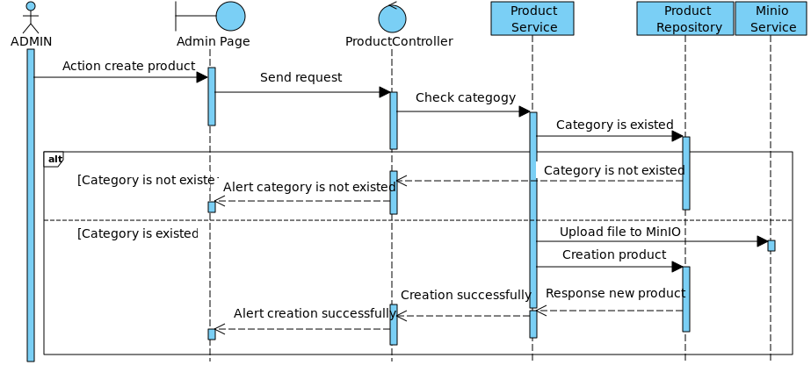

Figure 4‑29. Create product sequence diagram

### 4.2.29. Update product

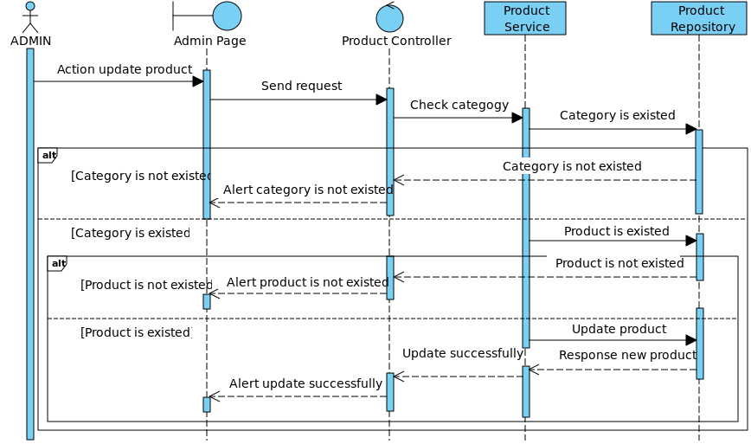

Figure 4‑30. Update product sequence diagram

### 4.2.30. Delete product

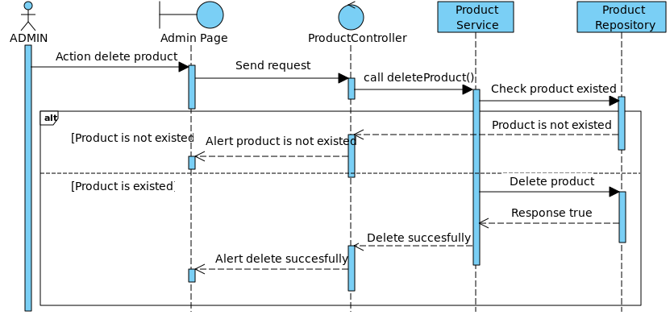

Figure 4‑31. Delete product sequence diagram

### 4.2.31. Create topic

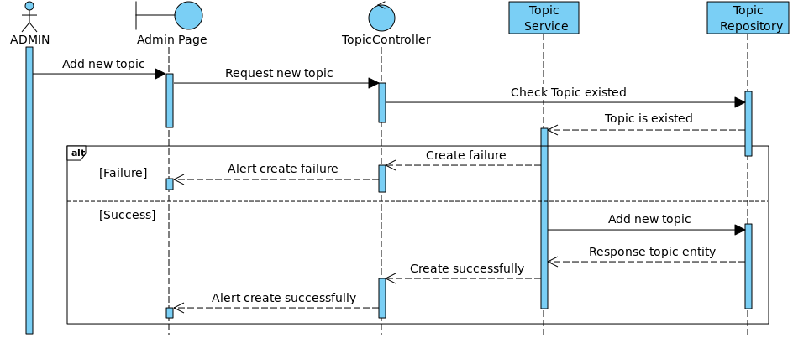

Figure 4‑32. Create topic sequence diagram

### 4.2.32. Update/Delete topic

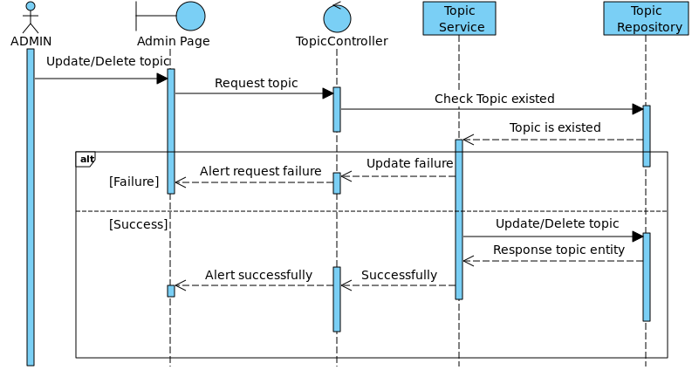

Figure 4‑33. Update/Delete topic sequence diagram

## 4.3. Database design

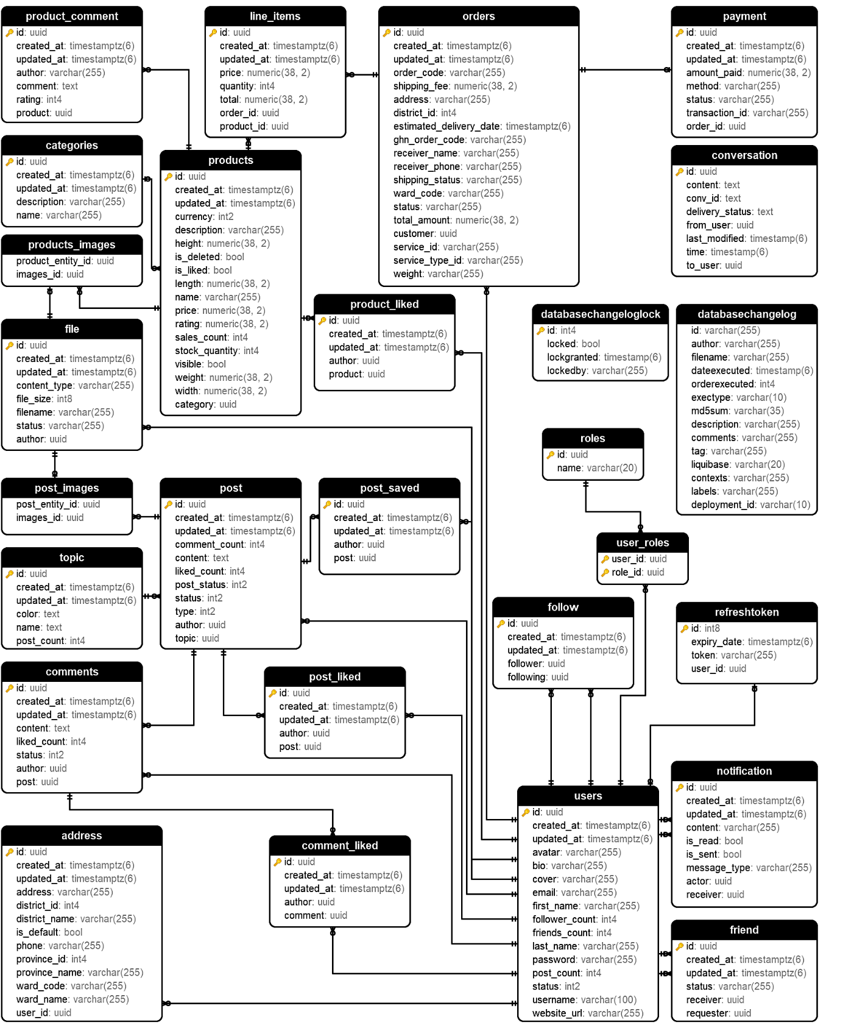

Figure 4‑34. Entity-Relational database

### 4.3.1. Table description

#### 4.3.1.1. User entity

|  |  |  |  |  |
| --- | --- | --- | --- | --- |
| **No** | **Attribute** | **Type** | **Range/**  **Contraints** | **Meaning** |
| 1 | id | UUID | UUID format | Unique identifier for the user. |
| 2 | username | VARCHAR | Minimum 2 characters | The username chosen by the user. |
| 3 | password | VARCHAR | Minimum 6 characters | The user's account password. |
| 4 | email | VARCHAR | Valid email format | Email address of the user. |
| 5 | create_at | TIMESTAMP |  | Date and time user account is created |
| 6 | update_at | TIMESTAMP |  | Date and time user’s information were last updated |
| 7 | avatar | VARCHAR |  | Name file of user’s avatar |
| 8 | bio | VARCHAR |  | User description |
| 9 | cover | VARCHAR |  | Name file of user’s cover |
| 10 | first_name | VARCHAR |  | User’s first name |
| 11 | follower_count | INT |  | Number of followers |
| 12 | friends_count | INT |  | Number of friends |
| 13 | last_name | VARCHAR |  | User’s last name |
| 14 | post_count | INT |  | Number of posts |
| 15 | status | INT |  | User’s activation |
| 16 | website_url | VARCHAR |  | Url of another website |

Table 4‑. User entity

#### 4.3.2.2. Payment entity

|  |  |  |  |  |
| --- | --- | --- | --- | --- |
| **No** | **Attribute** | **Type** | **Range/**  **Contrains** | **Meaning** |
| 1 | uuid | UUID | Auto-generated UUID | Unique identifier for the line items record. |
| 2 | create_at | TIMESTAMP |  | Date and time when the payment is created |
| 3 | update_at | TIMESTAMP |  | Date and time when the payment’s information is updated |
| 4 | method | VARCHAR | PaymentMethod:  *PAYPAL*,  *VNPAY*,  *COD* | The method of payment |
| 5 | Status | VARCHAR | PaymentStatus:  *PENDING, SUCCESS, FAILED* | The status of payment |
| 6 | transaction_id | VARCHAR |  | The code of transaction |
| 7 | order_id | UUID | Matches UUID in Order table | References the Order |
| 8 | product_id | UUID | Matches UUID in Product table | References the Product which is add in order |

Table 4‑. Payment entity

#### 4.3.2.3. Address entity

|  |  |  |  |  |
| --- | --- | --- | --- | --- |
| **No** | **Attribute** | **Type** | **Range/**  **Contrains** | **Meaning** |
| 1 | id | UUID | Auto-incremented positive value | Unique identifier for the address. |
| 2 | create_at | TIMESTAMP |  | Date and time address were created |
| 3 | update_at | TIMESTAMP |  | Date and time address were updated |
| 4 | Address | VARCHAR |  | Address detail |
| 5 | district_id | INT |  | Districgt number code |
| 6 | district_name | VARCHAR |  | Name of district |
| 7 | is_default | BOOL |  | Set the address is defaulted |
| 8 | phone | VARCHAR |  | User’s phonenumber |
| 9 | province_id | INT |  | Province number code |
| 10 | province_name | VARCHAR |  | Name of province |
| 11 | ward_code | VARCHAR |  | Ward number code |
| 12 | ward_name | VARCHAR |  | Name of ward |
| 13 | user_id | UUID |  | User id |

Table 4‑. Address entity

#### 4.3.2.4. Role entity

|  |  |  |  |  |
| --- | --- | --- | --- | --- |
| **No** | **Attribute** | **Type** | **Range/**  **Contrains** | **Meaning** |
| 1 | id | UUID | Auto-incremented positive value | Unique identifier for the role. |
| 2 | name | VARCHAR | ERole values:  *ROLE_USER***,** *ROLE_ADMIN* | Name of role |

Table 4‑. Role entity

#### 4.3.2.5. User roles entity

|  |  |  |  |  |
| --- | --- | --- | --- | --- |
| **No** | **Attribute** | **Type** | **Range/**  **Contrains** | **Meaning** |
| 1 | user_id | UUID | Matches UUID in User table | Reference the user |
| 2 | role_id | UUID | Matches UUID in Topic table | Reference the Topic |

Table 4‑5. User roles entity

#### 4.3.2.6. Post entity

|  |  |  |  |  |
| --- | --- | --- | --- | --- |
| **No** | **Attribute** | **Type** | **Range/**  **Contrains** | **Meaning** |
| 1 | uuid | UUID |  | Unique identifier for the post. |
| 2 | status | INT | EstatusPost:  *PUBLIC***,** *PRIVATE***,** | Status of the post. |
| 3 | created _at | TIMESTAMP |  | Timestamp when the post was created. |
| 4 | update_at | TIMESTAMP |  | Timestamp when the post was updated |
| 5 | comment_count | INT |  | Number of comments in post |
| 6 | content | TEXT |  | The content of post |
| 7 | liked_count | INT |  | Number of like in post |
| 8 | post_status | INT | Epost:  *APPROVED, DELETED* | The post status |
| 9 | type | INT | EpostType:  *TEXT*, *MEDIA*, | Type of post |
| 10 | author | UUID | Matches UUID in User table | Reference the user |
| 11 | topic | UUID | Matches UUID in Topic table | Reference the topic |

Table 4‑6. Post entity

#### 4.3.2.7. Post saved entity

|  |  |  |  |  |
| --- | --- | --- | --- | --- |
| **No** | **Attribute** | **Type** | **Range/**  **Contrains** | **Meaning** |
| 1 | uuid | UUID | Auto-generated UUID | Unique identifier for the post saved. |
| 2 | created _at | TIMESTAMP |  | Timestamp when the post was saved. |
| 3 | update_at | TIMESTAMP |  | Timestamp when the saved post was updated |
| 4 | author | UUID | Matches UUID in User table | Reference the User |
| 5 | post | UUID | Matches UUID in Post table | Reference the Post |

Table 4‑7. Content entity

#### 4.3.2.8. Post liked entity

|  |  |  |  |  |
| --- | --- | --- | --- | --- |
| **No** | **Attribute** | **Type** | **Range/**  **Contrains** | **Meaning** |
| 1 | uuid | UUID | Auto-generated UUID | Unique identifier for the reaction. |
| 2 | post | UUID | Matches UUID in Post table | References the post being reacted to. |
| 3 | author | UUID | Matches UUID in User table | Refereces the user |
| 4 | create_at | TIMESTAMP |  | Date and time when user like the post |
| 5 | update_at | TIMESTAMP |  | Date and time when user update the reaction of the post |

Table 4‑8. Reaction entity

#### 4.3.2.9. Comments entity

|  |  |  |  |  |
| --- | --- | --- | --- | --- |
| **No** | **Attribute** | **Type** | **Range/**  **Contrains** | **Meaning** |
| 1 | uuid | UUID | Auto-generated UUID | Unique identifier for the comment. |
| 2 | post_UUID | UUID | Matches UUID in Post table | References the post the comment belongs to. |
| 3 | content_uuid | UUID | Matches UUID in Content table | References the content of the comment. |
| 4 | create_at | TIMESTAMP |  | Date and time when user comment the post |
| 5 | update_at | TIMESTAMP |  | Date and time when user update comment of the post |

Table 4‑9. Comment entity

#### 4.3.2.10. Liked comment entity

|  |  |  |  |  |
| --- | --- | --- | --- | --- |
| **No** | **Attribute** | **Type** | **Range/**  **Contrains** | **Meaning** |
| 1 | uuid | UUID | Auto-generated UUID | Unique identifier for the Liked Comment. |
| 2 | create_at | TIMESTAMP |  | Date and time when user liked the comment |
| 3 | update_at | TIMESTAMP |  | Date and time when user update information of liked comment |
| 4 | author | UUID | Matches UUID in User table | Reference the User |
| 5 | comment | UUID | Matches UUID in Comments table | Reference the Comments |

Table 4‑10. Image entity

#### 4.3.2.11. Follow entity

|  |  |  |  |  |
| --- | --- | --- | --- | --- |
| **No** | **Attribute** | **Type** | **Range/**  **Contrains** | **Meaning** |
| 1 | uuid | UUID | Auto-generated UUID | Unique identifier for the follow record. |
| 2 | create_at | TIMESTAMP |  | Date and time when user follow |
| 3 | update_at | TIMESTAMP |  | Date and time when user update follow |
| 4 | follower_uuid | UUID | Matches UUID in User table | References the user who is following another user. |
| 5 | following_uuid | UUID | Matches UUID in User table | References the user being followed. |

Table 4‑11. Follow entity

#### 4.3.2.12. Friend entity

|  |  |  |  |  |
| --- | --- | --- | --- | --- |
| **No** | **Attribute** | **Type** | **Range/**  **Contrains** | **Meaning** |
| 1 | uuid | UUID | Auto-generated UUID | Unique identifier for the friendship record. |
| 2 | receiver | UUID | Matches UUID in User table | References the User will get the request |
| 3 | requester | UUID | Matches UUID in User table | Reference the User create request |
| 4 | Status | VARCHAR | Efriend:  *PENDING*, *ACCEPTED*, *REJECTED*, *BLOCKED*, | The status of the relationship |
| 4 | create_at | TIMESTAMP |  | Date and time when user like the post |
| 5 | update_at | TIMESTAMP |  | Date and time when user update the reaction of the post |

Table 4‑12. Friend entity

#### 4.3.2.13. Topic entity

|  |  |  |  |  |
| --- | --- | --- | --- | --- |
| **No** | **Attribute** | **Type** | **Range/**  **Contrains** | **Meaning** |
| 1 | uuid | UUID | Auto-generated UUID | Unique identifier for the topic |
| 2 | create_at | TIMESTAMP |  | Date and time when user create topic |
| 3 | update_at | TIMESTAMP |  | Date and time when user update topic’s information |
| 4 | color | TEXT |  | Color for display topic |
| 5 | name | TEXT |  | Name of topic |
| 6 | post_count | INT |  | Number of posts using this topic |

Table 4‑13. Topic entity

#### 4.3.2.14. File entity

|  |  |  |  |  |
| --- | --- | --- | --- | --- |
| **No** | **Attribute** | **Type** | **Range/**  **Contrains** | **Meaning** |
| 1 | Id | UUID | Auto-generated UUID | Unique identifier for the media resource. |
| 2 | create_at | TIMESTAMP |  | Date and time when create new file |
| 3 | update_at | TIMESTAMP |  | Date and time when update file’s information |
| 4 | content_type | VARCHAR |  | Indicates whether the media is external (e.g., hosted outside the application). |
| 5 | file_size | INT |  | Size of the file in bytes. |
| 6 | file_name | VARCHAR |  | Name of the file. |
| 7 | status | VARCHAR | FileStatus:  *ACTIVE,*  *DELETED* | Status of the file |
| 8 | author | UUID | Matches UUID in User table | Represents the current user of the file. |

Table 4‑14. File entity

#### 4.3.2.15. Notification entity

|  |  |  |  |  |
| --- | --- | --- | --- | --- |
| **No** | **Attribute** | **Type** | **Range/**  **Contrains** | **Meaning** |
| 1 | uuid | UUID | Auto-generated UUID | Unique identifier for notification. |
| 2 | create_at | TIMESTAMP |  | Date and time when create new notification |
| 3 | update_at | TIMESTAMP |  | Date and time when update notification’s information |
| 4 | content | VARCHAR (255) |  | The content of notification |
| 5 | is_read | BOOL |  | The status of the notification is read or not |
| 6 | is_send | BOOL |  | The status of the notification is sent or not |
| 7 | message_type | VARCHAR | MessageType:  *CHAT*, *UNSEEN*, *FRIEND_ONLINE*, *FRIEND_OFFLINE*, *MESSAGE_*  *DELIVERY_UPDATE*, *LIKE_POST* | The type of notification |
| 8 | actor | UUID | Foreign key referencing User (UUID) | The user who sent the notification. |
| 9 | receiver | UUID | Foreign key referencing User (UUID) | The user who receives the notification. |

Table 4‑15. Notification entity

#### 4.3.2.16. Post images entity

|  |  |  |  |  |
| --- | --- | --- | --- | --- |
| **No** | **Attribute** | **Type** | **Range/**  **Contrains** | **Meaning** |
| 1 | post_entity_id | UUID | Foreign key referencing Post (UUID) | The post displays images |
| 2 | images_id | UUID | Foreign key referencing File (UUID) | The images of the post |

Table 4‑16. Post images entity

#### 4.3.2.17. Conversation entity

|  |  |  |  |  |
| --- | --- | --- | --- | --- |
| **No** | **Attribute** | **Type** | **Range/**  **Contrains** | **Meaning** |
| 1 | uuid | UUID | Auto-generated UUID | Unique identifier for the chat message. |
| 2 | content | TEXT |  | The content of the conversation |
| 3 | conv_id | TEXT |  | The id between sender and receiver in conversation |
| 4 | delivery_status | TEXT |  | The status of the conversation |
| 5 | from_user | UUID | Foreign key referencing User (UUID) | The sender of the conversation |
| 6 | last_modified | TIMESTAMP |  | The last time conversation is modified |
| 7 | time | TIMESTAMP |  | The time conversation is created |
| 8 | to_user | UUID | Foreign key referencing User (UUID) | The receiver of the conversation |

Table 4‑17. Conversation entity

#### 4.3.2.18. Products entity

|  |  |  |  |  |
| --- | --- | --- | --- | --- |
| **No** | **Attribute** | **Type** | **Range/**  **Contrains** | **Meaning** |
| 1 | uuid | UUID | Auto-generated UUID | Unique identifier for the products. |
| 2 | create_at | TIMESTAMP |  | Date and time when create new product |
| 3 | update_at | TIMESTAMP |  | Date and time when update notification’s product |
| 4 | currency | INT | Currency:  *USD*, *VND…* | The currency of the product |
| 5 | description | VARCHAR |  | The description of the product |
| 6 | height | NUMERIC |  | The height of the product |
| 7 | is_deleted | BOOL |  | Indicates whether the product is deleted or not |
| 8 | is_liked | BOOL |  | Indicates whether the product is liked or not |
| 9 | length | NUMERIC |  | Length of the product |
| 10 | name | VARCHAR |  | Name of the product |
| 11 | price | NUMERIC |  | Price of the product |
| 12 | rating | NUMERIC |  | Rating of the product |
| 13 | sales_count | INT |  | Number of products is bought |
| 14 | stock_quantity | INT |  | Number of the product in the Stock |
| 15 | visible | BOOL |  | The visible of the product |
| 16 | weight | NUMERIC |  | The weight of product |
| 17 | width | NUMERIC |  | The width of product |
| 18 | category | UUID | Foreign key referencing Category (UUID) | The category of product |

Table 4‑18. Product entity

#### 4.3.2.19. Product-like entity

|  |  |  |  |  |
| --- | --- | --- | --- | --- |
| **No** | **Attribute** | **Type** | **Range/**  **Contrains** | **Meaning** |
| 1 | uuid | UUID | Auto-generated UUID | Unique identifier for the liked product record. |
| 2 | create_at | TIMESTAMP |  | Date and time when user likes product |
| 3 | update_at | TIMESTAMP |  | Date and time when user update liked product’s information |
| 4 | author | UUID | Matches UUID in User table | References the user who liked product. |
| 5 | product | UUID | Matches UUID in Product table | References the product which is liked |

Table 4‑19. Product-like entity

#### 4.3.2.20. Product images entity

|  |  |  |  |  |
| --- | --- | --- | --- | --- |
| **No** | **Attribute** | **Type** | **Range/**  **Contrains** | **Meaning** |
| 1 | product_entity_id | UUID | Foreign key referencing Product (UUID) | The product displays images |
| 2 | images_id | UUID | Foreign key referencing File (UUID) | The images of the product |

Table 4‑20. Product images entity

#### 4.3.2.21. Category entity

|  |  |  |  |  |
| --- | --- | --- | --- | --- |
| **No** | **Attribute** | **Type** | **Range/**  **Contrains** | **Meaning** |
| 1 | uuid | UUID | Auto-generated UUID | Unique identifier for the liked product record. |
| 2 | create_at | TIMESTAMP |  | Date and time when user create category |
| 3 | update_at | TIMESTAMP |  | Date and time when user update category’s information |
| 4 | description | VARCHAR |  | Description of the category |
| 5 | name | VARCHAR |  | Name of the category |

Table 4‑21. Category entity

#### 4.3.2.22. Product comment entity

|  |  |  |  |  |
| --- | --- | --- | --- | --- |
| **No** | **Attribute** | **Type** | **Range/**  **Contrains** | **Meaning** |
| 1 | uuid | UUID | Auto-generated UUID | Unique identifier for the comment of product record. |
| 2 | create_at | TIMESTAMP |  | Date and time when user create comment |
| 3 | update_at | TIMESTAMP |  | Date and time when user update comment’s information |
| 4 | author | VARCHAR |  | References the user who liked product. |
| 5 | comment | TEXT |  | The content of the comment |
| 6 | rating | INT |  | The rating of the product |
| 7 | product | UUID | Matches UUID in Product table | References the product which is commented |

Table 4‑22. Product comment entity

#### 4.3.2.23. Line items entity

|  |  |  |  |  |
| --- | --- | --- | --- | --- |
| **No** | **Attribute** | **Type** | **Range/**  **Contrains** | **Meaning** |
| 1 | uuid | UUID | Auto-generated UUID | Unique identifier for the line items record. |
| 2 | create_at | TIMESTAMP |  | Date and time when user add product to order |
| 3 | update_at | TIMESTAMP |  | Date and time when user update product in order |
| 4 | price | NUMERIC |  | Price of the product |
| 5 | quantity | INT |  | The quantity of product of item |
| 6 | total | NUMERIC |  | The total price of item |
| 7 | order_id | UUID | Matches UUID in Order table | References the Order |
| 8 | product_id | UUID | Matches UUID in Product table | References the Product which is add in order |

Table 4‑23. Line items entity

#### 4.3.2.24. Order entity

|  |  |  |  |  |
| --- | --- | --- | --- | --- |
| **No** | **Attribute** | **Type** | **Range/**  **Contrains** | **Meaning** |
| 1 | uuid | UUID | Auto-generated UUID | Unique identifier for the order record. |
| 2 | create_at | TIMESTAMP |  | Date and time when user add product to order |
| 3 | update_at | TIMESTAMP |  | Date and time when user update product in order |
| 4 | order_code | VARCHAR |  | The code of the order |
| 5 | shipping_fee | NUMERIC |  | The shipping fee of the order |
| 6 | address | VARCHAR |  | Address of the user |
| 7 | district_id | INT |  | Code of district |
| 8 | estimated_  delivery_date | TIMESTAMP |  | The time that user can receive the order |
| 9 | ghn_order_code | VARCHAR |  | The code of Giao Hang Nhanh |
| 10 | receiver_name | VARCHAR |  | The name of user |
| 11 | shipping_status | VARCHAR |  | The status of the order |
| 12 | ward_code | VARCHAR |  | The code of ward |
| 13 | status | VARCHAR | OrderStatus:  *PENDING*, *SHIPPED*, *DELIVERED*, *FAILED*, *CANCELLED*, | The status of the order |
| 14 | total_amount | NUMERIC |  | The total price of the order |
| 15 | customer | UUID | Matches UUID in User table | Reference to the user who ordered. |
| 16 | service_id | VARCHAR |  | The code of the service |
| 17 | service_type_id | VARCHAR |  | The code of type service we use |
| 18 | weight | VARCHAR |  | The total weight of the order |

Table 4‑24. Order entity

#### 4.3.2.25. Payment entity

|  |  |  |  |  |
| --- | --- | --- | --- | --- |
| **No** | **Attribute** | **Type** | **Range/**  **Contrains** | **Meaning** |
| 1 | uuid | UUID | Auto-generated UUID | Unique identifier for the line items record. |
| 2 | create_at | TIMESTAMP |  | Date and time when the payment is created |
| 3 | update_at | TIMESTAMP |  | Date and time when the payment’s information is updated |
| 4 | method | VARCHAR | PaymentMethod:  *PAYPAL*,  *VNPAY*,  *COD* | The method of payment |
| 5 | Status | VARCHAR | PaymentStatus:  *PENDING, SUCCESS, FAILED* | The status of payment |
| 6 | transaction_id | VARCHAR |  | The code of transaction |
| 7 | order_id | UUID | Matches UUID in Order table | References the Order |
| 8 | product_id | UUID | Matches UUID in Product table | References the Product which is add in order |

Table 4‑25. Payment entity

## 4.4. User interface design

|  |  |  |
| --- | --- | --- |
| **No.** | **Screen Name** | **Description** |
| SCU01 | Register screen | User will be forced to fill all of the fields for registering an account |
| SCU02 | Login Screen | Login page for registered users |
| SCU03 | Main Screen | Show social information, including new posts, user information, follow request recommendations, change languages |
| SCU04 | Post Detail | Show detail of post, comment for this post |
| SCU05 | Create Post | User can create new post. |
| SCU06 | BookMark | User can save the posts |
| SCU07 | Notification | User can view the notification |
| SCU08 | Chat Screen | User can view online friends and send message for them |
| SCU09 | Search Screen | User can find information |
| SCU10 | All Friend Screen | User can view all friends, follows, followings. |
| SCU11 | Suggested Friend Screen | User will view the suggested users. |
| SCU12 | Friend Request Screen | User will view Friend Request and Accept or Deny |
| SCU13 | Market Place Screen | User will view products and filter to file product. |
| SCU14 | Favorite Product Screen | User will view the favorite products |
| SCU15 | Cart Screen | User will view the line items and choose payment options; set address and products they want to buy. |
| SCU16 | Order detail Screen | User will view the information of the order. |
| SCU17 | Tracking Orders Screen | User will view all of orders they have bought. |
| SCU18 | Product Detail Screen | User will view the product detail and comment in it. |
| SCU19 | LLMs Admin Screen | Admin will view the activation of user and chat with ChatBot |
| SCU20 | Topic Management Screen | Admin will view all of the topic and manage them |
| SCU21 | User Management Screen | Admin will view all the uses and manage them. |
| SCU22 | Product management Screen | Admin will manage all of products. |

Table 4‑26. List of user interface design

### 4.4.1. Admin interface

#### 4.4.1.1. LLMs admin screen (SCU19)

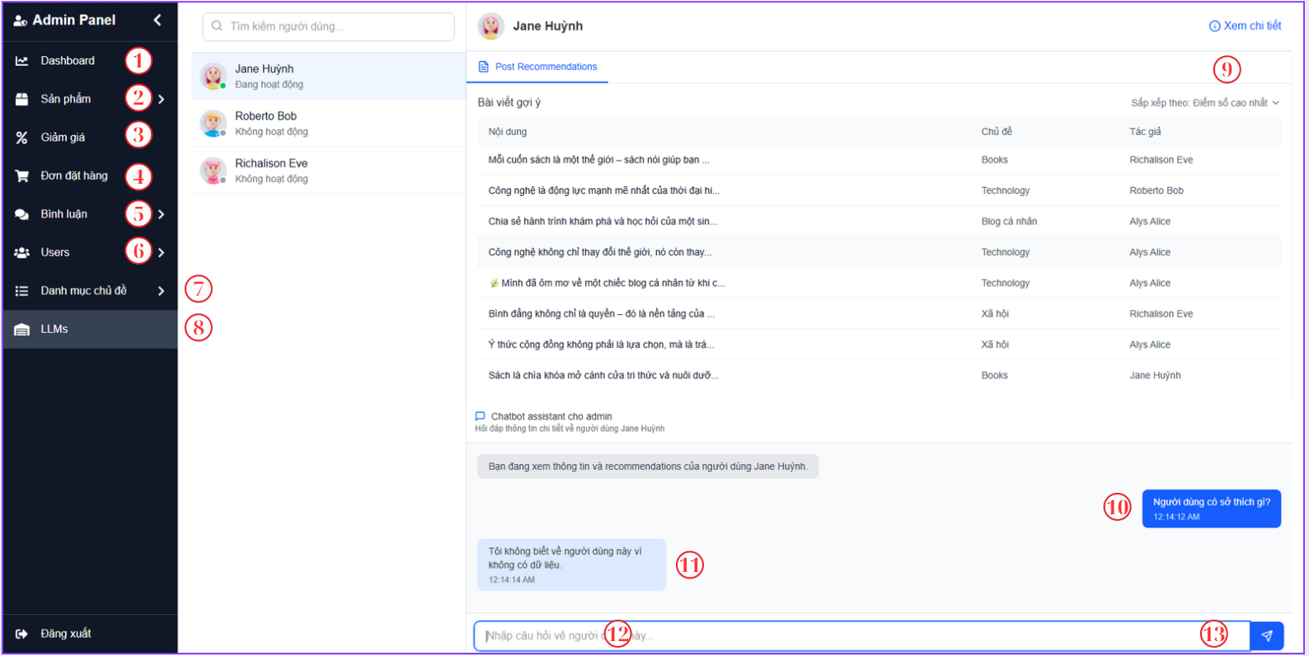

Figure 4‑35. Dashboard admin screen

|  |  |  |  |
| --- | --- | --- | --- |
| **No.** | **Name** | **Type** | **Event** |
| 1 | Dashboard | Button | After clicking, the page goes to dashboard screen |
| 2 | San Pham | Button | After clicking, the page goes to “San Pham” screen |
| 3 | Giam Gia | Button | After clicking, the page goes to “Giam Gia” screen |
| 4 | Don Dat Hang | Button | After clicking, the page goes to “Don Dat Hang” screen |
| 5 | Binh Luan | Button | After clicking, the page goes to “Binh Luan” screen |
| 6 | Users | Button | After clicking, the page goes to users’ screen |
| 7 | Danh muc chu de | Button | After clicking, the page goes to “Chu De” screen |
| 8 | LLMs | Button | After clicking, the page goes to LLMs screen |
| 9 | Xem chi tiet | Button | After clicking, the page goes to user detail |
| 10 | Admin input content | TextView | Show the content that input by admin |
| 11 | LLM response | TextView | Show the response of the LLMs model |
| 13 | Send | Button | After clicking, the content will be sent. |

Table 4‑27. Dashboard admin screen

#### 4.4.1.2. Topic management screen (SCU20)

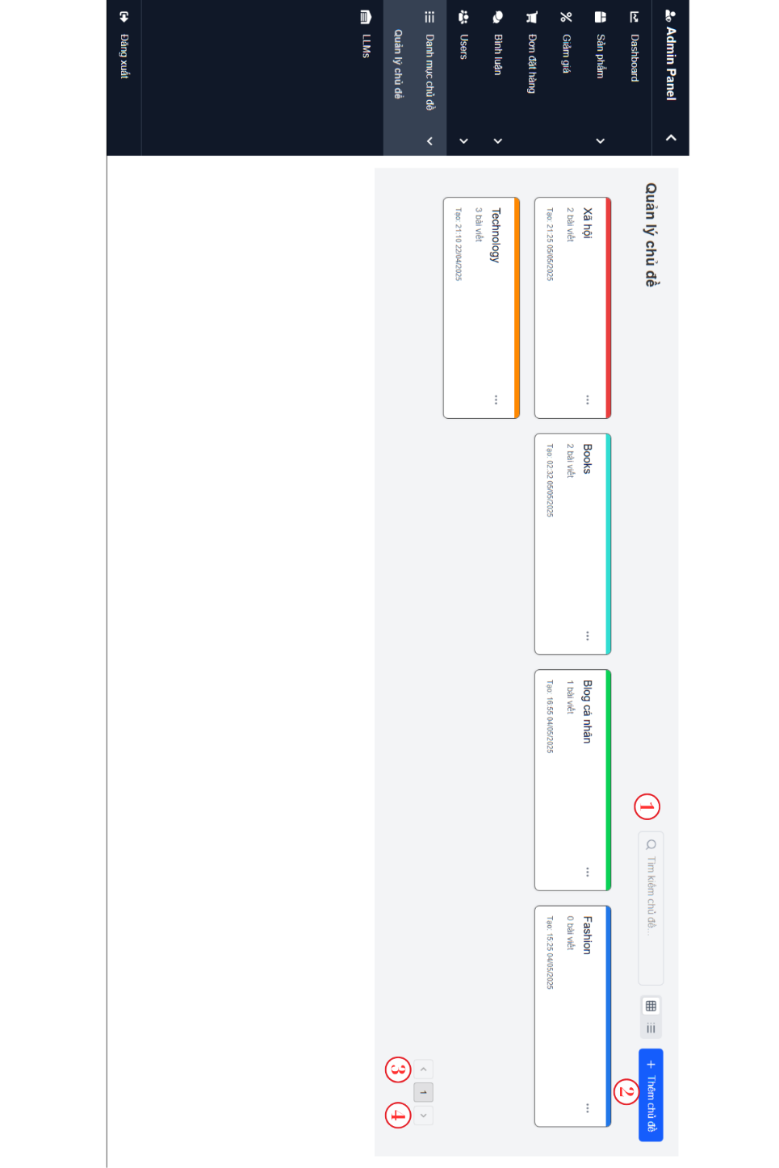

Figure 4‑36. Topic management screen

|  |  |  |  |
| --- | --- | --- | --- |
| **No.** | **Name** | **Type** | **Event** |
| 1 | Search | TextBox | For admin searchs topic in system |
| 2 | Add Topic | Button | After clicking, the page popup a form for create new topic |
| 3 | Previous | Button | After clicking, get previous list |
| 4 | Next | Button | After clicking, get next list |

Table 4‑28. Topic management screen

#### 4.4.1.3. User management screen (SCU21)

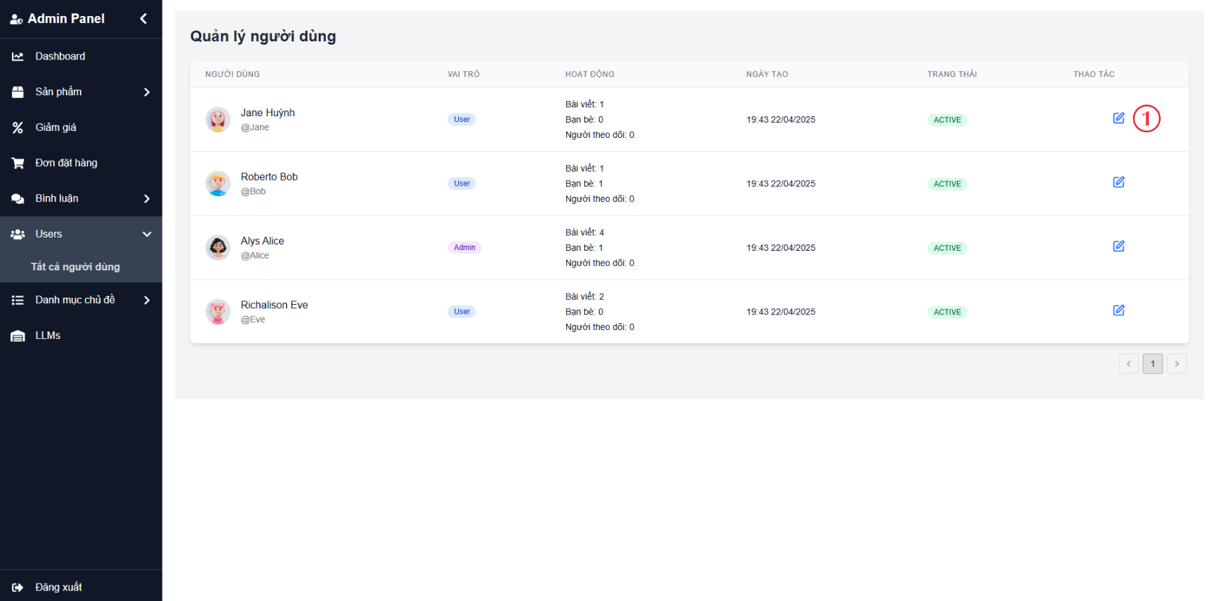

Figure 4‑37. User management screen

|  |  |  |  |
| --- | --- | --- | --- |
| **No.** | **Name** | **Type** | **Event** |
| 1 | Edit | Button | For admin delete or unactivate user |

Table 4‑29. User management screen

#### 4.4.1.4. Product management screen (SCU22)

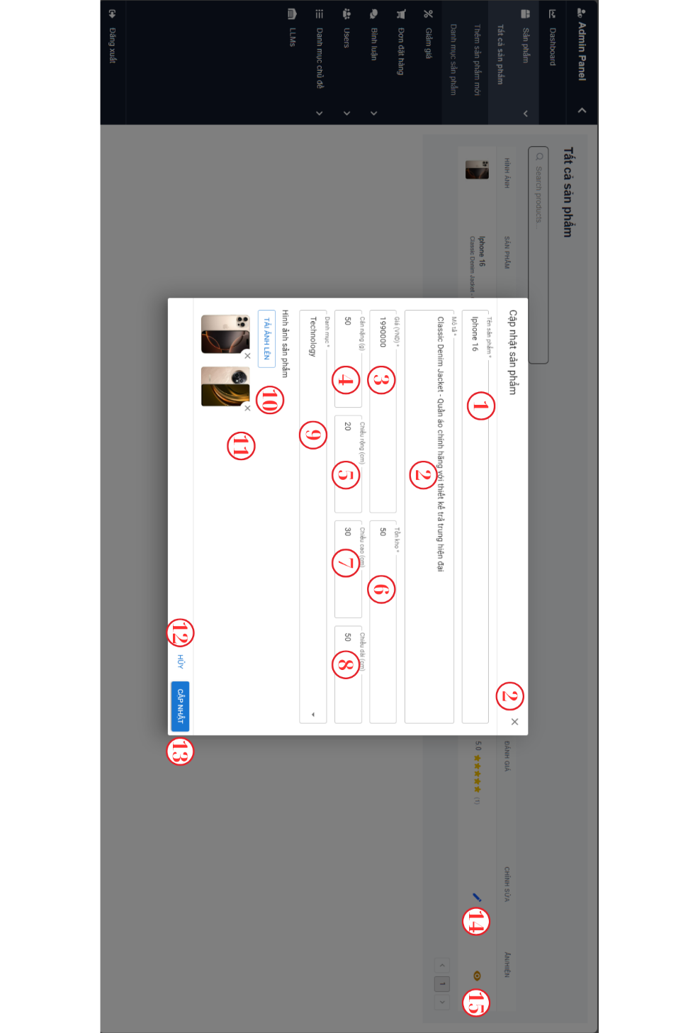

Figure 4‑38. Product management screen

|  |  |  |  |
| --- | --- | --- | --- |
| **No.** | **Name** | **Type** | **Event** |
| 1 | Product Name | TextBox | For admin add name of product |
| 2 | Description | TextBox | For admin add description of product |
| 3 | Price | TextBox | For admin add the price of product |
| 4 | Weight | TextBox | For admin add the weight of product |
| 5 | Width | TextBox | For admin add the width of product |
| 6 | Stock | TextBox | For admin add the stock quantity |
| 7 | Height | TextBox | For admin add the height of product |
| 8 | Length | TextBox | For admin add the length of product |
| 9 | Category | Dropdown | For admin select the category of product |
| 10 | Upload | Button | After clicking, admin upload images from the device. |
| 11 | Delete | Button | After clicking, admin delete the iamge they don’t want to upload for product |
| 12 | Cancel | Button | After clicking, admin break the proccess to update product |
| 13 | Save | Button | After clicking, save the changes. |
| 14 | Edit | Button | After cliciking, a form to update information of product. |
| 15 | Hint | Button | After clicking, the status of product is change. |

Table 4‑30. Product management screen

### 4.4.2. User interface

#### 4.4.2.1. Register screen (SCU01)

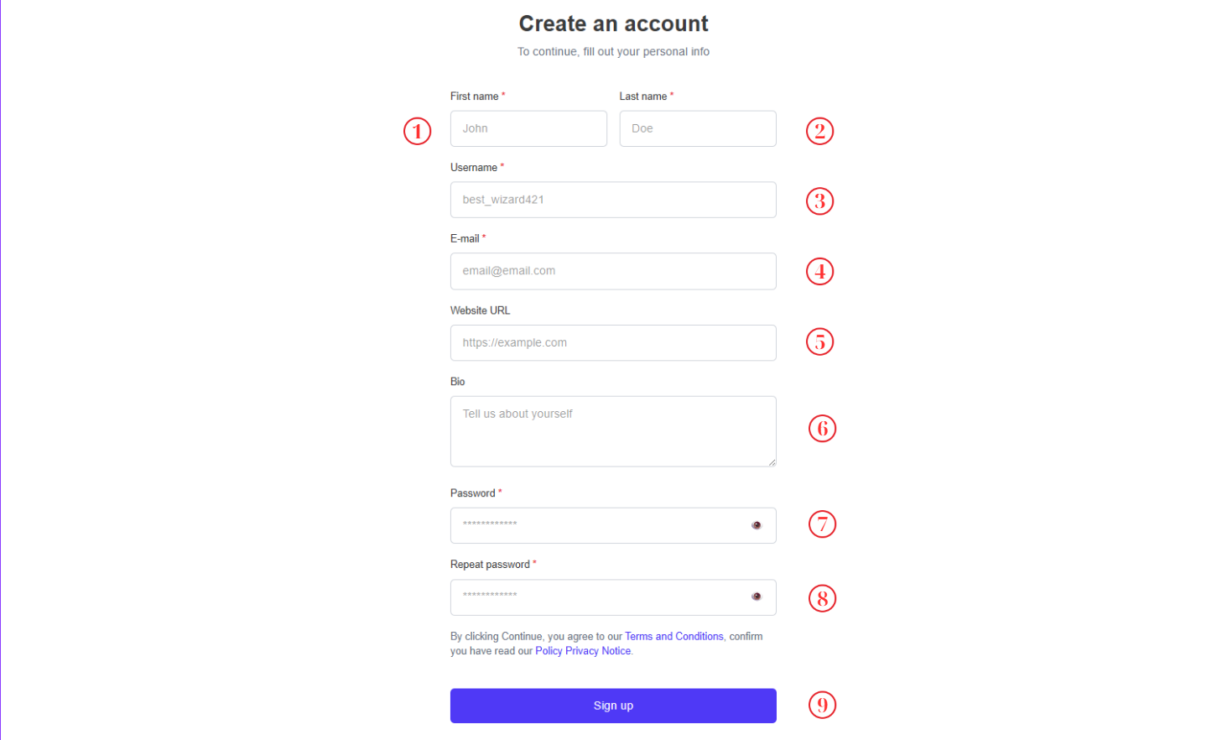

Figure 4‑39. Register screen

|  |  |  |  |
| --- | --- | --- | --- |
| **No.** | **Name** | **Type** | **Event** |
| 1 | First name | TextBox | For user input first name |
| 2 | Last name | TextBox | For user input last name |
| 3 | User name | TextBox | For user input user name |
| 4 | Email | TextBox | For user input email |
| 5 | Website URL | TextBox | For user input website url |
| 6 | Bio | TextBox | For user to input Bio |
| 7 | Password | TextBox | For user to input password |
| 8 | Repeat password | TextBox | For user to input password |
| 9 | Sign up | Button | After clicking, new user will be created and the page goes to main screen |

Table 4‑31. Register screen

#### 4.4.2.2. Login screen (SCU02)

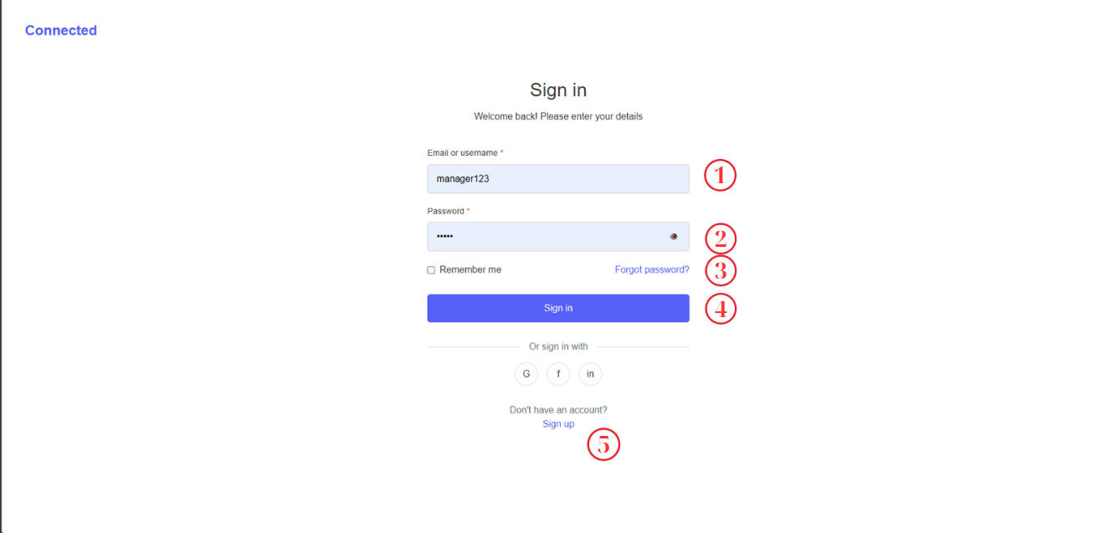

Figure 4‑40. Login screen

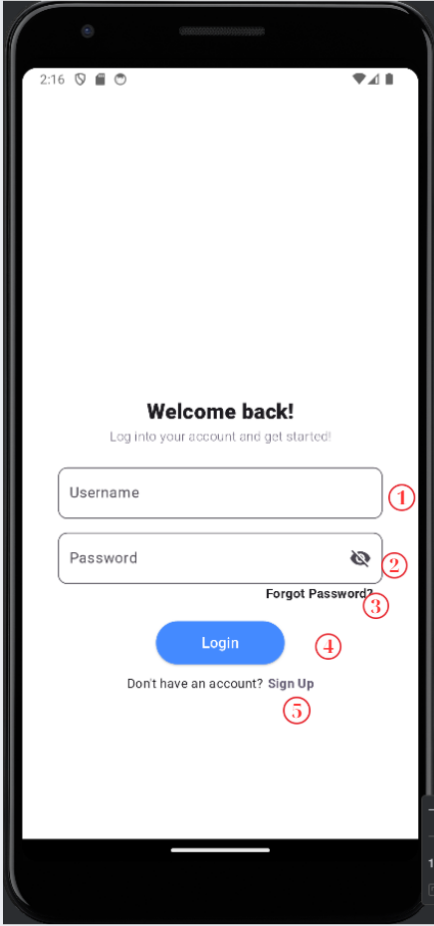s

Figure 4‑41. Login screen mobile

|  |  |  |  |
| --- | --- | --- | --- |
| **No.** | **Name** | **Type** | **Event** |
| 1 | User Name | TextBox | For user to input username |
| 2 | Password | TextBox | For user to input password |
| 3 | Forgot Password | Button | Navigate to forgot password screen |
| 4 | Login | Button | After clicking, the page goes to main screen |
| 5 | Sign Up | Button | After clicking, the page goes to Register Screen |

Table 4‑32. Login screen

#### 4.4.2.3. Main screen (SCU03)

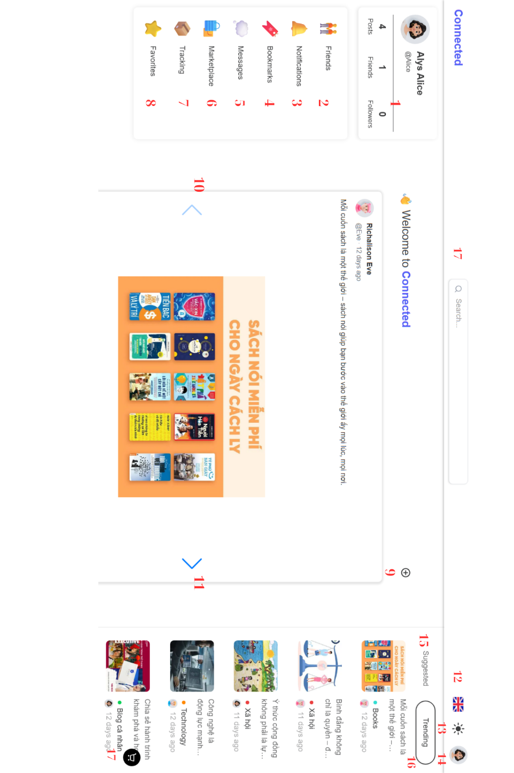

Figure 4‑42. Main screen light mode

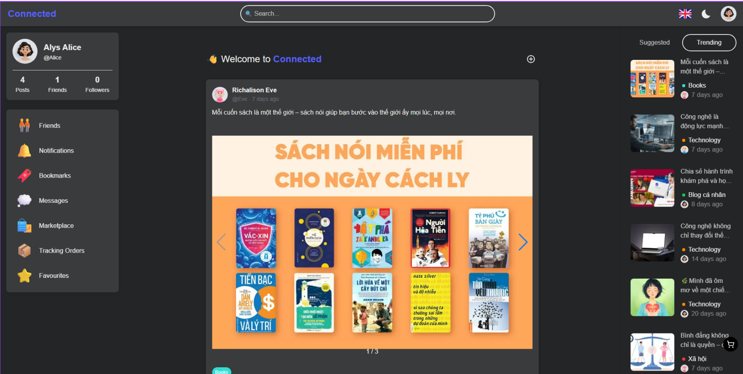

Figure 4‑43. Main screen dark mode

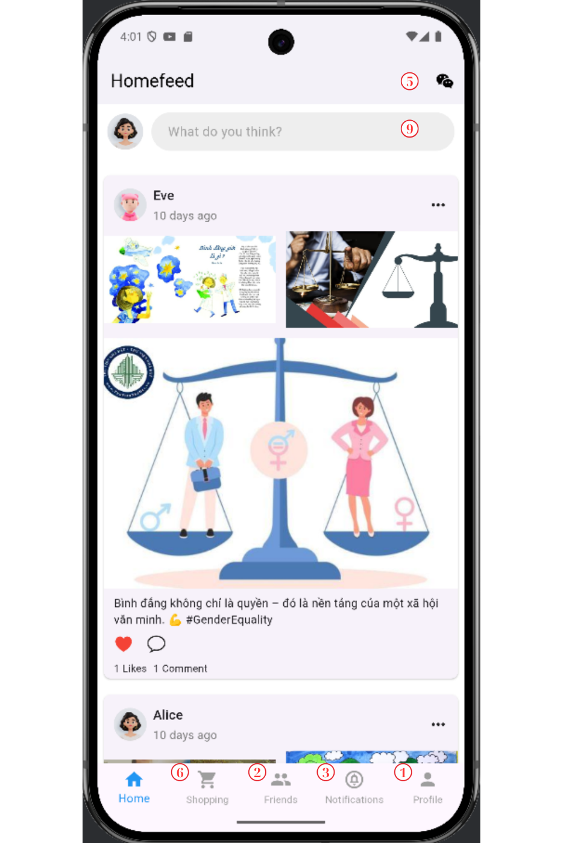

Figure 4‑44. Main screen mobile

|  |  |  |  |
| --- | --- | --- | --- |
| **No.** | **Name** | **Type** | **Event** |
| 1 | User information | Text | Show name and email of user |
| 2 | Friend | Button | After clicking, the page goes to feed screen |
| 3 | Notification | Button | After clicking, the page goes to notification screen |
| 4 | BookMark | Button | After clicking, the page goes to BookMark screen |
| 5 | Messages | Button | After clicking, the page goes to Messages screen |
| 6 | MarketPlace | Button | After clicking, the page goes to MarketPlace screen |
| 7 | Tracking Orders | Button | After clicking, the page goes to Tracking Orders screen. |
| 8 | Favorite | Button | After clicking, the page goes to Favorite screen. |
| 9 | Create Post | Button | After clicking, the page goes to Create Post screen. |
| 10 | Previous Image | Button | After clicking, slider images |
| 11 | Next Image | Button | After clicking, the page goes to detail profile user screen |
| 12 | Change language | Button | After clicking, the popup will show to choose the language |
| 13 | Dark/Light Mode | Button | After clicking, the system will change to light/dark mode |
| 14 | User information | Button | After clicking, the system goes to profile screen |
| 15 | Suggested | Button | After clicking, the system shows list of suggested users. |
| 16 | Trending | Button | After clicking, the system shows list of trending posts. |
| 17 | Cart | Button | After clicking, the system shows cart. |

Table 4‑33. Main screen

#### 4.4.2.4. Post detail (SCU04)

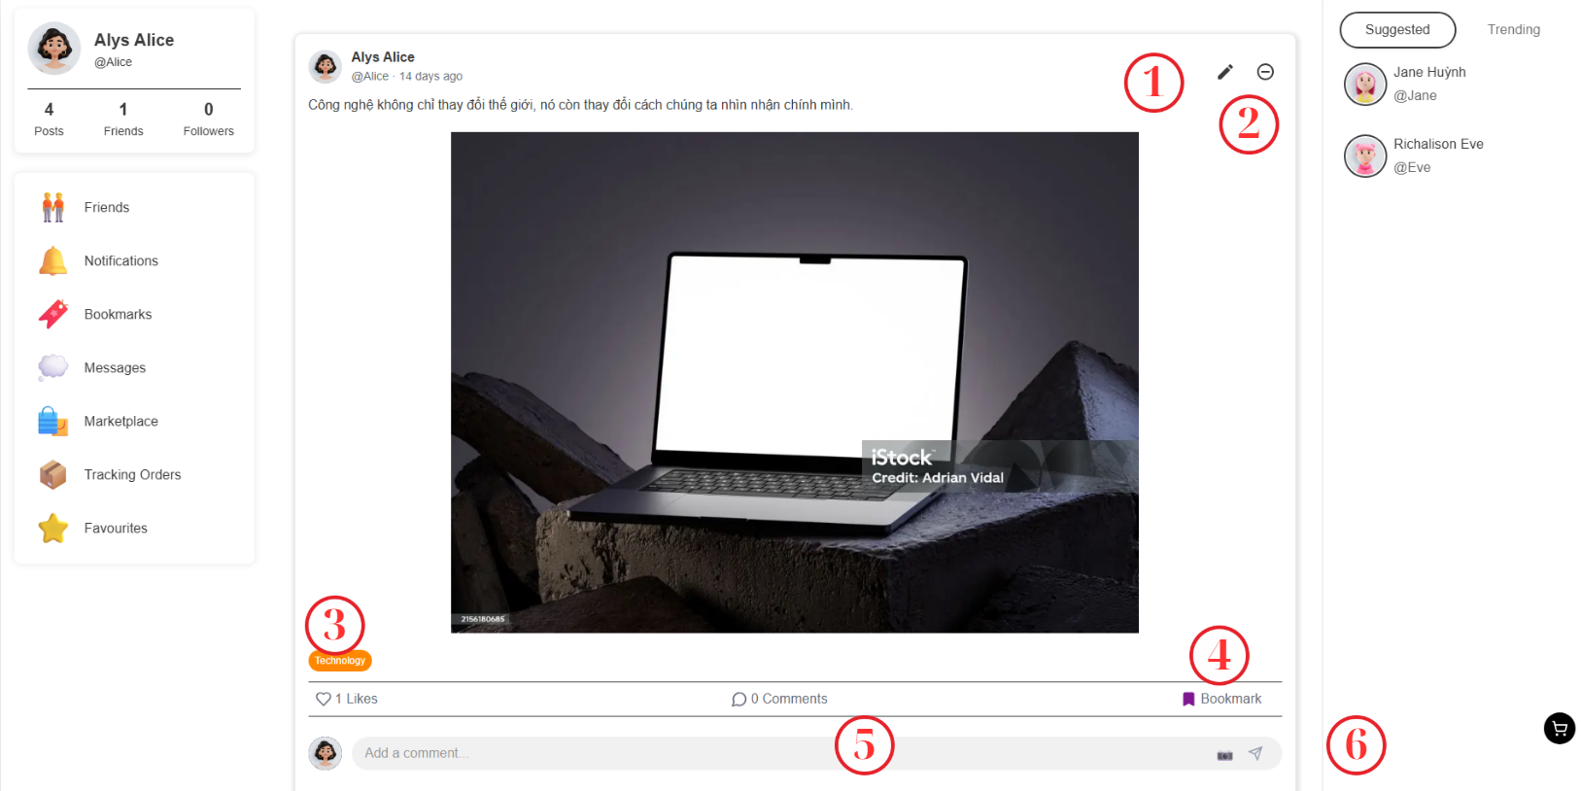

Figure 4‑45. Post detail screen

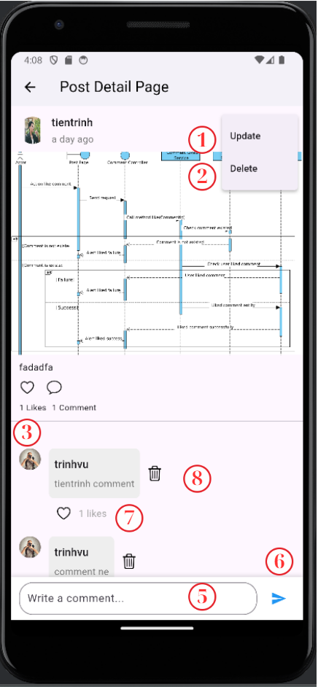

Figure 4‑46. Post detail mobile screen

|  |  |  |  |
| --- | --- | --- | --- |
| **No.** | **Name** | **Type** | **Event** |
| 1 | Edit | Button | After clicking, the system goes to edit post |
| 2 | Delete | Button | After clicking, the post will be deleted |
| 3 | Like | Button | After clicking, the post will be liked |
| 4 | BookMark | Button | After clicking, the post will be saved in BookMark |
| 5 | Input comment | TextView | For user to input content |
| 6 | Send | Button | After clicking, new comment will be created |
| 7 | Like comment | Button | After clicking, the comment will be liked |
| 8 | Delete comment | Button | After clicking, the comment will be deleted |

Table 4‑34. Post detail screen

#### 4.4.2.5. Create post screen (SCU05)

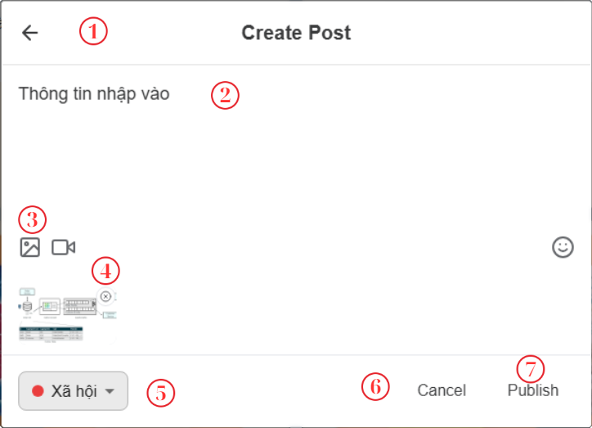

Figure 4‑47. Create post screen

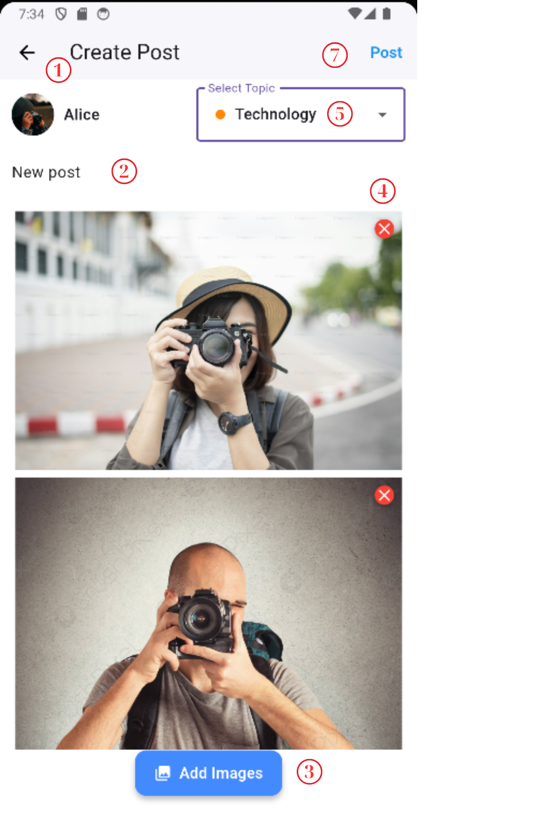

Figure 4‑48. Create post mobile screen

|  |  |  |  |
| --- | --- | --- | --- |
| **No.** | **Name** | **Type** | **Event** |
| 1 | Back | Button | Back to main screen |
| 2 | Input information | TextView | For user to input the status of the post |
| 3 | Input Image | Button | After clicking, the popup will show for user to choose image from the device. |
| 4 | Delete image | Button | After clicking, user can delete the image, not to display in new post |
| 5 | Topic | Dropdown | For user to choose topic for the post |
| 6 | Cancel | Button | After clicking, clear the information and stop the process to create new post. |
| 7 | Publish | Button | After clicking, new post will be created and the system goes to main screen. |

Table 4‑35. Create post screen

#### 4.4.2.6. Bookmark screen (SCU06)

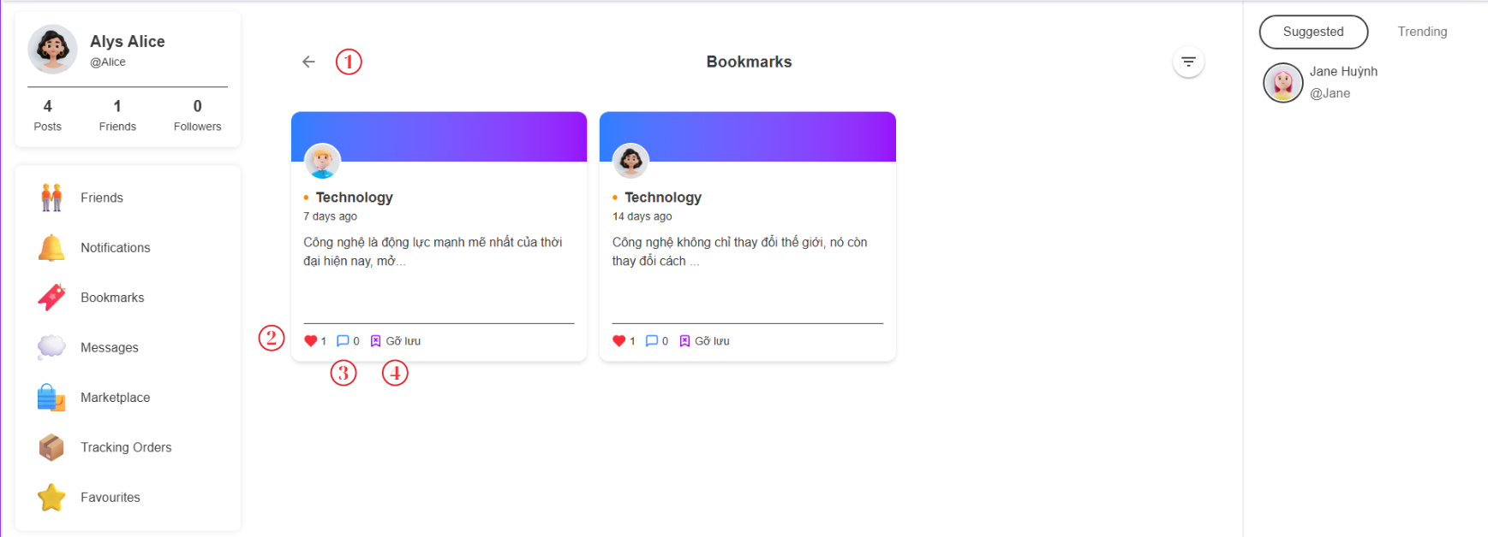

Figure 4‑49. Saved items screen

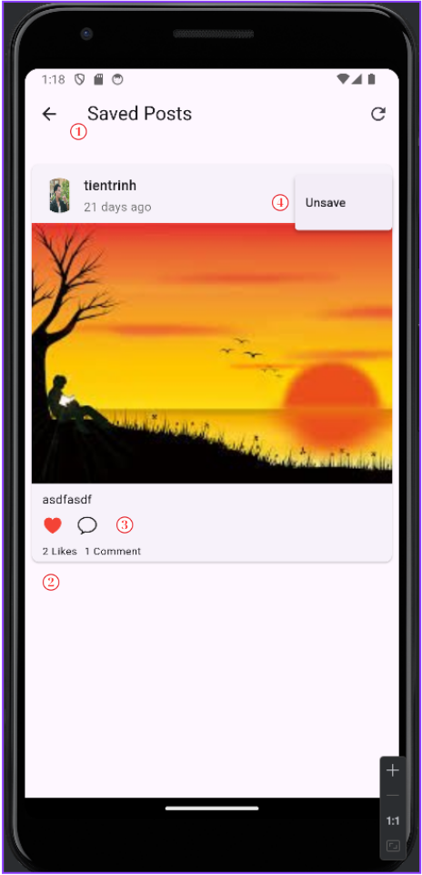

Figure 4‑50. Saved items screen

|  |  |  |  |
| --- | --- | --- | --- |
| **No.** | **Name** | **Type** | **Event** |
| 1 | Back | Button | Back to main page |
| 2 | Like | Button | For user to like and unlike saved post |
| 3 | Comment | Button | For user to navigate to detail post to comment |
| 4 | Unsave | Button | For user to unsave post |

Table 4‑36. Saved items screen

#### 4.4.2.7. Notification screen (SCU07)

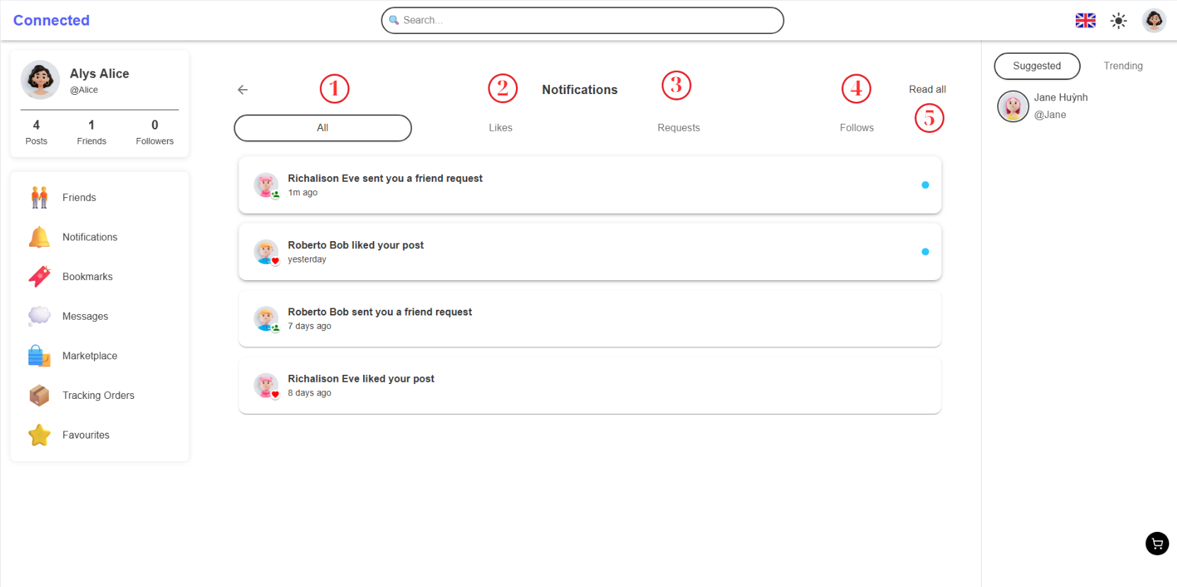

Figure 4‑51. Resource screen

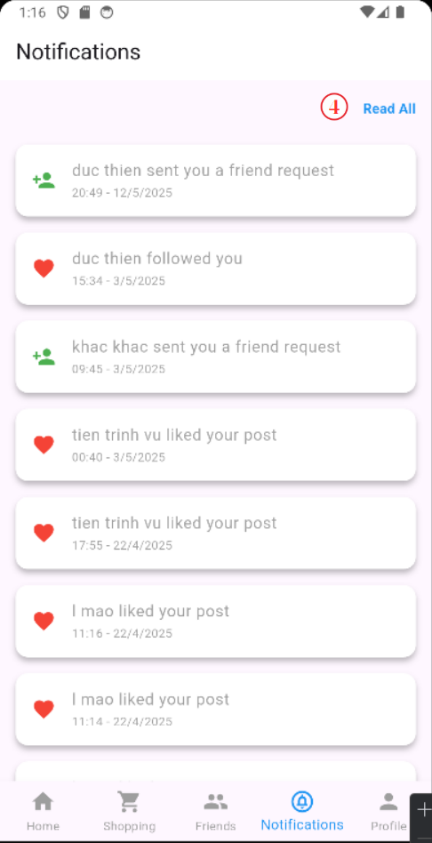

Figure 4‑52. Resource screen

|  |  |  |  |
| --- | --- | --- | --- |
| **No.** | **Name** | **Type** | **Event** |
| 1 | Edit | Button | Open edit mode. |
| 2 | View | Button | User can view image larger. |
| 3 | Download | Button | User can download image to their devices. |
| 4 | Delete | Button | User can delete media item. |

Table 4‑37. Resource screen

#### 4.4.2.8. Chat screen (SCU08)

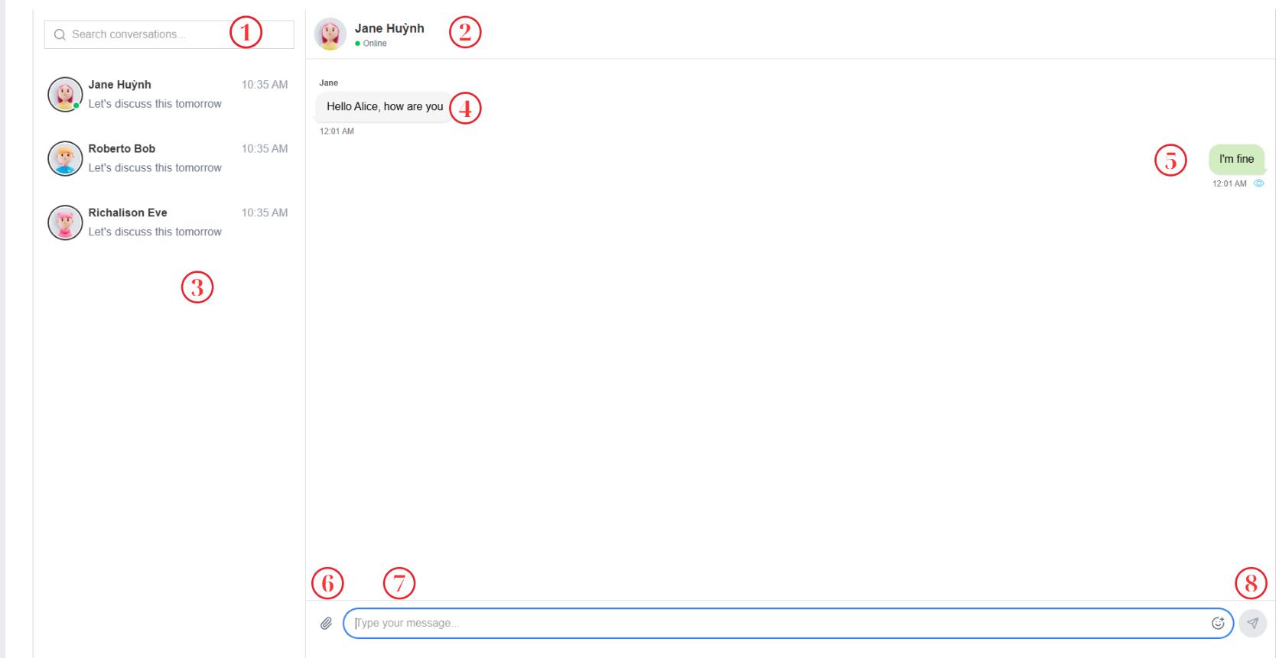

Figure 4‑53. Chatting screen

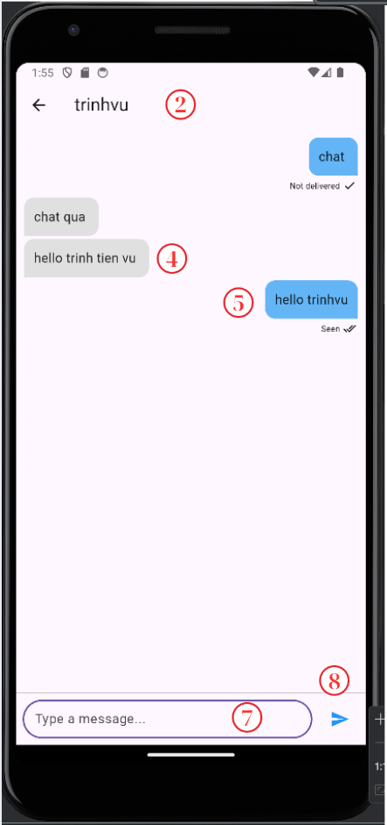

Figure 4‑54. Chatting mobile screen

|  |  |  |  |
| --- | --- | --- | --- |
| **No.** | **Name** | **Type** | **Event** |
| 1 | Search | Textbox | Search user |
| 2 | Receiver Information | TextView | Display name and avatar of receiver. |
| 3 | Another user | TextView | For user can click to choose receiver message |
| 4 | Receiver’s message | TextView | Display Receiver’ messages |
| 5 | Sender’s messages | TextView | Display Sender’s messages |
| 6 | Choose fille | Button | After clicking, the file popup will display for user can choose. |
| 7 | Type your message here | TextBox | For user input messages |
| 8 | Send | Button | After clicking, new message will send to receiver |

Table 4‑38. Chatting screen

#### 4.4.2.9. Search screen (SCU9)

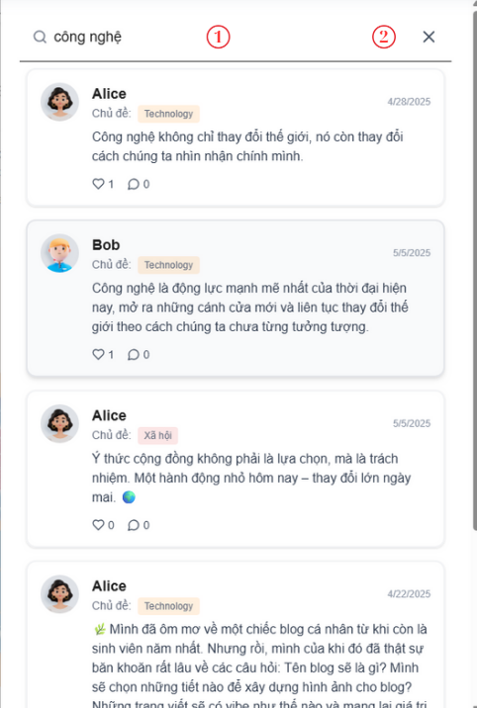

Figure 4‑55. Search screen

|  |  |  |  |
| --- | --- | --- | --- |
| **No.** | **Name** | **Type** | **Event** |
| 1 | Search input | TextBox | For user input information to search |
| 2 | Delete | Button | After clicking, the TextBox will be deleted |

Table 4‑39. Search screen

#### 4.4.2.10. All Friend Screen (SCU10)

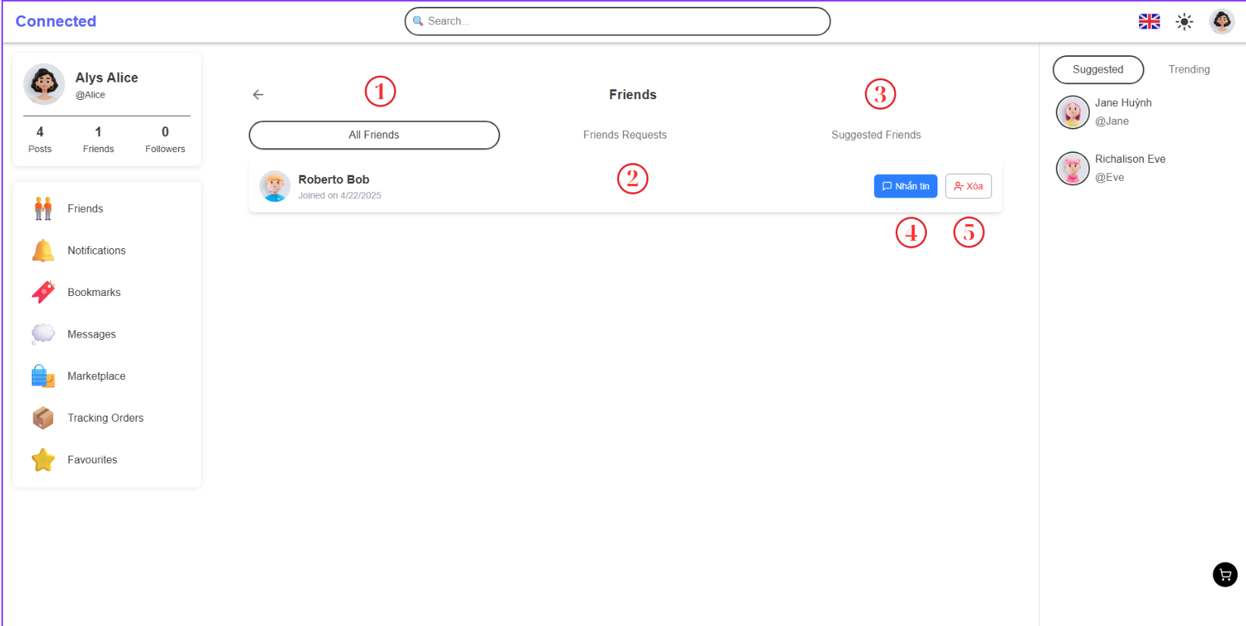

Figure 4‑56. Show all friend screen

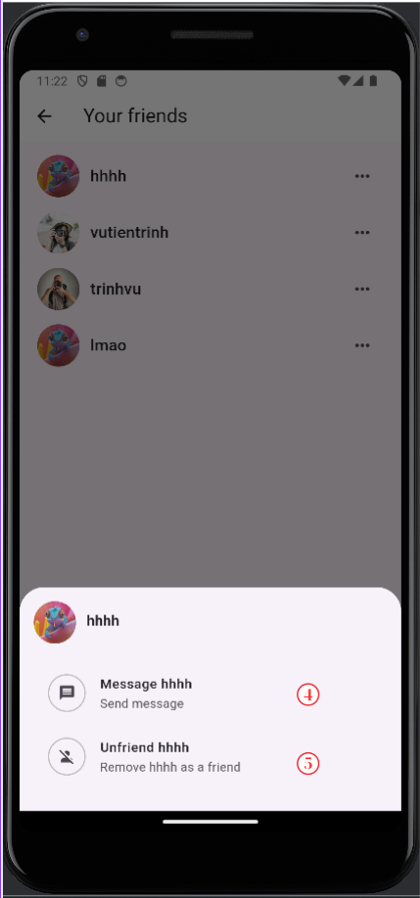

Figure 4‑57. Show all friend mobile screen

|  |  |  |  |
| --- | --- | --- | --- |
| **No.** | **Name** | **Type** | **Event** |
| 1 | All Friend | Tab View | Show all user |
| 2 | Friend Requests | Tab View | Show the friend requests |
| 3 | Suggested Friends | Tab View | Show the suggested Friends |
| 4 | Message | Button | For user can chat with friend |
| 5 | Delete | Button | For user can delete friend. |

Table 4‑40. All friend screen

#### 4.4.2.11. Market Place Screen (SCU13)

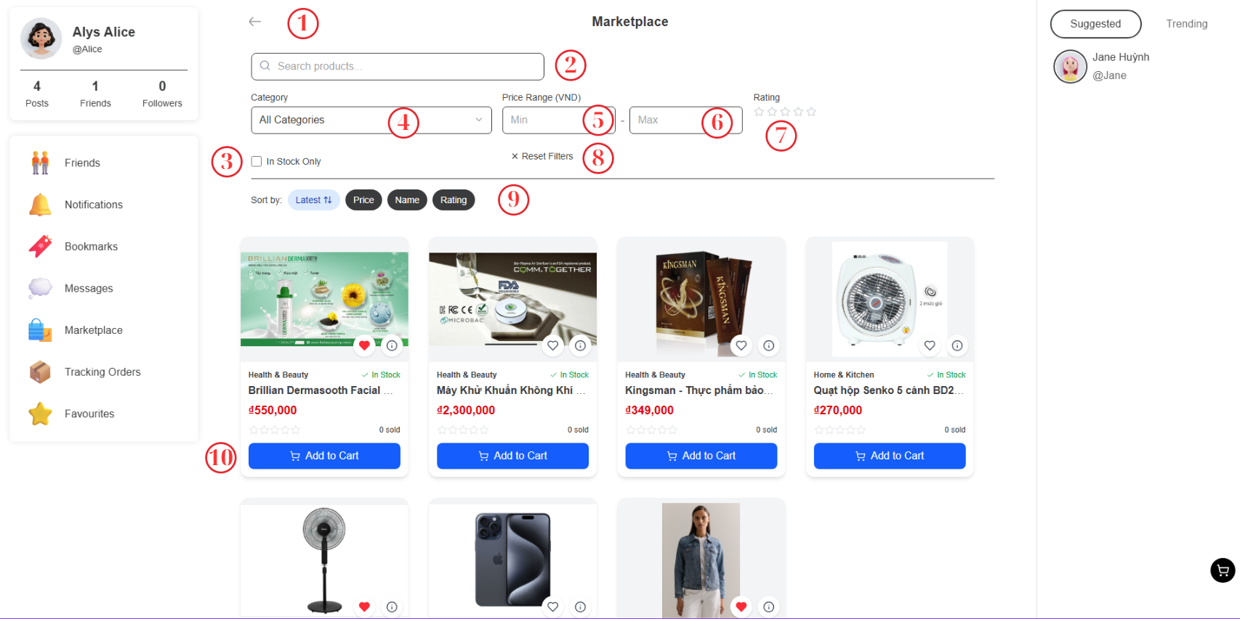

Figure 4‑58. Market place screen

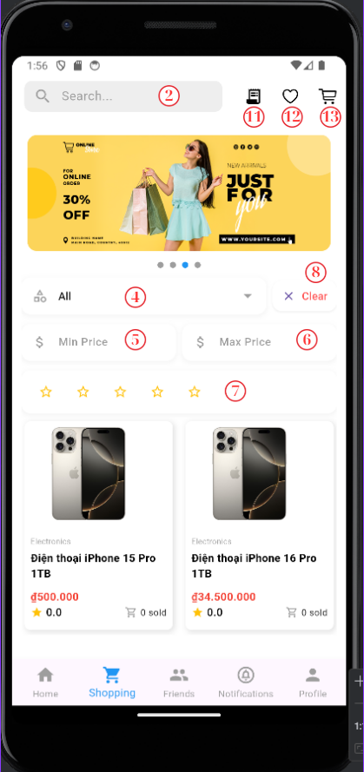

Figure 4‑59. Market place mobile screen

|  |  |  |  |
| --- | --- | --- | --- |
| **No.** | **Name** | **Type** | **Event** |
| 1 | Back | Button | Back to previous screen |
| 2 | Search | Text Box | For user input name of product, they want to find |
| 3 | In stock Only | Check Box | For user to filter the product in stock |
| 4 | Category | Dropdow | For user to choose the type of product. |
| 5 | Min price | Text Box | For user to filter products with the price more than the min price |
| 6 | Max Price | Text Box | For user to filter products with the price less than the max price |
| 7 | Star | Button | For user to filter product with number of star that user have reviewed. |
| 8 | Reset filter | Button | After clicking, all of fields for filter will be cleared |
| 9 | Sort | Button | After clicking, the products will be sorted |
| 10 | Add to cart | Button | After clicking, the product will be added in cart. |
| 11 | Tracking order | Button | After clicking, the system goes to tracking order screen. |
| 12 | Favorite product | Button | After clicking, the system goes to favorite product screen. |
| 13 | Cart | Button | After clicking, the system goes to cart screen. |

Table 4‑41. Market screen

#### 4.4.2.12. Cart Screen (SCU15)

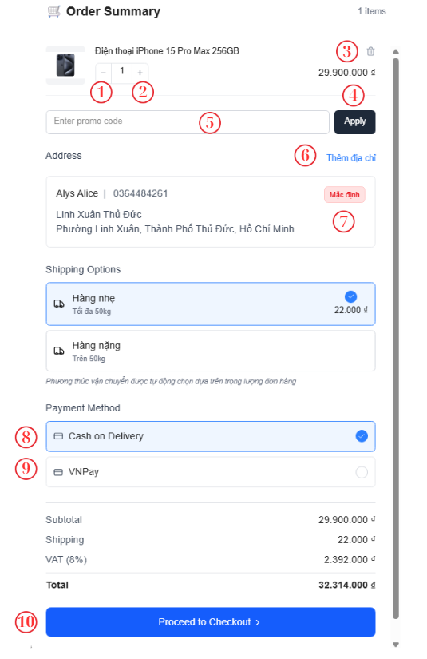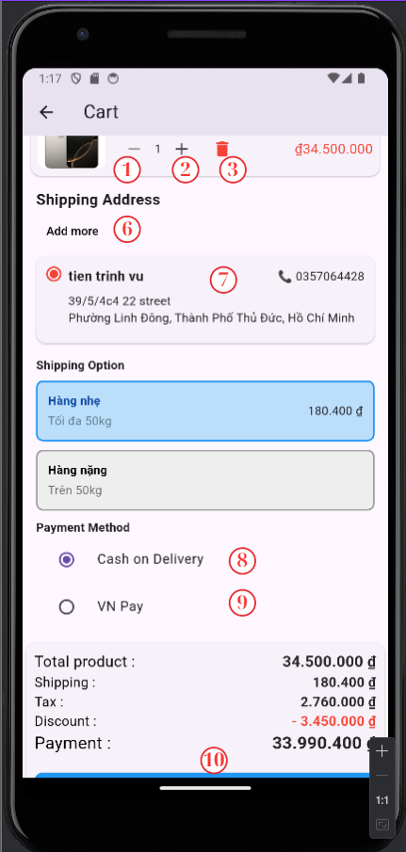

Figure 4‑60. Cart screen

Figure 4‑61. Cart mobile screen

|  |  |  |  |
| --- | --- | --- | --- |
| **No.** | **Name** | **Type** | **Event** |
| 1 | Decrease | Button | After clicking, decrease the quantity of product |
| 2 | Increase | Button | After clicking, increase the quantity of product |
| 3 | Delete | Button | After clicking, delete product in cart |
| 4 | Apply | Butotn | Afer clicking, apply promo code |
| 5 | Enter promo code | TextBox | For user input promo code |
| 6 | Add more | Button | After clicking, navigate to create new address form. |
| 7 | Set default | Button | After clicking, set default for this address. |
| 8 | Cash on delivery | Selected Box | Choose option payment using cash |
| 9 | VN Pay | Selected Box | Choose option payment using VN Pay |
| 10 | Proceed to checkout | Button | After clicking, move to payment using vnpay or finish the order. |

Table 4‑42. Cart screen

#### 4.4.2.13. Order detail screen (SCU16)

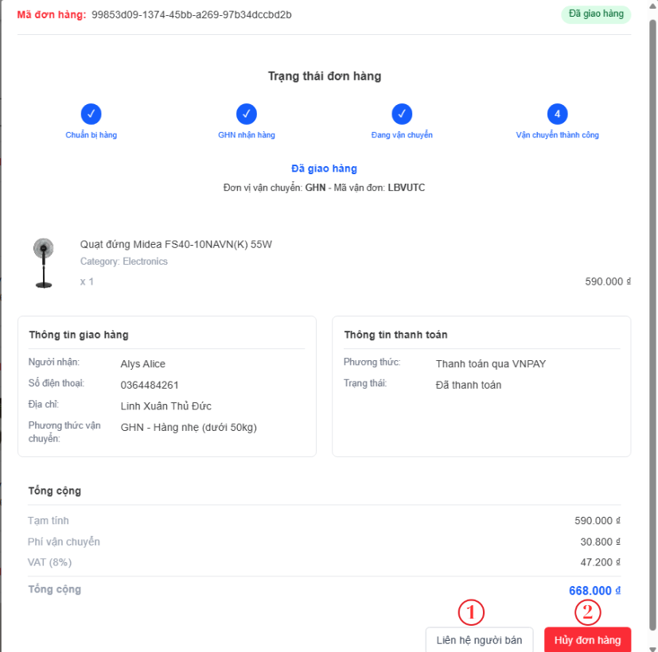

Figure 4‑62. Order detail screen

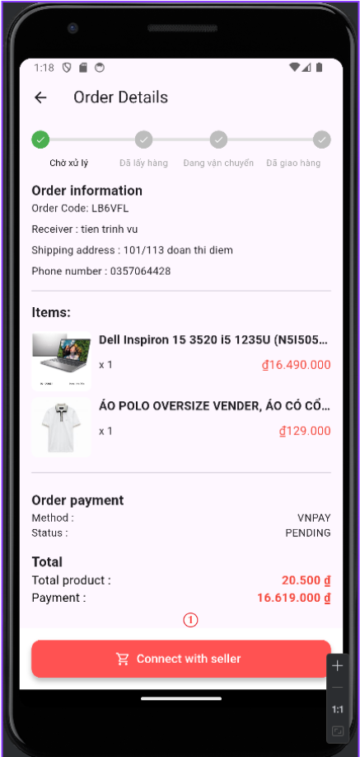

Figure 4‑63. Order detail mobile screen

|  |  |  |  |
| --- | --- | --- | --- |
| **No.** | **Name** | **Type** | **Event** |
| 1 | Connect to Seller | Button | For user to connect with seller |
| 2 | Order Cancel | Button | After clicking, the order can be deleted |

Table 4‑43. Product detail screen

#### 4.4.2.14. Tracking Orders Screen (SCU17)

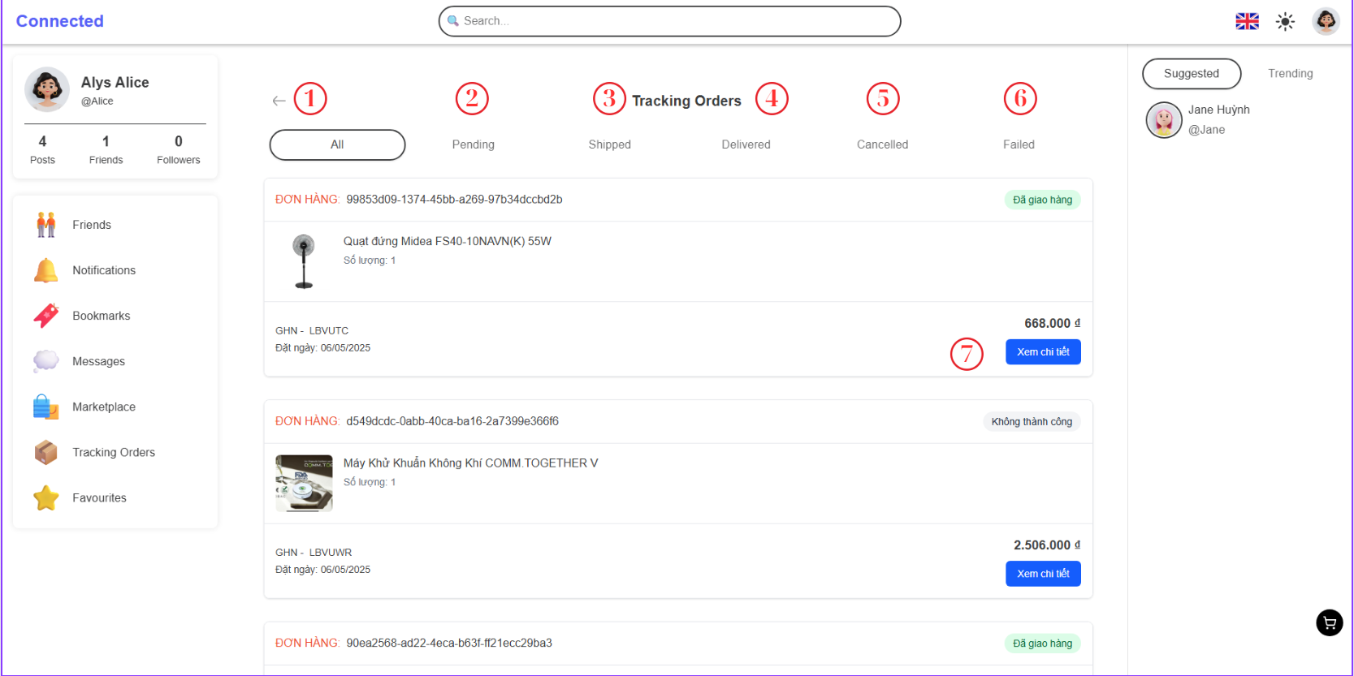

Figure 4‑64. Tracking orders screen

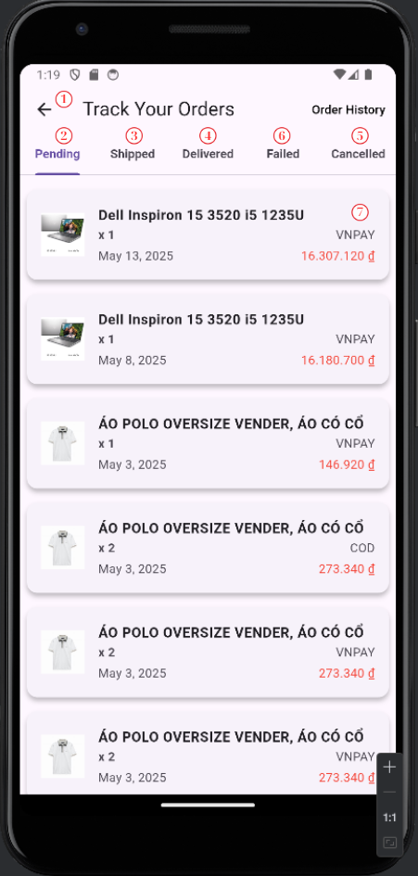

Figure 4‑65. Tracking orders mobile screen

|  |  |  |  |
| --- | --- | --- | --- |
| **No.** | **Name** | **Type** | **Event** |
| 1 | Back | Button | After clicking, the system goes to previous screen |
| 2 | Pending | TabView | After clicking, the system shows the order has pending status |
| 3 | Shipped | Tabview | After clicking, the system shows the oder has shipped status |
| 4 | Delivered | Tabview | After clicking, the system shows the order has delevered status |
| 5 | Cancelled | Tabview | After clicking, the system shows the order has cancelled status |
| 6 | Failed | Tabview | After clicking, the system shows the order has failed status |
| 7 | Detail | Button | After clickingm the system goes to detail order. |

Table 4‑44. Market screen

#### 4.4.2.15. Product Detail Screen (SCU18)

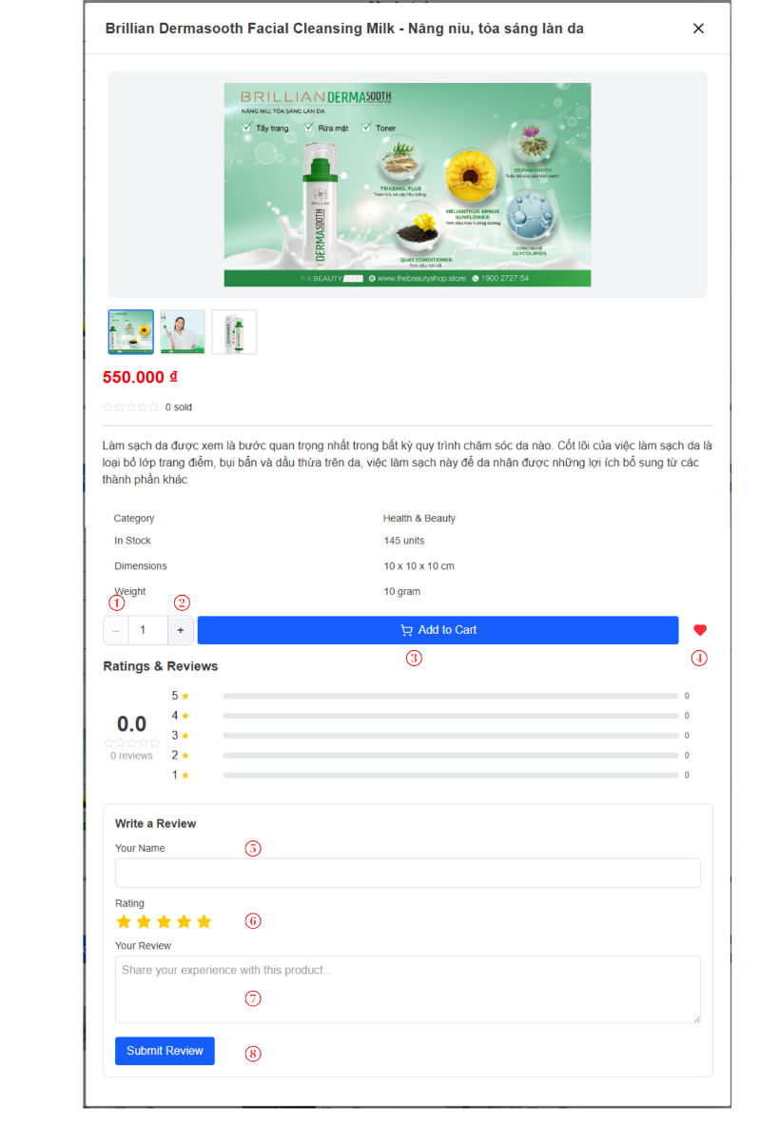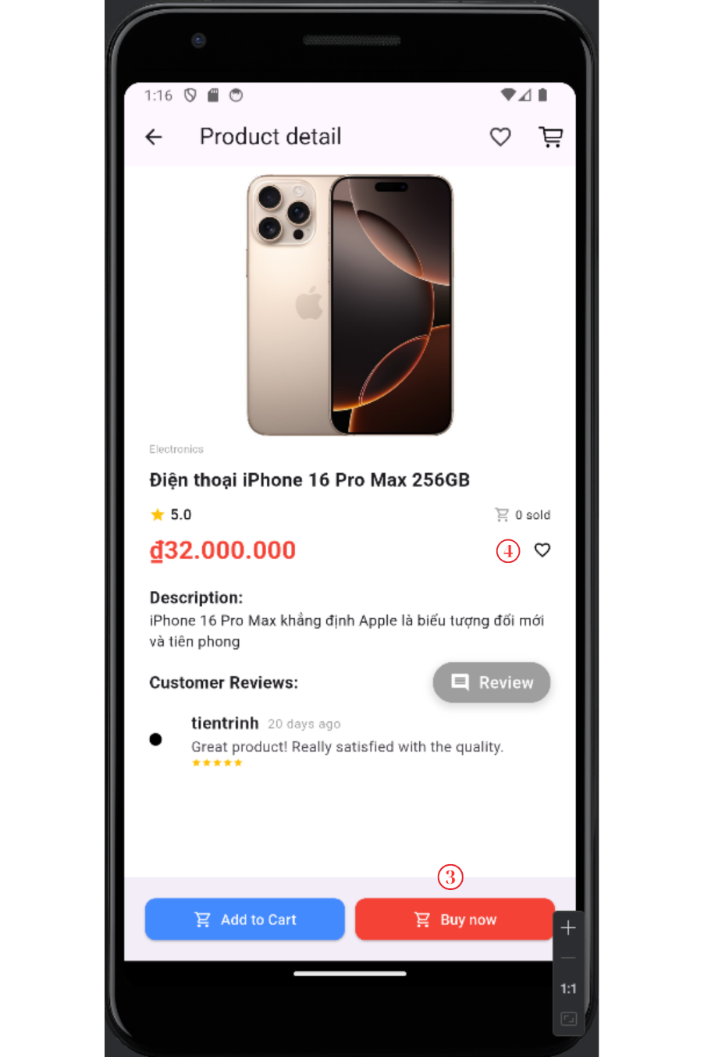

Figure 4‑66. Product detail screen

Figure 4‑67. Product detail mobile screen

|  |  |  |  |
| --- | --- | --- | --- |
| **No.** | **Name** | **Type** | **Event** |
| 1 | Decrease | Button | After clicking, decrease the quantity of product |
| 2 | Increase | Button | After clicking, increase the quantity of product |
| 3 | Add to cart | Button | After clicking, add the product to cart |
| 4 | Like | Button | After clicking, add product into favorite product’s lists |
| 5 | Your name | TextBox | For user input name for comment |
| 6 | Rating | Seleted box | For user select the rating (from 1 to 5) |
| 7 | Content | TextBox | For user input comment |
| 8 | Submit | Button | After clicking, new comment will be created and display |

Table 4‑45. Product detail screen

# CHAPTER 5. IMPLEMENTATION AND TESTING

## 5.1. Development environment

|  |  |  |
| --- | --- | --- |
| No | Application | Description |
| 1 | NodeJs | - Version: v20.11.1  - Download: <https://nodejs.org/en/download> |
| 2 | Git | |  | | --- | |  |   - Version: v2.42.0  - Download: <https://git-scm.com/download> |
| 3 | NextJs | - Version: 14.1.0  - A React framework for server-side rendering and static site generation.  - Install via Node Package Manager (npm): npm install next  - Docs: https://nextjs.org/docs |
| 4 | Spring Boot | |  | | --- | |  |  |  | | --- | | - Version: 3.2.5  - A Java framework for creating standalone, production-grade applications.  - Download (via Initializr): <https://start.spring.io> | |
| 5 | SpringAI | - Version: 0.8.0  - A Spring project to integrate AI models like OpenAI and Azure AI into Spring apps.  - Docs: <https://docs.spring.io/spring-ai> |
| 6 | Apache Kafka | |  | | --- | |  |  |  | | --- | | - Version: 3.7.0  - A distributed event streaming platform for high-performance data pipelines.  - Download: <https://kafka.apache.org/downloads> | |
| 7 | Apache Flink | - Version: 1.19.0  - A real-time stream processing engine for distributed data processing.  - Download: <https://flink.apache.org/downloads.html> |
| 8 | Flutter | - Version: 3.19.6  - A UI toolkit from Google for building natively compiled apps across mobile, web, and desktop from a single codebase.  - Download: https://flutter.dev/docs/get-started/install |

Table 5‑. List of application need for system

### 5.1.1. Implementation

#### 5.1.1. Back-End implement

*Installation Instruction*

**Step 1:** Clone the repostory with SSH keys

* git clone <https://github.com/ThanhDuy21110759/connected.git>

**Step 2:** Running Docker compose base on README.MD

Check all container is running

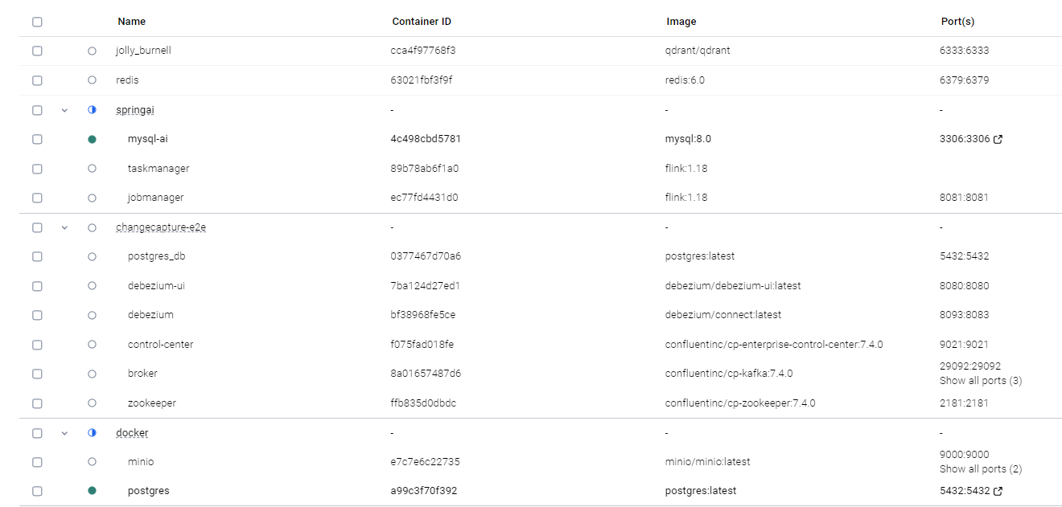

Figure 5-1. Docker container

**Step 3:** Copy env from /env folder to Project (satchat & springAI) and change name to .env

**Step 4:** Running satchat, springAI and semantic-search-qdrant with Intellji and VSCode

#### 5.1.2. Front-End Implement

* Website

**Step 1**: Install Dependencies

Navigate to the project directory and install all required dependencies using yarn:

* cd satchat-fe
* yarn install

**Step 2**: Copy env from /env folder to Project (satchat-fe) and change name to .env and build.

* yarn build

**Step 3**: Running application with Yarn

* Production**:** yarn dev
* Staging**:** yarn start
* Mobile

**Step 1:** Clone the repostory with SSH keys

* git clone <https://github.com/vutientrinh/flutter-social-share.git>

**Step 2:**  Run command

* Flutter pub get
* Flutter pub update
* Flutter pub run

**Step 3:** Select a device to run

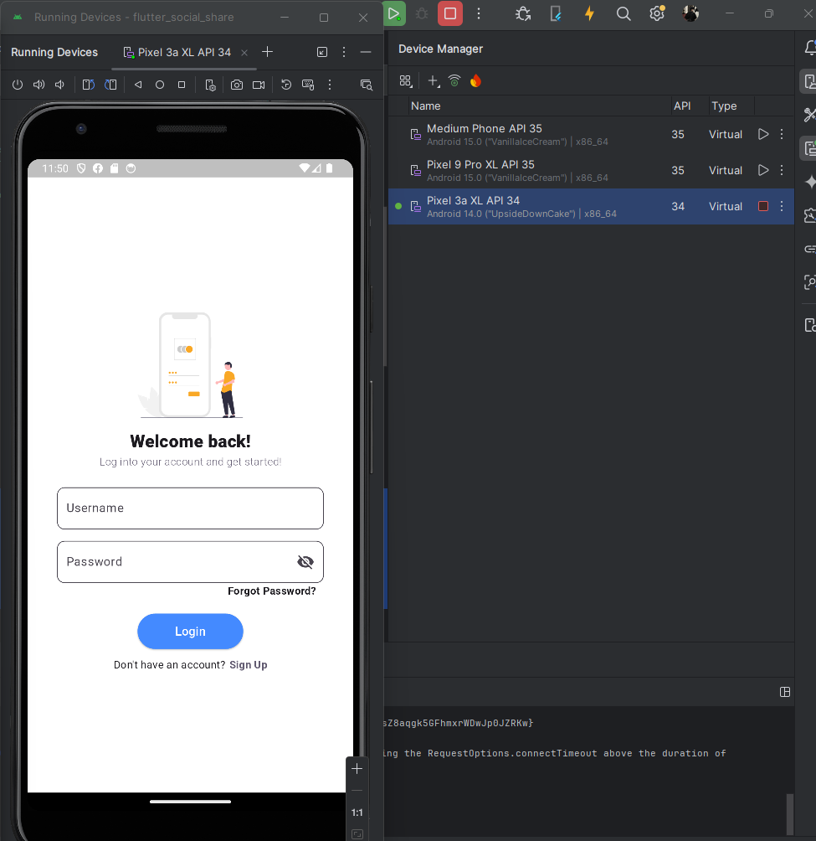

Figure 5-2. Selected device

### 5.1.2. Tools

|  |  |  |
| --- | --- | --- |
| **No.** | **Tool’s name** | **Descriptions** |
| 1 | Github | Source code management tools |
| 2 | Vscode | Text editor  - version: 1.95  - Link download: <https://code.visualstudio.com/download> |
| 3 | Microsoft Edge | Browser  - version: 97.0.1072.55 |
| 4 | Intellij IDEA | IDEA coding Back-End  - Version: 22.04  - Link download: <https://www.jetbrains.com/idea/download/?section=windows> |
| 7 | Android Studio | - IDE for Android app development  - Version: Hedgehog |
| 6 | Draw.io | Draw schema (mockup & sequence diagram) |

Table 5‑2. Tool needed for social application

### 5.1.3. TechStack

|  |  |  |
| --- | --- | --- |
| **No.** | **Technologies** | **Description** |
| 1 | PostgresSQL | Database |
| 2 | NextJs + Flutter | Building User Interface for application |
| 3 | NodeJS | Front-end development environment |
| 4 | Restful API | Communication protocals for Clients and Servers |
| 5 | JsonWeb Token |
| 6 | Redux Saga | State management system |
| 7 | Spring boot | Server-side backend |
| 8 | Minio | Store media file |
| 9 | Apache Flink | Real-time data processing |
| 10 | Apache Kafka | Message queue for microservices |
| 11 | Debezium | Sync database changes to Kafka |
| 12 | Redis | Cache and fast data access |
| 13 | Docker | Containerize and deploy apps |

Table 5‑3. Technologies stask of system

## 5.2.Deploy Environment

### 5.2.1. Environment Overview

The system is deployed in a Virtual Machine (VM) instance hosted on Google Cloud Platform (GCP). This deployment environment was chosen for its flexibility, scalability, and integration with a wide range of cloud services. The system operates in a cloud-based environment, which ensures high availability and reliability.

### 5.2.2. Hardware Specifications.

* Platform: Google Compute Engine (GCE)
* Machine Type: e2-custom-4-18432 (4 vCPUs, 18 GB Memory)
* Boot Disk: 40 GB Standard Persistent Disk
* Region: asia-southeast1-b (Singapore)
* Network: Default VPC with firewall rules configured for HTTP, and SSH

## 5.3. Testing

To ensure the system's functionality, reliability, and user experience, we conducted a comprehensive suite of tests, including:

* Functional Testing: Verified that each feature, including core functionalities like login, register, logut, and CRUD operations, adhered to the specified requirements.
* Boundary Value Analysis: Assessed the system's behavior at the limits of input values and parameters, such as minimum and maximum allowable inputs and form field constraints.
* Usabisility Testing: Evaluated the system's user-friendliness and intuitiveness, focusing on seamless navigation, consistent layout, clear error messages, and overall user experience.

Tool Utilization Postman was employed as a tool for functional testing, enabling us to validate API endpoints, verify response accuracy, and compare actual outputs against expected results. This rigorous approach ensured that the backend services met the defined requirements effectively.

### 5.2.1. Test case with user

|  |  |  |  |
| --- | --- | --- | --- |
| **No.** | **Function** | **Expectation** | **Result** |
| 1 | Login | User Login with account using right username and password | Pass |
| 2 | Post detail | Display the post detail in the main screen | Pass |
| 3 | Send friend request | Send request to new user (make new friend request) | Pass |
| 4 | Edit profile | Edit the information of profile | Pass |
| 5 | Create new post | Create new post successfully | Pass |
| 6 | Logout | Account logout the system, doesn’t store any information about the account | Pass |
| 7 | Following | Follow another user successfully | Pass |
| 8 | Order | New order will be created successful | Pass |
| 9 | Payment (VN Pay) | Payment successfully | Pass |
| 10 | Create address | New address will be created | Pass |

Table 5‑4. Test case with user

### 5.2.2. Test case with Admin

|  |  |  |  |
| --- | --- | --- | --- |
| **No.** | **Function** | **Expectation** | **Result** |
| 1 | Create new product | New product is created successfully | Pass |
| 2 | Change product status | Product status will be changed | Pass |
| 3 | Create new topic | New topic is created successfully | Pass |
| 4 | Delete user | The status of user change | Pass |
| 5 | Create new category | New category is created successfully | Pass |
| 6 | Delete comment | The comment is deleted | Pass |
| 7 | Change status of order | The status of the order is changed | Pass |
| 8 | Update product | The product’s information is updated successfully | Pass |
| 9 | Change user’s status | The user’s account status will be changed | Pass |

Table 5‑5. Test case with admin

# CHAPTER 6. CONCLUSION

## 6.1. Achievements

After the process of research and development of the topic “BUILDING A SOCIAL NETWORK SYSTEM INTEGRATE ECOMMERCE FEATURES”. Our team has achieved following results:

### 6.1.1. Knowledge

* Our team has gained an in-depth understanding of NextJs and Flutter, focusing on its application in creating dynamic and user-friendly interfaces for a social networking platform integrate ecommerce features.
* On the backend, we have acquired significant expertise in the Spring Boot framework, as well as Apache Kafka, Flink, Debenzium, ZooKeeper and SpringAI which facilitated the creation of a robust and scalable server-side architecture.
* Our knowledge of semantic search has grown significantly, and we have successfully implemented Qdrant, a vector database, to enable intelligent search and recommendation systems using embeddings, enhancing the relevance and personalization of user queries and product discovery.
* Our knowledge of PostgreSQL and MySQL has expanded, particularly in terms of efficient data storage and retrieval, ensuring the integrity and security of the application’s data.
* The team has prioritized performance optimization, ensuring the system responds quickly and operates reliably under various conditions.
* Our knowledge of GCP (Google Cloud Platform) has improved about deployment and use GCP environment to manage the system.

### 6.1.2. Skills

* Significantly improved proficiency in full-stack development by Next.js for server-side rendered web applications, Flutter for cross-platform mobile development, and Spring Boot for scalable and secure backend services.Members have developed problem-solving skills, effectively addressing challenges related to database management, backend logic, and frontend responsiveness, and Gained in-depth experience working with both MySQL and PostgreSQL, including schema design, query optimization, and data consistency across microservices.
* The collaborative nature of the project has fostered strong teamwork, communication, and project management skills, ensuring smooth and efficient progress.
* Core Social Network Features Implementation: Acquired practical experience in building key social media features, including real-time messaging, media uploads (images), user profile management, follow/unfollow systems, and feed algorithms.
* Integrated E-commerce Functionality: Developed and integrated e-commerce features including product listings, shopping cart, wishlist, payment processing with VN Pay, order tracking, and transaction history; enabled sellers to upload product images and manage inventory, while buyers could browse, search, and securely purchase products.

### 6.1.3. Product

* The platform successfully implemented core social media features like sharing, commenting, liking, and real-time chat, significantly boosting user interaction.
* An intelligent recommendation system was integrated, providing tailored content, connections, and product suggestions, thereby improving relevance and user satisfaction.
* The system fostered the creation of valuable user-generated content, including detailed product reviews, and comment’s posts.
* Integrating social and e-commerce features demonstrably enhanced sales and streamlined the overall customer journey.
* The final product is a robust, scalable, and flexible platform optimized for both web and mobile devices, ensuring long-term viability

## 6.2. Strength and drawback

### 6.2.1. Strength

* The login and registration systems incorporate advanced encryption protocols, ensuring user data and credentials remain safe.
* The platform includes real-time chatting capabilities, allowing users to communicate instantly, enhancing engagement and fostering dynamic social interactions.
* Users receive instant updates for activities realtime such as friend requests, or post interactions, ensuring they stay informed and engaged.
* The website's dynamic content delivery and intuitive navigation collectively enhance user engagement, providing a more interactive and enjoyable browsing experience.
* The application provides robust administrative tools for managing user accounts, moderating content, and ensuring a safe and organized community environment.
* The application is optimized for dynamic use on mobile phones
* Integrated AI features, a chatbot, assist administrators in managing users’ activities.

### 6.2.2. Drawback

* The platform may face occasional slowdowns or reduced responsiveness during high traffic periods, particularly when many users interact with both social and e-commerce features simultaneously.
* Combining social networking and e-commerce components increases system complexity, which can lead to challenges in scalability, maintenance, and troubleshooting during unexpected failures.

## 6.3. Future work

* Implement live streaming capabilities for product launches, influencer promotions, and user-generated content to drive engagement and conversions.
* Improve image and video compression algorithms to enhance media quality while minimizing storage and bandwidth usage.
* Add video and voice calling features to support more personal and real-time social interactions within the platform.
* Develop group and community features for product discussions, interest-based clubs, and user-generated events to promote engagement.

# REFERENCES

[1] Gamma, E., Helm, R., Johnson, R. and Vlissides, J., 1994. *Design patterns*. 1st ed.

[2] Bruegge, B., & Dutoit, A. H. (2010). *Object-oriented software engineering: Using UML, patterns, and Java*. Prentice Hall.

[4] NodeJS Learn, “*Introduction to Node.js”* 16/11/2024. <https://nodejs.dev/learn>

[5] IBM Cloud Learn Hub, “*REST APIs*” 06/4/2021.

<https://www.ibm.com/cloud/learn/rest-apis>

[6] Redux Official Tutorials, *“Redux Essentials, Part 1: Redux Overview and Concepts”* 7/7/2021. <https://redux.js.org/tutorials/essentials/part-1-overview-concepts#what-is-redux>

[7] Redux Toolkit Guide, “*Redux toolkit - Usage Guide*” 21/11/2024 <https://redux-toolkit.js.org/usage/usage-guide>

[8] Spring boot documentation, “*Documentation Spring Framework*” 26/11/2024. <https://docs.spring.io/spring-boot/index.html>

[9] Draw.io Documentation, “*Tutorial full course Draw.io proffesional*” 26/11/2024. <https://www.drawio.com/doc/>

[10] User Guide to draw.io. Introduction | by Hasali Edirisinghe, “*Guild to draw.io*” 26/11/2024.<https://medium.com/@hasaliedirisinghe/user-guide-to-draw-io-6a1a4d7b5d33>

[11] Anjum, N. (2020). *Beginning Flutter: A Hands-On Guide to App Development*. Apress. <https://link.springer.com/book/10.1007/978-1-4842-6253-3>

[12] Google Developers, "Flutter Documentation." 22/11/2024.  
<https://docs.flutter.dev/>

[13] Kreps, J., Narkhede, N., & Rao, J. (2011). *Kafka: a distributed messaging system for log processing*. LinkedIn.  
<https://dl.acm.org/doi/10.1145/2001269.2001271>

**[14]** Next.js Documentation, "Learn Next.js – an interactive tutorial." 22/11/2024.  
<https://nextjs.org/learn>

**[15]** Docker Docs, "Get Started with Docker." 22/11/2024.  
<https://docs.docker.com/get-started/>